
Community Impact Report 2026
Pūrongo Whakaaweawe Haporia

Adapted in 2026 by Accessible Formats Service,
Blind Low Vision NZ, Auckland
Total print pages: [63]
Total large print pages: [127]

Notes for the Large Print Reader
Print page numbers are indicated as:
Page 1
Main text is in Arial typeface, 18 point.
Headings are indicated as:

Heading 1

Heading 2

Heading 3

Alterations
Photographs have been enlarged.

Contents
Section | Print Page | Large Print Page
The Year in Review | 1 | 1
Shining a Light on Blindness | 4 | 5
Who we help | 5 | 9
Our Services | 7 | 12
Client Services | 8 | 14
Library Service | 15 | 30
Accessible Formats | 17 | 34
Client Story | 19 | 39
Community and Inclusion | 20 | 42
Our People | 24 | 50
Volunteering | 27 | 56
Equipment Solutions | 28 | 60
Support Grants | 30 | 63
Policy and Advocacy | 31 | 65
Fundraising | 33 | 69
Philanthropy and Corporate Partnerships | 34 | 72
Donor Stories | 37 | 78
In Gratitude and Gifts in Wills | 39 | 83
Financials | 45 | 94
Consumer Organisations' Impact | 46 | 95
The Board | 50 | 106
Executive Leadership Team | 55 | 115
Amsler Grid | 58 | 122
Blind Low Vision NZ across the country | 60 | 125
***
[AN]: Denotes an audited number. It was verified as part of our FY26 financial statements.

Pages 1-2

The Year in Review, Pūrongo Arotake i Tēnei Tau
Tēnā koe,
Every day, we see how connection can change what is possible.
Whether it is connecting someone to support, information, skills, employment, or community, those connections help people build the lives they want.
It is about making sure a person who is blind, deafblind, or has low vision can find support when they need it. That support can help someone develop new skills, gain confidence, find work, enjoy a good book, travel with greater independence, or have a say in the decisions that affect them.
This year, connection has been at the heart of that work.
One area of particular focus has been strengthening our connection with young people. Through our Youth Reconnection Project, we reached out to hundreds of young people and their whānau, helping many better understand the support available and reconnect with our services. We also created new opportunities for young people to build confidence, develop leadership skills, and prepare for the future through mentoring, engagement with BLENNZ transition students, and the establishment of our Youth Council. Together, these initiatives are helping ensure young people are not only connected to support, but are also helping shape the future of Blind Low Vision NZ.
We have also strengthened the voice of people with lived experience through the establishment of our Client Reference Group. By bringing together clients with a wide range of skills, experiences, and perspectives, the group will help ensure our services, priorities, and future direction continue to be informed by the people we serve.
Page 3
Connection also means breaking down the barriers that can stand between people and the lives they want to lead. Through our advocacy work, we have continued to speak up on issues such as accessible transport, voting, eye health, and disability support. We have also invested in employment research that will help build a stronger evidence base for change, supporting our work to create more opportunities for blind, deafblind, and low vision New Zealanders to participate fully in their communities and workplaces.
This year, people continued to enjoy books, magazines and information in ways that worked for them. Through EasyReader and Alexa, our Library Service supported tens of thousands of accessible loans over the past year. As technology continues to evolve, we are working to ensure people can access information, learning, and entertainment in formats that support independence, confidence, and participation.
Across Aotearoa, volunteers, clients, and staff continued to create opportunities for connection in communities large and small. From volunteer hui and local events to growing peer networks such as the Braille Reading Group, these connections provide practical support, shared knowledge, and a sense of belonging that can make a lasting difference in people's lives.
And connection goes beyond our direct services. Through our Schools Awareness Programme, accessibility work with businesses, and our Braille and Library services, we are helping create a more inclusive Aotearoa. Whether it is introducing school students to blindness and low vision, supporting organisations to improve accessibility, or creating opportunities for people to participate and contribute, this work helps build communities where everyone can belong.
None of this happens alone. It is made possible by the dedication of our people, volunteers, supporters, partners, and the wider community. Most of all, it is made possible by people who believe that blind, deafblind, and low vision New Zealanders should have every opportunity to thrive.
As we look back on the year, we are proud of the progress made. We are also clear that there is more to do. Our focus remains on listening to the people we serve, strengthening the support we provide, and working with others to remove the barriers that still stand in the way.
Because when people are connected to the right support, information, opportunities, and community, possibilities open up. That is the future we are working towards every day.
Donna McCaskill
Royal New Zealand Foundation of the Blind (RNZFB)
Board Chair
***
Andrea Midgen
Blind Low Vision NZ
Chief Executive
Page 4

Shining a Light on Blindness, Te Whakaputa Māramatanga ki te Kāpōtanga
On 27 February 2026, we released Shining a Light on Blindness, groundbreaking Integrated Data Infrastructure (IDI) research that provides the clearest picture yet of the experiences of people who are blind, deafblind, or have low vision in Aotearoa New Zealand.
The research brought together administrative data from across government systems to identify a population of people with visual impairments. It then compared outcomes across areas including life expectancy, employment, education, housing and health with those of the wider population.
The findings revealed significant inequities, including:
- Only 26% of people with severe visual impairments are employed, compared with 75% of people with no visual impairment.
- 86% of people with severe visual impairments earn $60,000 or less each year.
- 60% of people with severe visual impairments have a calendar year income between $20,000 and $40,000.
- People with severe visual impairments are four times more likely to have no qualifications, and 2.5 times less likely to have a bachelor's degree or above.
- People with severe visual impairments are twice as likely to have one hospitalisation event each year, and four times as likely to have two or more hospitalisation events.
- People with severe visual impairments are half as likely to own their own home.
- People with severe visual impairments are seven times more likely to live in social housing, and five times more likely to be on a social housing waitlist.
- People with severe visual impairments are three times more likely to live in emergency housing than people with no visual impairment.
- People with severe visual impairments also experience much higher rates of communication, mobility and self-care difficulty.
"For the first time, we have evidence that shows the scale of the barriers faced by people who are blind, deafblind or have low vision across Aotearoa. This research helps us move from identifying inequity to understanding what needs to change."
—Andrea Midgen, Chief Executive, Blind Low Vision NZ
Page 5
The value of population-based research like Shining a Light on Blindness is not simply proving that people who are blind, deafblind or have low vision experience disadvantage. Many people already understand that inequities exist.
The value is quantifying the scale of those inequities, understanding the factors that contribute to them, and providing decision makers with evidence about the changes most likely to improve employment, income, education, independence and wellbeing.
This research helps us move beyond assumptions and conversations about what might be happening, to a clearer understanding of what the evidence shows.
By using whole-population evidence, we can better understand the pathways that influence people's experiences across education, employment, income, health, housing and social services. This strengthens advocacy and supports better decisions for people who are blind, deafblind, or have low vision.

Blind and Visual Impairment (BVI) Code Module
On 5 July 2026, Blind Low Vision NZ and Nicholson Consulting launched the Blind and Visual Impairment (BVI) Code Module within the Stats NZ Integrated Data Infrastructure (IDI).
Building on the population identified through Shining a Light on Blindness, the module gives researchers a consistent way to identify people who are blind, deafblind, or have low vision using administrative data.
This creates a stronger foundation for future research. Researchers can use the same definitions to better understand the experiences and outcomes of people with vision loss and track changes over time.
As Aotearoa New Zealand moves towards using administrative data to understand our population, having reliable and consistent measures of blindness and low vision will become increasingly important.
The BVI Code Module helps ensure that future research is based on stronger, more consistent data—supporting better evidence and, ultimately, better outcomes for people who are blind, deafblind, or have low vision.

Who we help, Ka āwhina mātou i a wai

Blind Low Vision NZ in numbers
Total number of clients: 15,613 [AN]
Number of new clients this year: 1,738 [AN]
Page 6

Age Breakdown
Age Bracket | Count | Percentage
0-21 | 1,117 | 7.2
22-44 | 2,101 | 13.2
45-64 | 2,408 | 15.6
65-75 | 1,991 | 13.0
76 and greater | 7,996 | 51.0
Total | 15,613 | 100.0%

Region Breakdown
Region | Count
Upper North | 3,356
Auckland | 3,795
Lower North | 2,649
Wellington | 1,460
Christchurch | 2,318
Other South Island | 2,034
Other | 1
Total | 15,613
Page 7
Clients receiving services in FY26: 5,898 [AN]
Total Library loans: 88,698
Books in our accessible library: 39,982
We received an average of 2500 calls each month last year.

Gender Breakdown
Gender | Count | Percentage
Female | 8,940 | 57.3
Male | 6,650 | 42.6
Non-Binary | 11 | 0.1
Other | 3 | 0.0
No data on record | 9 | <0.1

Ethnicity Breakdown
Our services reach a diverse community, supporting people from more than 80 unique ethnic groups.

Summary of Ethnic Groups Served
- NZ European/Pakeha: 72.5%
- Māori: 8.8%
- Samoan: 2.1%
- Not Stated: 1.7%
- Indian: 1.5%
- Chinese: 1.5%
- Other Ethnic Groups: 11.9%

Our Services, Ā Mātou Ratonga
- Mobility Training: We offer a wide range of mobility services to help people get around.
- Equipment Services: Access tools, products, demonstrations, and funding for people to live independently, pursue their goals, and stay connected.
- Skills for Independence: Our programmes provide skills to retain independence.
Page 8
- Sport and Leisure Support: We empower people to take part in the activities they choose by connecting them with people, services and communities, building strong partnerships, and advocating for inclusive opportunities. We also host two annual Kids Camps across the North and South Islands.
- Community Support: We foster a supportive community, helping people connect with each other through shared interests.
- Emotional Wellbeing: Receive emotional support for adjusting to vision loss and ongoing wellbeing.
- Accessible Library: Explore our accessible library for knowledge and cultural enrichment.
- Deafblind Services: Our specialist staff support people who are deafblind to communicate in new ways, access services and equipment, and stay connected with whānau, friends and their communities.
- Employment Readiness: Prepare for career stability through our employment readiness programmes.
- Youth Work Readiness: We support youth in preparing for their future careers.
- Independent Life Skills: Our specialists work with children and young people aged 0–21 who are blind, deafblind, or have low vision.
- Adaptive Technology Support: Get support for your technological needs.
- Guide Dog Services: Our guide dogs are trained to help people move safely and confidently in and around their community while also being wonderful companions.
- Online Webstore: We've partnered with Vision Australia to offer a dedicated online webstore for purchasing equipment.
- Accessible Formats Service: For individuals or businesses wanting documents and literature transcribed into Braille, large print, audio and other similar formats.

Client Services, Ngā Ratonga Kiritaki
At the heart of Client Services is a simple goal—making sure people can access the right support as their needs and goals change. In FY26, the team continued to strengthen how services are delivered, while creating new ways for clients to help shape what comes next.

Listening to clients
In the first half of 2026, Blind Low Vision NZ established a Client Reference Group to strengthen the client voice in service innovation and improvement. More than 50 people applied to join, showing strong interest in having a say in how services develop.
Page 9
The group brings together seven clients and two Directors. Members will provide input into key strategic projects and service reviews, creating another avenue for clients to influence decisions that affect their experience of our services.

Strengthening Client Services
Client Services also introduced changes to strengthen the way services respond to the needs of clients. The focus includes improving quality and service development, supporting strong people leadership, strengthening relationships with regional stakeholders, and building capability in technology and cultural responsiveness.
These changes also put greater focus on understanding the difference services make for clients—not just how much support is delivered, but the outcomes people achieve and how services can continue to improve.

Understanding changing needs
Client Services supports around 1,500 clients at any one time across Aotearoa. Each month, around 480 new referrals are received, more than 1,200 work orders are completed and more than 2,000 appointments are delivered.
Adaptive Communications and Adaptive Technology Services (ACATS) and Orientation and Mobility remain the services most in demand.
Around two-thirds of clients are aged over 65, while over 1,100 children are actively registered with Blind Low Vision NZ. As Aotearoa's population ages, particularly in regional communities, understanding how demand is changing will remain an important part of planning for the future.
Client data also shows that Māori, Pasifika and Asian communities are underrepresented compared with the wider New Zealand population. This highlights an important opportunity to strengthen relationships, access and engagement so our services better reflect the communities we serve.

Building knowledge to improve everyday support
This year, Blind Low Vision NZ invested in specialist Cerebral Visual Impairment (CVI) training for members of our Independent Life Skills team, who work with children and young people, as well as some of our Sport and Leisure Advisors.
CVI is a brain-based visual impairment. A person's eyes may be healthy and functioning, but their brain has difficulty processing and making sense of the visual information it receives. This can affect how they recognise objects, people and their surroundings.
The training has strengthened our teams' understanding of CVI behaviours and how visual attention and recognition can be developed through targeted training and support. It has also increased their understanding of how the environment can affect a person's ability to process visual information. Factors such as visual clutter, complexity, contrast, colour and lighting can all be considered and adapted to make everyday environments easier to navigate.
Page 10
While this knowledge is particularly valuable when supporting children with CVI, its applications extend across our services. The same principles can help when supporting older people experiencing changes in visual perception, including those associated with dementia. Simple changes, such as reducing visual clutter, improving lighting, using clear colour contrast and keeping spaces familiar, can make environments easier to understand and reduce confusion and risk.
Our teams can now apply their understanding of CVI and compensatory strategies when working with clients, considering not only how to improve visual recognition, but also how the environment can be adapted to work better for each person.
For clients and whānau, this can mean practical changes that make everyday activities easier, safer and less overwhelming.
The investment is part of our commitment to building the knowledge and capability of our people. By sharing specialist learning across teams and applying evidence-informed approaches in everyday practice, we can continue to improve the quality of support we provide to clients, families and whānau.

Client Technology Service

Exploring remote support
Distance and limited local availability can sometimes mean clients wait several weeks for help with their technology. This year, we began exploring how remote service delivery could provide more timely support when clients need it.
Through remote support, we have helped clients resolve technology issues, build confidence and continue accessing important information. While the approach is still being delivered on a small scale, early experience and client feedback indicate that it can be an effective way to provide assistance without requiring an in-person appointment.
Remote assistance for straightforward technology needs also allows our Adaptive Communications and Adaptive Technology Services (ACATS) trainers to focus their specialist expertise where it is most needed—including more complex support and programmes that require ongoing instruction, such as learning Braille.
These early learnings are helping us consider how technology can be used more widely to improve access to services, particularly for clients who face barriers to receiving support in person. The next step is understanding where remote delivery can add the most value while maintaining the quality, personal connection and specialist expertise clients need.

Guide Dog Services, Hiranga Ratonga Kurī Arataki

Growing our capability and strengthening partnerships
This year was a year of growth and investment for our Guide Dog Services, strengthening our breeding programme, growing our team and expanding support for people across Aotearoa.
Page 11
To strengthen and diversify our breeding programme, we expanded our genetic pool through partnerships with Guide Dogs NSW/ACT, Guide Dogs Queensland and Guide Dogs Western Australia. Together, these partnerships enabled us to welcome five potential breeding dogs to New Zealand—four puppies and one brood bitch.
We also welcomed an additional regional Guide Dog Mobility Instructor (GDMI) in the South Island, increasing our capacity to support guide dog teams across the region. Two new Cadet GDMIs also began their three-year training programme and successfully completed their first nine months.
These investments help strengthen our ability to match people with highly trained guide dogs and provide support throughout the lifetime of each working partnership.
During the year, 23 guide dog teams graduated. Each new team represents a unique partnership built on trust, training and shared experience. With a steady number of guide dogs qualifying, we have brought the average waiting time right down to around seven months.
As at June 2026:
- 70 [AN] puppies born
- 52 dogs with our volunteers
- 33 [AN] qualified guide dogs and Vision Loss Assistance Dogs (VLADs)
- 13 dogs in training
- 210 days: the average wait time to receive a guide dog
- 168 [AN] active working teams, including VLAD's

Jason and Guide Dog Robyn: A partnership built on courage and connection
Robyn is Jason's third guide dog, continuing a journey that began more than two decades ago.
Jason has always been determined to face challenges head-on. As a young man, he was afraid of birds. Rather than avoiding them, he volunteered at a bird rescue centre to overcome his fear. Today, his home is filled with birds, including two African Grey parrots, Zazu and Nandi, a Rainbow Lorikeet and around 20 cockatiels.
That same determination led Jason to the Guide Dog Centre in March 2003, when he approached the team about volunteering in the kennels. He started by grooming dogs, then took on more responsibilities, including exercising dogs and helping at the Breeding Centre. What began as two hours a week grew into six days a week.
Jason volunteered for 13 years, only stopping when he moved to Gisborne and the distance made the journey to Auckland impossible.
Page 12
His own guide dog journey began later that year. On 14 November 2003, he was partnered with his first guide dog, Luba, a white Labrador.
Since then, guide dogs have played an important role in Jason's independence and confidence. He describes guide dog mobility as "a team effort, and you're in it together."
His second guide dog, Billie, had a much shorter working life than expected. While living in Gisborne, Jason and Billie were attacked by three roaming dogs. Although Billie recovered physically, she never regained the confidence she needed to continue working.
Billie retired at just five years old, six years earlier than expected. Fortunately, she was able to spend her retirement with Jason's father, allowing Jason to remain part of her life and see her enjoy a happy retirement.
The experience had a lasting impact on Jason. It took him eight years to work through the grief of losing Billie as a working partner and the fear of experiencing another attack before he felt ready to apply for another guide dog.
Then came Robyn—his "pocket rocket".
Full of energy, enthusiasm and affection, Robyn has quickly become a special partner. Jason says she is "the sort of dog who makes 10 friends in 10 minutes." Her outgoing personality suits Jason, who enjoys connecting with people wherever he goes.
Although they have been together for less than a year, Jason and Robyn already travel extensively around Auckland. Their commitment to each other is clear in the journey they make to the Guide Dog Centre.
From Wellsford to Manurewa, their trip involves three bus rides and a train and takes more than three hours each way. Jason makes the journey so he can continue volunteering at the kennels, while Robyn gets to enjoy a free run with her four-legged friends.
For Jason, being part of the Guide Dog community has been about much more than mobility. His guide dogs have supported his independence, confidence, relationships and connection with others.
Through Luba, Billie and now Robyn, Jason's story shows the strength of a guide dog partnership. It is a story of trust, resilience, friendship and the courage to take the next step—together.

Sport and Leisure, Matawhānui hauora me te orange na roto i te tīma Hākinakina me te Rēhia
Our Sport and Leisure service helps clients and members find ways to be active, try new things and connect with others.
This year was another busy year, with more than 500 requests for support opened and completed. Through these requests, we connected members with activity providers and volunteers, helping people take part in sport and leisure activities in ways that worked for them.
Page 13
For younger members, opportunities to try new activities and spend time with their peers can have an impact that reaches well beyond the activity itself.
This year, 20 young people attended Kids Camp at Blue Mountain Adventure Centre. Over several days, they took on activities including river rafting, caving and indoor rock climbing, with opportunities to challenge themselves in a supportive environment.
Four older participants also took on Young Leader roles, becoming role models for other campers and leading teams of five through activities and camp duties.
For one young participant, the experience helped build confidence well beyond camp:
"I really enjoyed camp and making new friends. It has given me confidence to have sleep overs at friends places now. I loved the high ropes and the swing to challenge me. I found caving a bit scary but I tried something new and did it! The food was great. Thanks so much for having me on camp and I would love to come again next year."
A parent saw the difference too:
"Lily has asked to go back to camp again. This is a great indication that it went well and she had fun. We would be very keen for her to attend again, and it was lovely to see her enjoying the company of her peers and to hear that she was joining in with new activities. We appreciated the thoughtfulness around inclusion and that Lily was challenged to do new things while still being in a safe and secure environment."
These experiences show what accessible sport and leisure can make possible: new friendships, new skills, greater confidence and the chance to discover that something that feels challenging can also be achievable.
Whether it is joining a local activity, trying something for the first time or taking on a leadership role, Sport and Leisure helps people find opportunities to be active, connected and involved in the things they enjoy.

Registrations and Referrals, Ngā rēhitatanga me ngā tuku tohutoro
For people experiencing vision loss, registering with Blind Low Vision NZ can be the first step towards finding the right support. It can come at a time of uncertainty, when timely information, reassurance and connection can make a real difference.
In 2026, more than 1,700 people registered with us, ranging in age from newborn to 105. Their reasons for registering were varied, reflecting the many different ways vision loss can affect people's lives.
The most common eye conditions among people who registered this year were age-related macular degeneration, glaucoma and inherited retinal dystrophies, including retinitis pigmentosa.
People also registered with vision loss linked to a wide range of other conditions and experiences, including stroke, diabetic retinopathy, keratoconus, cataracts, eye or brain trauma, optic neuropathies such as optic atrophy, and congenital eye conditions.
Page 14

Strengthening low vision education with the University of Auckland
Helping people find the right support starts with strong connections across the eye health sector. Our long-standing partnership with the University of Auckland's School of Optometry and Vision Science has played an important role in this for more than 30 years.
Since the early 1990s, Blind Low Vision NZ has worked alongside the University's Bachelor of Optometry programme to help future optometrists understand that supporting someone with vision loss goes beyond clinical diagnosis. It also means understanding how vision loss affects everyday life and knowing when to connect someone with specialist rehabilitation.
Over more than three decades, the programme has evolved from a two-hour teaching session into a comprehensive, hands-on learning experience. Students now take part in workshops and clinical placements that explore the practical realities of living with vision loss, including sighted guiding, adaptive daily living skills, assistive technology and functional rehabilitation.
Final-year optometry students also gain practical experience through functional low vision assessments with Blind Low Vision NZ clients. Working alongside University of Auckland teaching staff and our rehabilitation team, students develop skills in areas such as reading optimisation, lighting and glare management, eccentric viewing, magnification, accessibility technology and personalised rehabilitation planning.
This interdisciplinary approach helps students understand the whole person, not just their clinical diagnosis. It also gives them the confidence to recognise when someone may benefit from rehabilitation and other specialist support.
In February 2026, we welcomed around 60 students and staff to an Open Day at our South Auckland Complex. They took part in practical activities including human guiding, simulated blind sport and leisure activities, and sessions about our services and referral pathways.
Hearing directly from people with lived experience was an important part of the day. Members of our Community & Inclusion team shared their experiences and insights, helping students understand the difference person-centred practice can make.
The programme now reaches around 60−65 final-year optometry students each year, with an estimated 1,500 or more students having taken part over the past three decades. Around 30 clients each year also take part in student assessments at Blind Low Vision NZ offices, creating valuable learning opportunities while contributing to the students' practical understanding of low vision rehabilitation.
Page 15
The School of Optometry and Vision Science described the experience as a highlight for final-year students:
"Being able to complete workshops with specialist instructors who work directly with clients in the community allows them to gain a new set of skills in areas such as sighted guiding and accessible technology. The lived experience session gives them insights into how they can support patients with vision impairment during their career, both directly as optometrists but also in ensuring they have been linked to rehabilitative services."
The programme continues to evolve alongside technology and rehabilitation practice. Current collaboration includes exploring emerging tools such as smart glasses and other assistive technologies, helping students understand how new technology can support people with vision loss.
The impact reaches beyond the classroom. Client feedback consistently highlights the professionalism, knowledge, empathy and encouragement shown by students, with participants reporting greater confidence, a better understanding of their vision loss and practical strategies that can support greater independence.
Through this long-standing partnership, we are helping future optometrists understand the real-life impact of vision loss, build practical rehabilitation skills and recognise the importance of connecting people with the right support at the right time.

Library Service, Ratonga Whare Pukapuka
Our Library Service helps people who are blind, deafblind, or have low vision access books, magazines, newspapers and other information in formats they can use independently.
Over the past year, the service has continued to support reading, lifelong learning, wellbeing and connection. For many library members, access to an audiobook, newspaper or magazine is about much more than enjoyment. It helps people stay connected, participate in their communities and remain informed about the world around them.
For Russell, talking books are an important part of everyday life.
"If I didn't have talking books, I'd have nothing to fill my time. I'd be lost without it."
Library members can access content in ways that work best for them, including through the Alexa Library Skill, Dolphin EasyReader, accessible playback devices, physical Braille and support from Blind Low Vision NZ staff. Providing different options is important because everyone's access needs, confidence with technology and preferences are different.
This year, we received a significant grant from Amazon Web Services to enhance our Alexa Library Skill, making it easier for members to discover and enjoy books, magazines and other content independently.
The project has also strengthened our relationship with Amazon and created opportunities to explore how emerging technologies can support greater access and independence. As technology continues to evolve, we are focused on ensuring library members can benefit from new tools while continuing to have access to the support they need.
Page 16
The Alexa Library Skill allows members to search for and listen to content using spoken commands. New features, including personalised recommendations and easier ways to discover new titles, help make the library experience simpler and more enjoyable without needing to use a screen.
Another important focus has been preparing for the replacement of ageing Plextalk accessible book players, which are no longer manufactured. We are introducing Envoy Connect devices and developing the systems needed to provide library books on these players. This gives members who prefer a simple physical device, or who are less confident with smartphones, computers or smart speakers, another way to access the library.
The Library Service has also continued to improve the production and delivery of accessible magazines and other publications, including exploring synthetic audio and emerging technologies. Partnerships with accessible-book organisations across Aotearoa and around the world have helped expand the range of content available to members.
While technology creates new opportunities, personal support remains essential. Library staff help members choose the right access options, set up devices, solve problems and discover content that reflects their interests.
Through accessible content, innovative technology and personalised support, Blind Low Vision NZ's Library Service continues to remove barriers to reading and information, helping people stay independent, informed, and connected.

Alexa device distribution
Alexa continues to be our most popular way for people to use the library. On average, we're now distributing 83 Alexa Gen 5 devices each month, mainly to new clients.
Alexa is a voice-activated smart speaker that lets people easily access books, newspapers, and updates from Blind Low Vision NZ. This is different from the EasyReader platform, which is an app for iOS, Android, and Windows that lets users read books from our Library as well as other accessible collections.
Giving people Alexa devices has made it easier than ever to stay informed, entertained, and connected.

More books to read
This year, we've added 840 new books. These are based on what people told us in the Library survey, popular requests, and the current NZ Top 50 list. Alongside new content, our studios are also restoring older audio using Artificial Intelligence (AI)—making sure great stories from the past are easier to enjoy again.

Alexa Stats FY26
- Total number of books borrowed: 49,762
- Number of newspapers read: 6,812
- Total number of magazines borrowed: 2,345
- Number of unique users: 1800 [AN]
Page 17

EasyReader Stats FY26
- Number of books borrowed: 20,014
- Number of magazines borrowed: 991
- Number of unique users: 315 [AN]

Accessible Formats Service, Hōputu Tomopai

Creating access through Braille, tactile innovation and inclusive design
Access to information is essential for learning, independence and participation. Our Accessible Formats Service (AFS) team creates resources that help people who are blind, deafblind, or have low vision access information in ways that are practical, meaningful and work for them.
Throughout 2025−26, AFS continued to strengthen how we create and deliver accessible resources across Aotearoa, combining specialist knowledge, new technology and strong partnerships to improve access.

Expanding tactile access through UV printing
A major development this year has been the expansion of tactile production through UV printing. With the introduction of the Roland MO-240 Flatbed UV Printer, AFS has begun producing durable tactile and Braille signage for Blind Low Vision NZ offices.
These signs support more consistent accessible wayfinding by combining clear print, Te Reo Māori and Braille, helping people navigate our spaces with greater confidence.
The introduction of UV printing has also opened new possibilities for creating tactile resources. As this technology develops, AFS is exploring what guidance and standards may be needed to ensure tactile materials remain consistent, practical and easy to understand for people who use them.
UV printing has also transformed the way AFS creates thermoform masters for tactile resources such as STAR and KIT books, which support Braille learning.
Previously, tactile masters were built by hand using materials such as glue, string and cardboard. While this approach supported valuable learning resources, it was time-consuming, difficult to reproduce consistently and could wear down over time.
UV printing allows AFS to create digitally designed masters that are more accurate, durable and repeatable. This provides a stronger foundation for producing high-quality tactile resources that support Braille literacy and learning.
Page 18

Strengthening access to Braille writing tools
AFS has also improved the Perkins Braille Typewriter loan and servicing programme, helping members access a reliable tool for learning, labelling, note-taking and everyday independence.
This year, AFS strengthened the servicing pathway by partnering with a local engineering company as an additional repair provider. This has reduced typical servicing wait times from around 30 days to a week or less.
AFS has also built a surplus of serviced machines, allowing members to receive a replacement or loan machine more quickly when repairs are needed.
These improvements mean less waiting, faster repairs and a more reliable service for people who rely on Perkins Braille Typewriters. By making these essential tools easier to access and maintain, we are supporting ongoing Braille use and literacy across Aotearoa.

Strengthening accessible production and partnerships
Behind the scenes, AFS has continued to build its capability through improved workflows, additional administration support and ongoing staff development. A Producer has progressed into a specialist role, reflecting the growing technical expertise within the team.
The AFS Manager has also joined the Round Table on Information Access for People with Print Disabilities Inc Executive as a committee member, strengthening connections with Braille services and accessible format providers across New Zealand and Australia.
AFS continues to support equitable access to education through NZQA work, tactile diagrams, Large Print, e-Text, Braille and other accessible formats. This year, Blind Low Vision NZ and NZQA renewed their agreements and simplified administrative processes, making requests easier to manage.
These improvements have strengthened a reliable partnership and support the timely delivery of accessible exam materials for students.
Together, these developments show AFS continuing to grow beyond production into a service that helps shape more accessible environments, resources and experiences. Through Braille, tactile innovation, inclusive design and strong partnerships, we are helping remove barriers and create greater access to information for people who are blind, deafblind, or have low vision.

Accessible formats in numbers
- 17 Perkins Braillers loaned or repaired for clients.
- 28 NZQA exams produced, across a range of complexity levels.
- 721 accessible format requests completed.
- Braille featured in 644 of those requests, often alongside Large Print and Audio.
- More than 2,500 pages of Braille produced.
Page 19
"I am grateful for the shelves of beautiful Braille books that make it possible to teach music students."

Client Story, Kōrero Kiritaki

Emily's story: Finding confidence beyond what's visible
Emily has always been someone who loves to be active. She enjoys downhill mountain biking, gardening, tennis, hiking, cooking and reading. She also works as a learning designer, helping create more accessible and inclusive learning experiences for others.
What many people do not see is the work it has taken for Emily to feel confident moving through the world after losing half of her vision as a teenager.
At 15, Emily developed a brain tumour that affected her optic nerve and resulted in hemianopia—the complete loss of her left visual field. Her vision loss happened quickly, changing from full vision to around half within a matter of weeks.
"There's just nothing there," Emily explains. "It's not blurry. It's not a shadow. The information just doesn't exist."
Learning to navigate the world again took time. Emily had to constantly scan her surroundings, turning her head to find information her vision could no longer provide. Busy environments, crossing roads, night-time travel and unexpected obstacles could all become challenging.
For many years, Emily downplayed the impact of her vision loss. After surviving cancer, she felt she should simply be grateful and tried to push aside the difficulties she experienced every day.
It was not until her thirties, when she connected with Blind Low Vision NZ, that Emily began to recognise she did not have to manage everything alone.
One moment stands out. While applying for a Total Mobility card, Emily was asked whether she felt anxious when crossing the road.
"I could have cried," she says. "For the first time, I felt like someone understood."
That moment helped Emily realise it was okay to acknowledge the challenges she faced and seek support. Connecting with stories from others in the blind and low vision community, including through Blind Low Vision NZ's ReVision podcast, also helped her feel less alone.
"Knowing there were other people balancing the same things made such a huge difference."
Today, Emily continues to challenge expectations about what life with vision loss can look like. She returned to rock climbing, took up tennis and discovered downhill mountain biking after moving to Christchurch. She approaches each activity in her own way, using strategies and equipment that help her stay safe while continuing to do the things she loves.
Page 20
Her work also reflects her passion for accessibility. As a learning designer, Emily helps improve digital content and workplace training so more people can access and participate.
While Emily is proud of what she has achieved, she knows there is still work to do. Because her vision loss is not always obvious, people can sometimes underestimate the challenges she faces.
"Just because someone doesn't look blind doesn't mean they don't face significant challenges."
Emily hopes to see a future where public spaces, transport, and digital services are designed with accessibility in mind from the beginning. She also encourages people experiencing vision loss to reach out for support.
"Be kind to yourself while you're adjusting. You don't have to figure everything out on your own."
Through her own journey, Emily shows that support is not about limiting what people can do. It is about helping people build confidence, stay connected, and live life on their own terms.

Community and Inclusion, Hapori me te Kauawhi
Our Community & Inclusion mahi helps create communities where people who are blind, deafblind, or have low vision feel understood, welcomed and included. Through awareness, education and partnerships, we work alongside communities to build confidence, challenge misconceptions and create environments where people can participate fully.
This work complements our Client Services teams by helping create communities where people who are blind, deafblind, or have low vision can feel confident and supported in the places they live, learn, work and connect.
In the year ending 30 June 2026, our awareness content reached more than 2,300 people across Aotearoa New Zealand, helping build greater understanding of blindness and vision loss.

Schools Awareness Programme
Our Schools Awareness Programme remains a key part of our community education mahi, reaching primary and intermediate schools across Aotearoa with content about vision loss and guide dogs.
The programme creates opportunities for children to learn, ask questions and better understand the experiences of people who are blind, deafblind, or have low vision. It also creates meaningful moments of connection that can change how young people see themselves and others.
Page 21
For one Christchurch primary school student, the impact of a Schools Awareness Programme was especially powerful.
When our team arrived at the school, it became clear that the school community already had a connection to blindness and low vision through one of its students. The nine-year-old proudly sat at the front of the hall during the presentation. As his confidence grew, he even shared parts of his own story to support the session.
The impact of that moment became clear after the presentation had finished and students had returned to class.
As the presenter was walking to the school office to meet their taxi, they noticed the student walking there too, using his white cane.
"I would never have had his courage when I was his age at primary school," the presenter shared with the principal.
With emotion clear in their response, the principal replied:
"That is the first time he has used his white cane here."
This moment showed the importance of creating environments where children feel safe, confident and supported to be themselves.

Changing Communities
Community awareness reaches beyond the classroom. It helps people of all ages understand blindness and low vision and creates more inclusive spaces.
Dan and his Guide Dog Ezra experienced this at the Weet-Bix Kids TRYathlon in Christchurch, where they were supporting Dan's son as he took part in the event.
As often happens, Ezra attracted plenty of attention. Children and adults stopped to ask questions, meet Ezra and learn more about guide dogs. Among them was 10-year-old Nicholas.
Nicholas approached Dan, introduced himself clearly and respectfully asked if he could meet Ezra.
When Dan asked what he already knew about guide dogs, Nicholas shared:
"I asked if I could meet Ezra because I know all about guide dogs, where they come from and the training they go through, their equipment and how you use that as Ezra's blind person."
He then explained:
"Blind Low Vision came to my school last term and taught us all about them."
This is the impact of community awareness: creating a generation that understands, respects and includes people who are blind, deafblind, or have low vision.
Page 22

Aged Care Awareness
Our Aged Care Awareness programme returned to aged care facilities across Aotearoa New Zealand in FY26, helping residents, whānau and staff better understand blindness and low vision.
Residents and their whānau learn about Blind Low Vision NZ and the support available, while aged care staff gain practical knowledge about how they can support residents who are blind, deafblind, or have low vision. This includes understanding the small changes that can make a significant difference, from communication approaches to adapting environments.
In the 12 months ending 30 June 2026, we also partnered with the New Zealand Deaf and Hard of Hearing Federation (NZDHHF), bringing together their retirement village awareness programme with our Aged Care Awareness programme.
This partnership means more aged care providers can access learning about both vision and hearing loss, supporting more inclusive environments for older people.

Employment and Youth Pathways Service, Ratonga Whakawhiti Mahi me te Rangatahi
Building inclusive communities is not only about how others understand blindness and low vision. It is also about ensuring people who are blind, deafblind, or have low vision have the confidence, opportunities and support to pursue their own goals.

BLVNZ Careers Network

Shifting the narrative on what's possible
In FY26, we proudly launched the BLVNZ Careers Network, a significant step forward in how we support people to explore and pursue their futures.
For many people we support, an early question in their journey is:
"What job can I do as a blind person?"
The Careers Network helps shift this thinking towards a more empowering question:
"What are my passions, and what do I want to do?"
At its heart, the Careers Network is about possibility. It recognises that vision is only one part of a person's story and does not need to define their aspirations, career choices or potential.
The online platform shares real stories from people who are blind, deafblind, or have low vision who are building meaningful careers across a wide range of industries. From business and technology to education, healthcare, the arts and beyond, these stories share experiences, challenges and achievements.
They provide more than inspiration. They offer practical examples that help others explore what is possible and consider their own pathways.
Page 23
The impact of the Careers Network is already being seen in conversations between staff and the people we support. It has become a valuable tool for career exploration, helping broaden expectations and challenge assumptions about what people who are blind, deafblind, or have low vision can achieve.
The Careers Network is also growing into a community of shared experience. By inviting people to share their journeys through employment, study and volunteering, we are building a resource that reflects the diversity, capability and ambition within the blind community.
The launch of the Careers Network represents an important achievement in FY26. It reflects our commitment to supporting people not only to access employment, but to explore their strengths, follow their interests and define success on their own terms.

BLVNZ Youth Council

Elevating the voices of the next generation
In FY26, we took an important step towards strengthening how we listen to and engage with younger members of our community through the establishment of the BLVNZ Youth Council.
For many years, consumer groups have provided valuable guidance and insight into our work. The Youth Council builds on this foundation by ensuring the experiences and perspectives of young people aged 16 to 30 are actively included in shaping the future of our organisation.
Young people who are blind, deafblind, or have low vision experience the world in different ways, influenced by changing technology, new opportunities and evolving expectations. The Youth Council provides a dedicated space for their voices to be heard and their ideas to influence decisions.
At its heart, the Youth Council is about partnership. Guided by the principle of "Nothing about us without us", it creates opportunities for young people to share their experiences and contribute to service development, planning and strategy.
The inaugural meeting in April 2026 highlighted the priorities that matter most to young people, including advocacy, strengthening community and connection, improving education and awareness, and enhancing communication.
As the Council continues to grow, it will play an important role in informing our 2028 strategic direction. By creating space for emerging voices and supporting young people to contribute, the Youth Council is helping shape a future that reflects the aspirations, insights and leadership of the next generation.
Number of youths we have supported via our employment and youth pathways programmes aged 16-21 years: 56 [AN]
Number of members we have supported via our employment and youth pathways programmes aged 22-65 years:167 [AN]
Page 24

Who we support
- Young people aged 16 to 21 receive personalised guidance on study and career options through our youth-focused programmes.
- Adults aged 22 and over benefit from structured support, tailored development plans, and flexible ways to engage.

Our People, Ō Mātou Tāngata

Number of Staff:
292

Number of Staff who are Clients:
[AN] 31

Age:
18−34 years—23%
35-54 years—40 %
55−64 years—22%
65+ years—11%
Undeclared—4%

Gender:
Male—25%
Female—73%
Undeclared—1%
Gender Diverse—1%

Ethnicity:
NZ European/Pākehā—67%
Māori—8%
Asian—7%
European—5%
MELAA—3%
Pasifika—2%
Undeclared—8%
[AN] Audited and verified as part of our FY26 financial statements.

Page 25

People and Performance Highlights
Our people are at the heart of everything we do. Investing in their skills, leadership, wellbeing and development helps create a stronger organisation and better experiences for the people we support.

Leadership Development
In February 2026, we launched Phase Two of our Leadership Development Programme for 33 People Leaders, building on the knowledge and skills developed during the first phase in 2025.
Continuing our partnership with The Learning Wave, the bespoke programme focused on three areas that help leaders build strong, supportive teams: effective communication, performance management and courageous conversations.
Leaders developed practical skills to:
- Build trust through effective communication, including understanding different communication styles and creating psychologically safe teams.
- Give strengths-based feedback that is timely, objective and supports both performance and professional growth.
- Manage performance fairly and confidently by understanding the causes of performance issues, addressing concerns objectively and applying fair employment practices.
The programme has received overwhelmingly positive feedback, with participants reporting greater confidence, self-awareness and practical skills to lead effective conversations, provide meaningful feedback and support their teams.
Planning is now underway for Phase Three, continuing our investment in capable, compassionate leaders who can support our people to do their best work.

Graduate Internship Programme
Our Graduate Internship Programme continues to create meaningful career opportunities for talented people who are blind, deafblind, or have low vision, while bringing valuable lived experience, skills and fresh perspectives into our organisation.
Page 26
Now in its third consecutive year, the programme welcomed three graduates into paid roles in our Community & Inclusion team in December 2025.
Each graduate has made a valuable contribution to our work while developing their own skills and career experience.
Riley Hovell-Allomes contributed to refreshing our Mentoring Programme and helped establish the Youth Council, supporting young people to share their voices and shape future initiatives. His enthusiasm, collaboration and commitment have helped move these projects forward.
William Richardson supported community engagement by building relationships with aged care providers and schools across Aotearoa. He also contributed to the Volunteer Ambassador Programme while developing his coordination, communication and organisational skills.
James Carrick has focused on advancing our Braille initiatives, working with internal and external stakeholders to help ensure Braille remains a vital part of an increasingly technology-driven world. His knowledge, energy and commitment have made a meaningful contribution to this important work.
The Graduate Internship Programme shows what can happen when people are given the opportunity to build their careers while bringing their own experience and expertise to the workplace. It strengthens pathways into employment while also strengthening our organisation through the skills, perspectives and passion of our graduates.

Recognition Programme
This year, we introduced a new Staff Recognition Programme to celebrate the people who bring our values to life every day.
Developed with a cross-functional working group, the programme creates opportunities for recognition at every level—from everyday peer-to-peer shout-outs to organisation-wide awards celebrating individuals and teams who consistently demonstrate our values.
Recognition is about more than celebrating achievements. It helps build a culture where people feel seen, supported and connected, while reinforcing the behaviours and values that shape how we work together.
When our people feel valued for the contribution they make, they are better placed to bring their skills, care and expertise to the people we support.
By investing in leadership, creating employment pathways and recognising the contribution of our people, we are building an organisation where people can grow, contribute and do their best work—helping us deliver on our commitment to people who are blind, deafblind, or have low vision, their whānau and communities.
Page 27

Volunteering, Ngā Mahi Tūao
Nearly 1,400 active volunteers give their time to Blind Low Vision NZ, helping people who are blind, deafblind, or have low vision build independence, stay connected and take part in the things that matter to them.
Volunteers contribute in many different ways. They provide sighted guiding and transport, organise group outings, run exercise classes and support groups, serve on committees, and help people take part in activities such as tandem cycling, skiing, running, cricket and bowls.
Others help raise and care for guide dogs and puppies, or share their knowledge of accessible technology and formats. Some provide one-to-one support or accompany someone to an appointment. Others simply make it easier for someone to get out, be active and connect with their community.
Every volunteer brings something different, but together they make a meaningful difference to the lives of the people we support.
Volunteers are an important part of the Blind Low Vision NZ team. Their time, skills and generosity help make more opportunities possible and strengthen the connections that help people live the lives they choose.

Volunteer Story

Nancy
For Nancy, volunteering with Blind Low Vision NZ has become a deeply rewarding way to give back, build meaningful relationships, and make a genuine difference in the lives of others.
Outside of volunteering, Nancy works full-time as a designer specialising in digital experiences, where she combines creativity with research to solve meaningful problems for a diverse range of people. In her spare time, she enjoys exploring the Waitākere Ranges on bush walks, watching films and sharing reviews on Letterboxd, and travelling whenever she has the opportunity. "I enjoy learning about new cultures, trying different cuisines, and immersing myself in diverse ecosystems, from rainforests to unique landscapes," she says.
Nancy's curiosity and thoughtful approach have naturally carried over into her volunteer role.
One experience that has stayed with her involved supporting a Blind Low Vision NZ member to learn how to use a DAISY audiobook player to access the organisation's audio library. What seemed like a simple task soon became a powerful lesson in patience, empathy, and perseverance.
"I realised it was incredibly challenging for them to navigate the buttons due to reduced tactile sensitivity in their fingers," Nancy recalls. Rather than rushing the process, she worked alongside the member over several visits, allowing them the time and confidence to build their skills at their own pace.
Page 28
"It brought me immense joy to know they eventually reached an "aha" moment through trial and error by being open-minded."
Looking back, Nancy says the experience reinforced the importance of understanding that everyone experiences the world differently. "Curiosity and empathy are incredibly important when working with people who experience the world differently than I do." It reminded her that volunteering is often about walking alongside someone, celebrating each milestone, and recognising that progress looks different for everyone.
Nancy also volunteers as a sighted supporter with the Auckland VIEW group, where she helps prepare meeting spaces and ensures members have everything they need to participate comfortably. While the practical support is important, it is the relationships she has built that have had the greatest impact.
"Over time, I've grown to know the members better, often finding myself in awe of their stories," she says. "Their positive outlooks and determination to support one another inspire me."
Nancy values the sense of connection that comes from being part of a community where people support one another. Her contribution also helps make sure others can take part and feel included.
"Knowing I can contribute to making these meetings just a bit more accessible makes my work feel incredibly meaningful."
Nancy hopes others will consider taking that first step into volunteering.
"We can all give back in our own ways. I didn't know how I could help until I signed up, and my volunteering experience has turned out to be more rewarding than I ever imagined."
Through volunteering, Nancy has discovered new skills, formed lasting connections, and been inspired by the resilience and generosity of the people she has met.
Her story is a reminder that volunteering doesn't require having all the answers. Sometimes, it simply begins with showing up, being willing to learn, and making a difference one meaningful connection at a time.

Equipment Solutions Ngā Rongoā Taputapu
The right equipment and financial support can make a significant difference to everyday life. Our Equipment Solutions, Trust and Funds teams help people who are blind, deafblind, or have low vision access the tools, products and funding they need to live independently, pursue their goals and stay connected.
Behind every grant approved and every piece of equipment provided is a team committed to understanding what people need and helping them find practical solutions.
Page 29

White Cane Initiative
This year, we introduced the White Cane Initiative to improve access to white canes outside existing funding pathways.
The response has been significant, with 688 applications received and more than 600 white canes and 1,042 replacement tips provided across Aotearoa.
By making this essential mobility equipment easier to access, the initiative helps people move through the world with greater confidence and independence.

Vision Store
Our Vision Store provides an expanded range of products designed to support people who are blind, deafblind, or have low vision in their everyday lives.
Over the past year, 3,742 products were purchased, with 52% of customers opening an account for the first time. Popular items included magnifiers, lamps and liquid level indicators.
We continued to introduce new and innovative products, including the Uccello Kettle, BlindShell 3 mobile phone, Speech Label QR and NFC stickers and Easy Mate 2 phone.
BLVNZ-funded freight and Pearson Fund subsidies helped make products more affordable and reduce barriers to access. Members continue to value the service, with an 89% client satisfaction rate with this service.

Braille Paper and Badges
This year, we made two important changes to improve access and support independence.
Braille paper is now fully subsidised through the Pearson Fund, and customised blind and low vision badges are fully funded by Blind Low Vision NZ.
These initiatives help people access the tools they need while also increasing public awareness of blindness and low vision. Since August, we have provided 402 badges to members across Aotearoa.

Equipment Demonstration Days
Equipment Demonstration Days bring products directly to members, providing opportunities to explore equipment, ask questions and discover solutions that may support greater independence in everyday life.
This year, five events were held in Invercargill, New Plymouth, Whanganui, Palmerston North and Whangārei, welcoming more than 150 attendees.
The events also provided valuable opportunities for the Equipment Solutions team to connect directly with members, share practical knowledge and better understand the needs of local communities.
Page 30
By working alongside Client Services, we created engaging and informative experiences that helped members learn more about the products, equipment and support available through Blind Low Vision NZ.

Support grants, Ngā tahua tautoko

Sir Arthur Pearson Memorial Fund
The Sir Arthur Pearson Memorial Fund remains our most widely used funding resource, helping reduce the additional costs associated with blindness and low vision.
In 2025−26, the Fund received 254 applications and supported 318 items, with applications increasing by 81% and funded items increasing by 74%. This growth reflects the increasing demand for financial support and the important role the Fund plays in helping members access equipment and services.
Eligible members are encouraged to apply, and our team is available to guide people through the process and help them understand what support may be available.

Oppenheim Tertiary Education Trust Fund
The Oppenheim Tertiary Education Trust Fund supports eligible members who are blind, deafblind, or have low vision to pursue tertiary study and build pathways towards future employment.
This year, the number of applications doubled from the previous year, reflecting growing demand from members across a wide range of study areas and career goals.
Through this support, members are gaining qualifications, developing skills and working towards futures that reflect their ambitions and strengths.

Henderson Trust
The Henderson Trust provides financial assistance to young people up to age 21 who are blind, deafblind, or have low vision across New Plymouth, Whanganui, Manawatū, Wairarapa and Wellington.
This year, applications increased by 29%, supporting a range of needs including swimming lessons, music therapy and sensory equipment such as weighted toys.
These resources help young people build confidence, develop skills and take part more fully in their communities.
Page 31

Shirley Owen Trust
Music continues to be a powerful source of creativity, self-expression and connection for members who are blind, deafblind, or have low vision.
Applications to the Shirley Owen Trust increased by 40% this year, with 43% of requests supporting musical instruments. Funding also supported music tuition and Braille music resources, helping members pursue their interests and express themselves through music.

Forsyth Fund
The Forsyth Fund provides financial assistance to members who are blind, deafblind, or have low vision and live in the Waikato region, supporting equipment, personal development, education, sport and peer connection.
This year, fitovers and magnifiers accounted for 60% of funded items. These tools help members manage glare, maximise their remaining vision and participate more confidently in everyday activities.

Policy and Advocacy Ngā Kaupapahere me te Kōkiri
Advocacy is about helping create a society where people who are blind, deafblind, or have low vision can participate fully and live the lives they choose.
Our Policy and Advocacy team works alongside members to raise issues, influence decision makers and challenge barriers. We also support people to understand their rights and build confidence to speak up for themselves.

Taking action on Total Mobility
Accessible transport is essential for many people who are blind, deafblind, or have low vision. With most of our clients unable to drive, the Total Mobility scheme plays an important role in helping people get to work, appointments, education, social activities and the places that matter to them.
On 10 June, we organised a Day of Action in response to changes to Total Mobility and proposals for further changes.
From 1 July 2026, the Government reduced the Total Mobility subsidy from 75% to 65% and required councils to reduce the maximum fare cap in their region by 10%. We raised concerns that these changes would make travel less affordable for people who rely on the scheme.
More than 500 people called or emailed Minister Louise Upston and Minister Chris Bishop on the Day of Action to share their concerns about the changes.
This collective action showed decision makers how strongly people value Total Mobility and how important affordable transport is to our community. We will continue to advocate for a transport system that supports people to get where they need to go.
Page 32

Shining a Light on Blindness
Evidence is an important part of effective advocacy. On 27 February, we launched Shining a Light on Blindness at our Parnell Community Hub.
The research is the first comprehensive population-level study of the lives and outcomes of people who are blind, deafblind, or have low vision in New Zealand using the Stats NZ Integrated Data Infrastructure (IDI).
It provides robust evidence across employment, income, housing, education, health and wellbeing, highlighting the barriers people experience and where change is needed.
The research strengthens the evidence we can bring to conversations with decision makers. It helps shift those conversations from "we believe" to "the evidence shows", supporting better-informed policy, advocacy and service planning.

Supporting people to speak up
Advocacy is not only about influencing government. It is also about supporting people to understand their rights and have confidence to advocate for themselves.
This year, we supported a member to approach her local council about rising costs at her local swimming pool. Through conversations with our team, she recognised that she had the contacts, knowledge and mana to make her case directly to the people who could influence the decision. She successfully advocated for change.
Another member was refused entry onto a public bus with her guide dog. She knew her rights and understood the connections she had within her community. Rather than letting the experience stop her, she continued her journey and knew where to turn for support.
These moments matter. When people know their rights and feel confident to use their voice, they can challenge barriers and help create change in their own communities.

Keeping important issues on the agenda
Some barriers take time to change. Our work to improve access to accepted forms of identification for people who are blind, deafblind, or have low vision is one example.
Many everyday services require accepted identification, yet a driver licence is not an option for everyone. Through the Government's Digital Identity Trust Framework, organisations can verify information held by government without that information being shared directly with them.
We have been working with the Department of Internal Affairs to explore whether the Blind Low Vision NZ client card could become a trusted source of identification. We have also raised the issue with political parties and decision makers.
We welcomed the decision to make the SuperGold Card a trusted form of identification for people aged 65 and over, with this change expected to begin in 2028. We will continue working with the Department of Internal Affairs to find a solution for people under 65 who need an accessible form of identification.
Page 33
Change does not always happen quickly. By keeping important issues in front of decision makers, building relationships and supporting people to use their voices, we can keep pushing for a more accessible and inclusive Aotearoa.

Fundraising, Hiranga Mahi Moni

Walk for Humanity
We were honoured to once again be chosen as the charity for the annual Walk for Humanity, hosted by the Ahmadiyya Muslim Community New Zealand.
Despite the threat of a cyclone, families and community members came together at Barry Curtis Park for a day of walking, connection and fundraising. Together, they raised almost $10,000 to support people who are blind, deafblind, or have low vision.
This year's event brought the total raised by the Ahmadiyya Muslim Community since our partnership began in 2009 to an incredible $100,000.
We are grateful for their long-standing commitment and the difference their generosity helps make possible.

Tap N Go
As more people move away from cash, we are finding new ways to make giving simple and accessible.
This year, we introduced Tap N Go donation terminals, allowing people to make a quick donation using a card or phone, just as they would with a standard contactless payment.
The first terminal was trialled at the Wellington practice of BLVNZ Board member and dispensing optician John Billings. John invited clients to make a donation when they came in for routine repairs—services that are usually provided free of charge. The trial was a success, and the initiative is now expanding to optometry practices across Aotearoa.
Every tap helps fund services that support people who are blind, deafblind, or have low vision to live the lives they choose.

Fundraising campaigns
With more than 40% of our income coming from fundraising, our annual campaigns are an important opportunity to connect with people across Aotearoa and share why support for people who are blind, deafblind, or have low vision matters.
This year, the Guide Dog Puppy Appeal raised more than $283,000 to help give future guide dogs the best start in life, supporting their breeding, early care and development.
Page 34
Our Winter Appeal raised more than $157,000 to help kids like Celine build everyday independence skills, like feeding herself and using a white cane.
Our Christmas Appeal raised more than $134,000 to help fund essential services and support for people living with vision loss.
PAWGUST raised more than $165,000, helping fund guide dog services and the training and matching of guide dog teams.
Together, these campaigns raised more than $596,000 and gave our supporters across Aotearoa opportunities to learn more about our work and contribute to the services and support people need to live the lives they choose.

Philanthropy, Te Tuku Aroha

Corporate Partnerships

Thank you to our Corporate Partners
The partnerships that we have enable us to empower people who are blind, deafblind or have low vision to live the life they choose while also continuing the creation of an inclusive and accessible community.
Once again, we extend our thanks and appreciation to our corporate partners for their continued support.

A special partnership with Royal Canin and NZ Post
Every guide dog represents thousands of hours of breeding, puppy raising, training and care. Ensuring each dog receives the right nutrition, and that this food reaches our handlers across Aotearoa, is an essential part of supporting every guide dog's journey.
Our partnership with Royal Canin and NZ Post helps make this possible. Royal Canin provides premium, science-based nutrition for guide dog puppies, dogs in training and working guide dogs. NZ Post then delivers the food free of charge through its Delivering for Good programme to guide dog handlers, volunteer puppy raisers, boarders and trainers across New Zealand.
By removing the cost of delivering guide dog food, the partnership helps us direct more philanthropic funding towards breeding, training and matching guide dogs with people who are blind, deafblind, or have low vision.
The partnership also creates value beyond food and delivery. Royal Canin's Recycling Programme donates $1 to Blind Low Vision NZ for every kilogram of eligible pet food packaging returned for recycling, creating another source of funding while supporting more sustainable practices.
Page 35
By working together, we can make better use of every dollar raised and help more people experience the confidence, connection and independence that a successful guide dog partnership can support.

Park Hyatt Auckland
Park Hyatt Auckland continues to be a valued supporter of Blind Low Vision NZ, helping to raise awareness and support for guide dogs in a unique and meaningful way.
At the heart of this partnership is Beau, a retired guide dog in training who chose a different career path to become the beloved canine Ambassadog of the hotel. Owned by General Manager Brett Sweetman and his family, Beau can often be found in the hotel lobby, either offering a warm welcome or snoozing in his bed.
As the hotel's four-legged Ambassadog, Beau plays an important role in sharing Blind Low Vision NZ's story with visitors plus the sale of Beau-inspired plushie toys at the hotel helps to raise awareness and vital funds for the training and care of future guide dogs, while also sparking conversations about the life-changing impact these dogs have for people who are blind, deafblind or have low vision.
We are grateful to Park Hyatt Auckland for their ongoing commitment to inclusion, awareness and community connection.

Petstock Foundation
With support from the Petstock Foundation's Team Giving programme, we were able to continue to raise, train and provide life-changing guide dogs to people across Aotearoa New Zealand.
Choosing us to feature in their annual Christmas campaign showed the impact that guide dogs bring and their continued support is so appreciated.

Pic's Peanut Butter
We are grateful to Pic's Peanut Butter for their enthusiastic support and their ongoing commitment to helping raise funds and awareness for Blind Low Vision NZ.
Pic's Peanut Butter are an active supporter of our PAWGUST campaign and have played an important role in encouraging New Zealanders to get involved, get active with their dogs, and make a difference for people who are blind, deafblind or have low vision. Their support helps amplify the reach and impact of Blind Low Vision NZ, enabling more people to connect with the cause and they do this while making New Zealand's best peanut butter!

Royal Canin
Our dogs receive the best possible nutritional support at every stage of their journey to becoming life-changing companions for New Zealanders who are blind, deafblind or have low vision, thanks to Royal Canin. This invaluable partnership helps our dogs thrive, giving them the best opportunity to develop into confident, healthy guide dogs that can provide greater independence, mobility and connection for the people they support.
Page 36
Through its commitment to science-based, tailored nutrition, Royal Canin provides specialised diets that meet the evolving needs of each dog, helping to ensure the health and wellbeing of our guide dogs throughout their entire lives.

Southern Cross Pet Insurance
We are grateful to Southern Cross Pet Insurance for recognising the unique contribution guide dogs make to our community. Their partnership helps safeguard the health and wellbeing of our guide dog puppies and raise awareness of our work. Since the beginning of our partnership two years ago, over 100 guide dog puppies have been protected by comprehensive insurance—from puppyhood through to retirement. Together, we are helping to ensure these remarkable dogs are ready to transform lives and help create a more accessible future.

Specsavers
This year, we were delighted to welcome Specsavers as a new partner of Blind Low Vision NZ.
The key focus of this collaboration is the development of a schools programme, designed to educate and inspire young people while fostering greater understanding of vision loss, eye health and the important role that support services play in communities across Aotearoa New Zealand.
We are excited about the opportunities this partnership will create and grateful to Specsavers for their commitment to helping build a more inclusive and healthier future.

Wellington Cable Car
The partnership with Wellington Cable Car demonstrates how local businesses can make a meaningful difference through creativity, community engagement and a shared commitment to inclusion.
As one of Wellington's most iconic attractions, Wellington Cable Car has helped raise awareness of our work by promoting campaigns and sharing our story with both national and international visitors. Their support extends beyond advocacy, with proceeds from the popular Dogs of the Wellington Cable Car calendar initiative being donated to Blind Low Vision NZ to help support the training and care of guide dogs.

Zoetis NZ
The continued support of Zoetis New Zealand helps ensure our dogs receive the highest standard of preventative healthcare throughout every stage of their journey.
From puppyhood through to guide dog qualification and beyond, Zoetis provides trusted health solutions that help keep our dogs healthy, active and ready to perform their vital role. Guide dogs are more than companions—they are life-changing partners who provide greater independence, confidence and connection for the people they support.
Page 37

Donor Stories, Ngā Kōrero Kaikoha

Taumarunui Opportunity Shop
For more than 30 years, a small volunteer-run opportunity shop in Taumarunui has been quietly making a big difference.
This year, the Taumarunui Community Op Shop is celebrating its 50th anniversary—a remarkable milestone for a much-loved part of the local community.
Located on Hikaia Street in the heart of the King Country, the Taumarunui Community Op Shop is a much-loved part of the local community. Its volunteers, donors and shoppers have helped raise an incredible $130,000 for Blind Low Vision NZ since 1990.
For Ruth Pengelly, the connection is deeply personal. When her mother's eyesight deteriorated, Ruth saw first-hand the difference specialist support could make.
Her mother had an undiagnosed detached retina in 1974 and later developed both glaucoma and macular degeneration. After receiving support from Blind Low Vision NZ, she gained practical skills and confidence to manage everyday life.
"The help she had was fantastic. Little hints to make life easier. The gadgets she brought and the confidence in walking with her stick."
Ruth began suggesting Blind Low Vision NZ as a charity for the shop to support. In 2010, it became one of the organisations the shop supported regularly each month.
Ruth volunteered at the shop for 22 years before convincing Terri Taylor to take over in 2024. Today, Terri coordinates up to 48 volunteers across a three-week roster, with around four volunteers working each shift. Together, they sort donations, prepare displays and welcome shoppers, with most items selling for less than $10.
The shop continues to evolve. This year, the volunteers reorganised the store and introduced new racks, while continuing to rely on the generosity of their local community.
Ruth's husband, Graeme, has also been part of the effort for many years. He became the shop's treasurer and general "man about the place" in 2000 and continues to collect donations from Blind Low Vision NZ collection boxes across the district.
What began with one family's experience of vision loss has grown into more than three decades of community generosity. Every donated item, purchase and volunteer shift has contributed to the $130,000 raised so far.
We are deeply grateful to the Taumarunui community for its remarkable and enduring support. Their generosity helps people who are blind, deafblind, or have low vision access the services, skills and support they need to live the lives they choose.
Page 38

Roger's story: A lasting legacy in Dunedin
For Roger Kan, the Dunedin office of Blind Low Vision NZ is much more than a building. It is where he found support when he was losing hope, regained his independence and discovered that life could continue after sight loss.
Now, that connection has become part of the organisation's history. In recognition of Roger and his extraordinary generosity, the Dunedin office has been renamed the Roger and Jessie Kan Centre.
It is a special honour for someone whose giving comes from a deeply personal place. Roger has chosen to support Blind Low Vision NZ generously during his lifetime, with a particular connection to the Dunedin community that supported him when he needed it most.
Roger first heard about Blind Low Vision NZ, then known as the Blind Foundation, through a friend. As his sight deteriorated, he had stopped going out and became increasingly isolated.
"I became a bit of a recluse," Roger says. "Jessie, my beloved late wife, had to step in to keep our family catering business running."
His friend encouraged him to visit the Dunedin office, but Roger initially refused.
"I said, "No way. I'm not going there.""
A few days later, his friend arrived at Roger's home with a pair of sunglasses to help with the glare he was experiencing. He explained that Roger could access these and other practical aids through Blind Low Vision NZ.
That changed his mind.
Roger visited the Dunedin office and was introduced to technology that could help him continue using his computer.
"I ended up having JAWS put on my computer so I could see. Honestly, it was life changing. From then on, I never looked back."
The support helped Roger reconnect with the things that mattered to him. He has always been an active gardener, growing an impressive range of vegetables at his hillside property. He created a rope system to help him navigate the steep garden and remember where everything was planted.
He has also enjoyed fishing with his family, running businesses and staying involved in his local community. Even after recently moving into care, Roger still visits his family home to check on his garden.
For Roger, giving back is his way of making sure other people do not experience the same isolation and loss of hope he once felt.
"The staff and the Dunedin office saved me. If it wasn't for them, I don't know where I would be."
Page 39
He wants his support to help other people access the same opportunities.
"Quite simply, it makes me happy to know I am helping. I don't want people to feel how I did."
Roger believes that is what Blind Low Vision NZ does best.
"They help you to live the life you were living before you started to lose your sight."
The decision to name the Dunedin office the Roger and Jessie Kan Centre recognises not only Roger's extraordinary generosity, but the personal connection behind it. It honours the place that helped Roger rebuild his life and the community he continues to care deeply about.
For Roger, giving is about more than making a donation. It is about giving someone else the chance to find their way forward.
"If it speaks to you, do it. It feels good to give back and to know I am helping others."

In Gratitude, Me Te Mihi Nui
Thank you to everyone who has supported Blind Low Vision NZ this year. Your generosity helps people who are blind, deafblind, or have low vision access the support, skills, equipment and opportunities they need to live the lives they choose.
Every donation, gift, partnership and act of support helps make this work possible. We are deeply grateful for the trust you place in us and for the difference you help create for people, their whānau and communities across Aotearoa.

Major Donors
A Christie
Aerocool Charitable Trust
AJ Motors Ltd
Akarana Community Trust
Alison and Andrew Cochrane Charitable Trust
Amazon Web Services
Andrew & Adrienne Hopkins
Aotearoa Gaming Trust
Arohanui Foundation
B Newton
Boston Scientific
Bruce McIntosh
Page 40
Central Lakes Trust
Community Trust South
Danesmead Charitable Trust
Dawn Charities Ltd
Des and Yukiko Hunt
Dorothy Cutts
Elaine Hutchinson
Estate of Ernest Hyam Davis and Ted & Mollie Carr Endowment Trust
Estate of W A & E M Anderson Memorial Trust
Ewins Family Trust
FIT New Zealand
Frances Allen
Furkert Family
Grumitt Sisters Charitable Trust
Hilda Bottomley Charitable Trust
Hugh Green Foundation
In Memory of Joan Goile
Jack and Marilyn Nazer
Jack Jeffs Charitable Trust
Jane Scoular and Graham Pomstra
Jane Sutton
Julie-Anne Lee and Tony Lynch
Kathleen Dorothy Kirkby Charitable Trust
Kiwi Gaming Foundation
Lindsay Foundation
Macleans College—Mansfield House
Malcolm Turner
Marriott Trust
Masfen Foundation
Mike and Ann Thompson, Auckland
Mrs Jenny Cornell
Ms Marian Carter
Page 41
N H Taylor Charitable Trust
N R & J H Thomson Charitable Trust
New Zealand Community Trust
Nikau Foundation's Porirua District Fund
Noble Heights Trust
Pelorus Trust
Ray Watts Charitable Trust
Rita Carter
Robin Wilson & Geraldine Wilson
Roger Kan
Roland Stead Charitable Trust
Room-Simmonds Charitable Trust
Royston Health Trust
Scots College Middle School Students
Shirley Estelle Owen Charitable Trust
Silk Route Limited
Siobhan and Phil Logan
Sylvia Burbery
T M Hosking Charitable Trust
Taumarunui Opportunity Shop
Tennyson Charitable Trust
The Caiger Charitable Trust
The Dr Marjorie Barclay Trust
The Dudley Martineau Burrows Trust
The Graeme Manson Charitable Trust
The Lion Foundation
The Pyrenean Mountain Dog Club of New Zealand
The Reed Charitable Trust
The Trusts Community Foundation Ltd
Tim Robertson, on behalf of the late Georgie Robertson
Tony Lee
Trust House Foundation
Trust Waikato
Una and John Kennedy Trust
We Care Community Trust Limited
Page 42

Gifts in Wills, Ngā Koha kei ngā Wira
Gifts in Wills fund roughly one third of all our services at Blind Low Vision NZ. A gift in a Will of as little as 1% makes a tremendous difference. Last year, many of our services would not have been possible without the kind support of the following people who left a gift in their Will.

Legacies
Acorn Foundation
B R Thorp Charitable Trust
Bob and Dorothy Garratt Family Trust
Charles Edward Otley Memorial Trust
Estate of Alan James McVicar
Estate of Alan Keith Witty
Estate of Alexander Keith Whitfield
Estate of Anita Enid Mills
Estate of Arthur Henry Wall
Estate of Bruce Godsiff
Estate of Caroline Alison Ross
Estate of Cornelia Maria Nielsen
Estate of Daphne Monica Langlois
Estate of David James Smith
Estate of David John Nicholson
Estate of Diana Florence Hill
Estate of Dorothy Ruesink
Estate of Elizabeth Black
Estate of Elizabeth Harriette Barnett
Estate of Enid Chubb
Estate of Esme Gwenyth Richards
Estate of Ewen Macgregor McMillan
Page 43
Estate of Gordon Mervyn Kelly
Estate of Graeme William Leaming
Estate of Heather Kathleen Bell
Estate of Heather Pugh
Estate of Helen Harris
Estate of Henry Ernst Ward
Estate of Henry George Sparks
Estate of Hilary Margaret Simpson
Estate of Ivy McAuley Sutherland
Estate of Jacqualine Bryant
Estate of Jacqueline Dorothy Hudson
Estate of Joan Hinton Woolford
Estate of Joan Winifred Dodson
Estate of Jocelyn Mary Bell
Estate of John Douglas Macgregor
Estate of Joy Attwood
Estate of Joyce Irene Taylor
Estate of Kathleen Marion Brown
Estate of Lady Joan Mary Gillies
Estate of Lily Rollings Williamson
Estate of Lorraine Astrid Nilsson
Estate of Lynne Melita Zimmerman
Estate of Margaret Catherine Frampton
Estate of Margaret Keith Gordon
Estate of Margaret Swain
Estate of Marie Patricia McWhannell
Estate of Marjorie Sybil Billington
Estate of Mary Elizabeth Guild
Estate of Michelle Judith Kynaston Paterson
Estate of Mr Edmund Alfred Bonner
Estate of Nancy Gibbs
Estate of Noaline Ann Dunning
Page 44
Estate of Owen Earnest Hodgetts
Estate of Pamela Mary Binnie
Estate of Patricia Ann Cross
Estate of Patrick Stanislaus Schaab
Estate of Peter Gresson Buck
Estate of Robert Gordon
Estate of Robert Paterson
Estate of Robert Walter Hamilton
Estate of San Keung Yu
Estate of Sandra McNae
Estate of Sean Charles Patrick McKillop
Estate of Stephanie Cynthia Benfell
Estate of Thomas Watson Devine
Estate of Tonia U'Dell Forbes
Estate of Verna Catherine Chambers
Estate of Victor Mangous
Estate of Wendy Josephine Luckie
Estates Paul George and Gwenda Ann Hanrahan
Gwendoline Rakura Dobbs Charitable Trust
Ivy Mearle Shaw Trust
John and Mary Wilson Foundation
Joyce Wellings Charitable Trust
JR & MPJ Tucker Family Trust
MA & NV McLean Family Trust
Mac & Tui Chapman Charitable Trust
Mae & Betty Sherratt Charitable Trust
Percy Wheatley Trust
Perpetual Guardian
Public Trust
Ron Gilbertson Family Trust
Ronald Hermanns Charitable Trust
Stanley V. Ratley Trust
The Brian Hurle Charitable Trust
The Fred Ruddenklau Charitable Trust
The Glyn Evans Charitable Trust
The Owen and John Whitfield No 1 Fund Charitable Trust
The Owen and John Whitfield No 2 Fund Charitable Trust
Page 45

Blind Low Vision NZ Financials, Tauākī Pūtea a Kāpō, Matarehu Aotearoa

Where our income comes from:
Property and rental income | <1%
Government | 24%
Gifts in Wills | 32%
Charitable Gifts | 43%
Other | <1%

Where our income goes:
Governance | 1%
Grants to client peer support groups | 2%
Income Generation | 20%
Innovation & adaption for client services | 16%
Personalised rehabilitation & support services | 45%
Awareness raising & advocacy | 16%

Page 46

Consumer Organisation Impact, Pānga Whakahaere Kiritaki
Strong communities are built when people have opportunities to connect, share experiences and have a voice in the issues that affect their lives.
In FY26, Blind Low Vision NZ allocated $948,198 to consumer organisations that support people who are blind, deafblind, or have low vision, along with their families and whānau. This funding contributes to a diverse network of organisations working across advocacy, peer support, accessible information, sport and recreation, and community connection.
These connections also play an important role in the support people receive. During the year, more than 800 new clients were connected with relevant organisations, including Blind Citizens NZ, Parents of Vision Impaired NZ, Deafblind Association New Zealand, Retina NZ and Macular Degeneration NZ. These connections can help clients and whānau access peer support, eye health information, advocacy and community networks alongside Blind Low Vision NZ services.
Each organisation brings its own purpose, expertise and connection to the communities it serves. Together, they create opportunities for people to share knowledge and lived experience, connect with others and advocate for positive change.
Over the past year, these organisations have supported parents and whānau, strengthened participation in sport, shared trusted information about retinal conditions, and brought people together through national and local networks.
The following highlights offer a snapshot of their impact over the past year.

Page 47

FY26 Grants to Blind Low Vision organisations
Association of Blind Citizens of NZ | 230,000
Parents of Vision Impaired (NZ) Incorporated | 180,000
Kāpō Māori Aotearoa New Zealand Inc | 150,000
Deafblind Association NZ Charitable Trust | 115,000
Blind Sport New Zealand | 60,000
Grants to Community Support Groups | 53,498
Retina New Zealand Inc | 45,000
Macular Degeneration New Zealand Trust | 40,000
The Braille Authority of New Zealand Aotearoa Trust | 20,000
Goalball Manawatu Titans Sports Club | 10,000
Goalball New Zealand | 5,000
New Zealand Lawn Bowling Association | 5,000
New Zealand Blind & Vision Impaired Indoor Bowlers Federation | 5,000
Auckland Blind Sports and Recreation Club Inc | 5,000
Wellington Regional Blind & Low Vision Indoor Bowls | 5,000
Hamilton Blind & Vision Impaired Indoor Bowling Club | 5,000
New Zealand Blind Cricket Association INC | 4,000
Blind Sailing New Zealand Inc | 4,000
Kiwi Blind Fishing | 3,000
Waikato Bay of Plenty Blind Lawn Bowling Assn | 2,500
Gisborne Vision Impaired Indoor Bowling Club | 1,200
[AN] Audited and verified as part of our FY26 financial statements.
The summaries below are presented in alphabetical order.

Blind Citizens NZ
For 80 years, Blind Citizens NZ has brought blind people together to connect, share experiences and influence change.
During FY26, the organisation celebrated its 80th anniversary with a two-day AGM and Conference, bringing together members, stakeholders, government officials and sector leaders from across the motu. The event created opportunities to share knowledge, build connections and discuss issues affecting blind people.
Page 48
The conference was preceded by a range of side events, including Kāpō Tāngata Whenua, led by Blind Citizens NZ's Te Tiriti o Waitangi Advisory Group, as well as sessions for guide dog handlers and Braille users. Members also explored the work of the World Blind Union and opportunities for international advocacy.
Advocacy remains at the heart of Blind Citizens NZ's work. During the year, it continued to advocate on issues including access to information, public transport, the Total Mobility Scheme, audio description, pedestrian safety and benefit payments—helping to promote participation, independence and inclusion.
Its nationwide network of Branches, Geographic and Special Interest Networks provides opportunities for peer support and connection. The Braille, Guide Dog Handlers and Blind Women's Networks bring people together around shared experiences and interests.
Blind Citizens NZ also keeps its community informed through Focus, its national publication, available in Braille, large print, audio and electronic text, alongside a monthly e-bulletin.
Across eight decades, Blind Citizens NZ has helped create a stronger collective voice for blind people in Aotearoa—supporting connection, advocacy and the power to influence change.

Blind Sport
Through our support of Blind Sport New Zealand, more people who are blind or have low vision can access opportunities to take part in sport, build connections and explore what is possible.
During FY26, Blind Sport New Zealand continued to create new opportunities for participation while strengthening the systems and partnerships that support accessible sport.
A major milestone was the launch of a new website, membership portal and customer relationship management system. These improvements make it easier for members and others in the community to access information, stay connected and engage with Blind Sport New Zealand.
Partnerships also played an important role throughout the year. By working more closely with National Sport Organisations, Blind Sport New Zealand is helping build awareness and create stronger pathways for people who are blind or have low vision to take part in sport.
One highlight was the delivery of Blind Tennis coaching workshops and Have-a-Go sessions across the Auckland region. Working alongside Tennis New Zealand, with support from Auckland Council, Blind Sport New Zealand helped coaches build the knowledge and confidence to deliver accessible blind tennis.
Page 49
The sessions also gave people the chance to try the sport in a welcoming environment and explore a new way to get active and connect with others.
Listening to the community has also been a focus. The launch of the Whānau Survey has provided valuable insight into the experiences, needs and aspirations of people who are blind or have low vision and their whānau. These insights will help shape future services and opportunities.
Together, these initiatives are helping create more opportunities for people to take part in sport in ways that work for them—whether they want to try something new, develop their skills, compete or simply enjoy being active and connected.

Parents of Vision Impaired (NZ) Inc
For many parents and whānau, connecting with others who understand their experiences can make a real difference.
A highlight of the year was the annual Parents of Vision Impaired NZ conference, held in Rotorua in October 2025. Families travelled from across Aotearoa, from the Far North to the Deep South. PVI helped make the conference more accessible by subsidising flights and accommodation, with flexible payment options also available for families.
The conference covered topics including changes to Needs Assessment and Service Coordination, education and the transition to adulthood. But for many parents, the greatest value came from connecting with others.
As one parent attending for the first time shared:
"We have felt a bit isolated since our child's diagnosis … it was useful to chat with others who have/are going through the same things we are."
Small-group workshops, including a dedicated Dad Chats session, gave parents space for honest conversations and peer support. Feedback from the conference was overwhelmingly positive, with satisfaction ratings ranging from 4.5 to 4.8 out of five.
That support continues throughout the year. Monthly Zoom workshops help parents build knowledge and confidence across topics ranging from preparing for Individual Education Plans to understanding Work and Income entitlements. Auckland coffee mornings also provide an opportunity for local families to connect in person.
PVI also works alongside organisations including Kāpō Māori Aotearoa, Blind Sport New Zealand and Carers NZ to support families and whānau.
Behind this work is an entirely voluntary Board, made up of parents who generously give their time and experience to help strengthen support and connection for families across Aotearoa.
Page 50

Retina NZ
Retina New Zealand supports people living with degenerative retinal conditions and their whānau with information, connection and opportunities to have their voices heard.
During FY26, Retina NZ continued to share accessible, practical information through its quarterly publication, Retina NewZ. The publication connects people with the latest research and treatment developments while also sharing lived experiences, practical advice and stories of people adapting to vision loss and continuing to take part in work, sport, creativity and community life.
Connection remains an important part of Retina NZ's work. Through regional gatherings, one-to-one contact and phone support, people can connect with others who understand their experiences. These opportunities can be particularly valuable for people who are newly diagnosed or have not previously connected with others living with a retinal condition.
Retina NZ also attended the Show Your Ability roadshow in five locations across Aotearoa, creating nearly 200 opportunities to connect with people, health professionals and members of the public. These conversations helped people access information and, where appropriate, connect with Blind Low Vision NZ for further support.
Advocacy and research also remained key priorities. Retina NZ contributed the perspectives of people with lived experience to discussions about treatment access, eye health, accessible transport and banking, rare disorders and health equity.
The organisation continued to strengthen relationships with researchers, clinicians and international organisations, helping keep its community informed about emerging research and potential treatments.
Together, this work helps ensure people living with retinal conditions and their whānau can access trusted information, connect with others and have a voice in the issues that affect their lives.
Page 51

The Board, Te Poari Kaitiaki
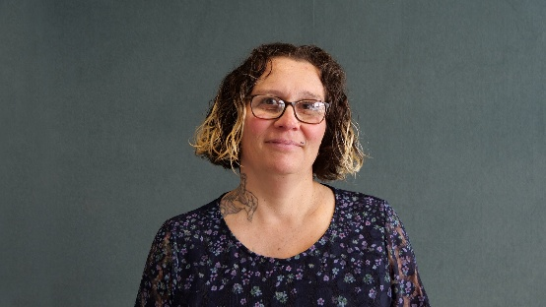  Donna McCaskill (Chair) | 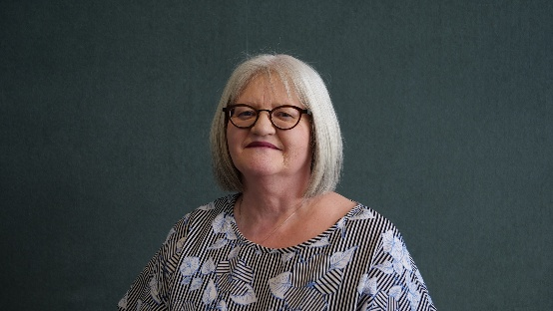  Anne-Marie Taggart (Deputy Chair)
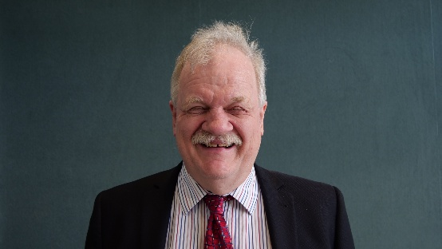  Clive Lansink | 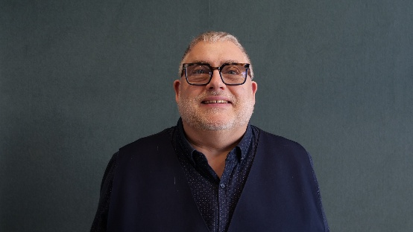  John Billings
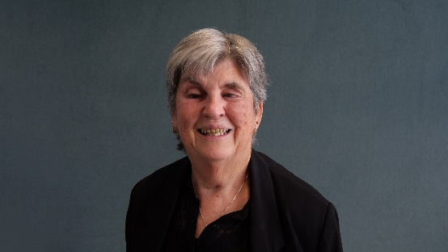  Judy Small | 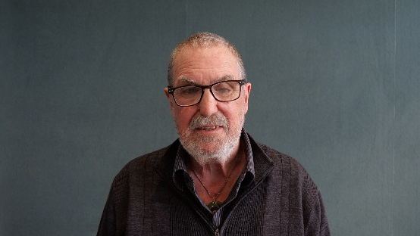  Chris Orr
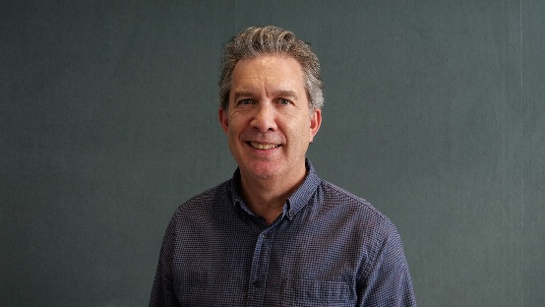  Richard Patete | 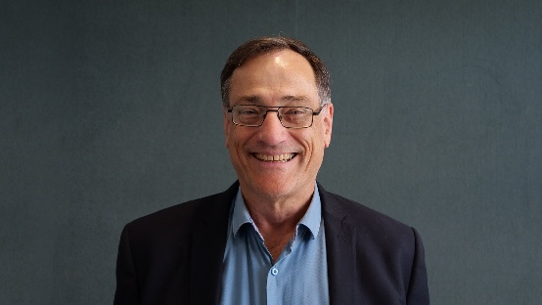  Ronald (Ron) Scott
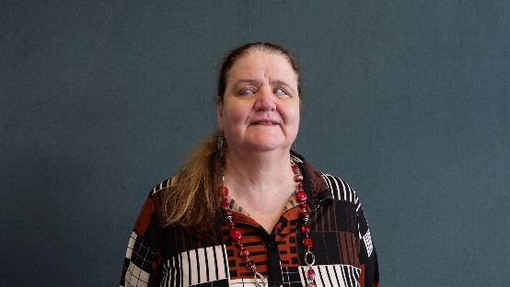
Martine Abel-Williamson (Director)

Donna McCaskill—Chair
Donna McCaskill has a deep personal and professional connection to Blind Low Vision NZ, having been a member since birth. Based in Ashburton, Donna is the proud parent of two sons, both members of the organisation, who were educated through the mainstream education system. Her wider family also has a long history of involvement as members, clients and volunteers.
Page 52
After 20 years working at Blind Low Vision NZ across a variety of roles, Donna joined the Board in 2020. She brings broad insight into the organisation's services, people and communities.
Donna works as an employment coach with The Y and is a trustee of The D*List, a disability-led social change movement in Aotearoa. Her areas of interest include future-focused sustainability, youth development and community engagement. She is committed to greater inclusion of disabled people in sport, recognising its power to build confidence, wellbeing, connection and opportunity.

Anne-Marie Taggart—Deputy Chair
Anne Marie joined the Board in May 2022 to fill a casual vacancy. Anne Marie is an experienced senior leader within the NZ public sector. She began her career as an HR professional but in recent years has branched out and has led both corporate and operational functions. She was the Deputy Chair of the NZ Government Women's Network from 2017−2020, and holds a Business Degree from Edith Cowan University in Western Australia as well as a Master's Degree in Public Administration from Victoria University in Wellington. She also holds an internationally recognised coaching qualification.

Board Committees:
Audit and Risk Committee, People Committee, Health and Safety Board representative, Governance Committee.

Clive Lansink—Board Member
Clive was first elected to the Board in November 2016 although he also served on it from 1991 to 1995.
Blind since birth, Clive has spent much of his personal life working on behalf of blind and low vision people and was President of Blind Citizens New Zealand for a total of thirteen years. He has an engineering degree as well as a law degree (Hons). Much of his career has been spent in the computer industry, and in the blind community he is particularly known for his development of the Foundation's Telephone Information Service. He is now semi-retired running his own business from home, doing consulting and projects in areas of technology and making information accessible to blind and low vision people.

Board Committees:
Audit and Risk Committee, Client Services Committee, Governance Committee, Blind Sector Forum Aotearoa New Zealand Board representative.

Judy Small—Board Member
Judy has been a client of Blind Low Vision NZ since she was four years old. Judy graduated in 1999 with a Master of Social Science (Hons). While studying Judy served on the Blind Citizens New Zealand National Executive. She worked as a Policy Analyst for 11½ years in social policy in the Office for Disability Issues. She has worked for nine years at Hamilton City Council, as Disability Advisor. All her roles have focused on policy and strategy development and leading community-based projects.

Board Committees:
Client Services Committee, Governance Committee, Health and Safety Board representative, Blind Sector Forum Aotearoa New Zealand Board representative, People Committee.

Page 53

John Billings—Board Member
John has been practicing his profession as a Dispensing Optician since 1984. He has always had a strong interest in providing Low Vision Aids and services to the partially sighted to help them continue with as good a quality of life as possible. To this end he is involved in puppy raising for Guide Dog Services. As well as the Low Vision community, he also has experience with the Deaf community.

Board Committees:
People Committee, Client Services Committee, Pearson Fund.

Chris Orr—Board Member
Chris is the newest Board Member elected in November 2023. He lost his sight in 1974 as the result of a traumatic injury. Now retired, Chris has dedicated over 46 years to Blind Low Vision NZ, holding diverse roles such as Braille Teacher, Fundraising Manager, Community Education and Awareness Manager, and Access and Awareness Advisor. His wealth of experience and extensive knowledge of Blind Low Vision NZ services make him a valuable addition to the board.
Beyond his contributions to Blind Low Vision NZ, Chris has served on the Auckland Council's Disability Advisory Panel and now actively serves on the Auckland Council Universal Design Panel. In these roles, he continues to advocate for inclusivity and accessibility, bringing his expertise to the broader community.

Board Committees:
Audit and Risk Committee, Client Services Committee, Pearson Fund.

Richard Patete—Board Member
Richard joined the RNZFB Board in November 2021 but has been involved with Blind Low Vision NZ for over 20 years as his eldest daughter, Renee, was born blind. Raising Renee has given him a strong understanding of the needs and challenges of the blind and low vision community. He is married to Letitia and has another lovely daughter, Zara.
He brings with him an extensive range of experience working in the not-for-profit sector as well as a wide range of skills essential for an effective Board from strategic leadership and financial and commercial expertise to change and risk management. He is a Chartered Accountant and his "day job" is as General Manager at Site Safe NZ Inc., a not-for-profit member-based organisation. He is a member of the Site Safe NZ's Audit and Risk Committee, so he fully understands the challenges and the oversight required of a Board.

Board Committees:
Audit and Risk Committee, People Committee, Health and Safety Board representative, and RNZFB Board Representative on the Foundation Properties Ltd.
Page 54

Ronald (Ron) Scott—Board Member
Ron lives in Tauranga. In addition to serving on the Blind Low Vision NZ Board, he holds governance roles with several purpose driven organisations, including Workbridge Holdings, Consumer NZ, and a community centre.
An economist by profession, Ron also holds a degree in History and Geography. Through his business, he works with boards and senior executives to strengthen strategy, governance, and leadership.
Ron has extensive experience connecting organisations and communities. He has served as a Regional Councillor, Deputy Chair of a District Health Board, and Trustee of the Tauranga Energy Consumer Trust (TECT). He brings strong relationships across the community, disability, local government, and philanthropic sectors, and is committed to using these connections to benefit the clients and members of Blind Low Vision NZ.

Board Committees:
Audit and Risk Committee, Governance Committee.

Martine Abel-Williamson—Board Director
Martine moved from South Africa to New Zealand in 1996. She has qualifications in vision rehabilitation, education and social policy, and previously worked at Blind Low Vision NZ in vocational advice, adaptive communication and technology, blindness awareness and service coordination.
Martine served as President of the World Blind Union from 2021 to 2025 and is now its Immediate Past President. She is also President of the International Council for Education of People with Visual Impairment Pacific, reflecting her passion for education and her commitment to improving opportunities for people who are blind or have low vision.
Martine also serves on the Board of the Blind and Low Vision Education Network (BLENNZ), the Office of the Ombudsman Disability Advisory Panel, and as a trustee of the National Advocacy Trust, which works alongside the Health and Disability Commissioner.

Board Committees:
People Committee, Client Services Committee, BLENNZ representative.
Page 55

Executive Leadership Team, Te Ranga Manahautū
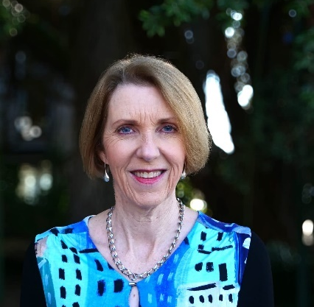  Andrea Midgen | 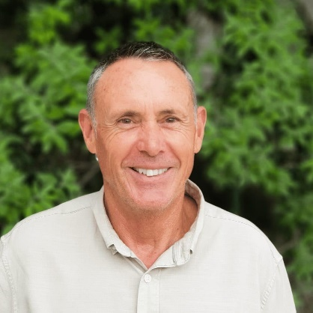  Greg Hurn
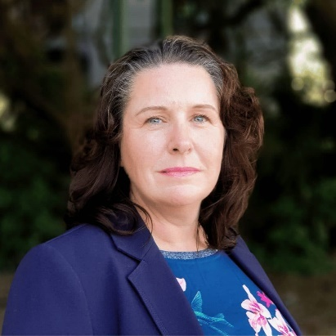  Gwen Green | 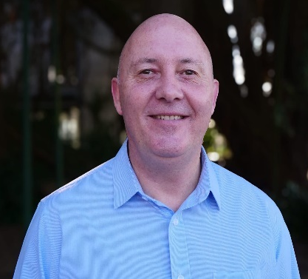  Stephen Keeling
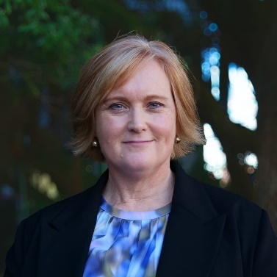  Catherine Simanu  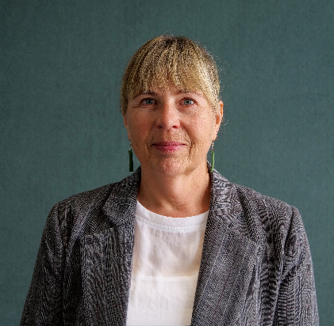  Natasha Mackie | 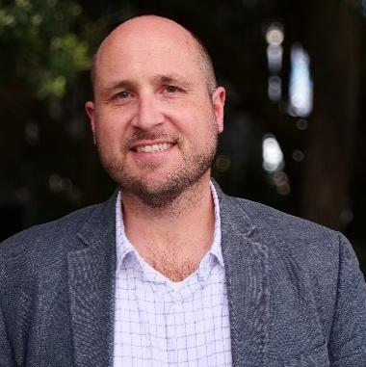  Dan Shepherd

Page 56

Andrea Midgen, Chief Executive
Andrea is a proven leader with extensive CEO and senior executive experience, both within and outside the not-for-profit sector. She has consistently demonstrated a clear sense of purpose and vision throughout her career. Andrea served as Chief Executive Officer of the Royal New Zealand Society for the Prevention of Cruelty to Animals (SPCA) for over seven years. Prior to that, she was Group Strategist/CFO for Southern Cross Group and held several senior executive roles at Vodafone, culminating as Director of Customer Operations. During her tenure at Vodafone, Andrea also gained valuable governance experience as Chair of the Vodafone New Zealand Foundation.
An alumna of Unitec Te Pūkenga with a Chartered Accountant (CA) qualification, Andrea Midgen brings a wealth of experience in organisational leadership, financial acumen, and stakeholder management. Andrea's leadership focus is on being curious, kind, people and client-focused, each and every day.

Greg Hurn, Chief Operating Officer
Greg joined Blind Low Vision NZ in 2010 as the Chief Financial Officer. He brings a wealth of experience in financial management, strategic planning, business development initiatives, and customer service. He consistently demonstrates a capacity for swift decision making and effective problem solving.
Page 57
Greg also oversees the property division of Blind Low Vision NZ and is a Board Member of Foundation Properties Limited. He was a key player in the development of the Mobility Training Centre, the new Parnell Office, and Retirement Village project.
Greg believes in leading by example and fostering an environment of open communication and shared purpose. Greg's aim is to ensure we are financially sound and sustainable over the long-term horizon.

Natasha Mackie, General Manager Client Services
Natasha Mackie is a highly experienced senior leader with a proven track record having worked across government, not-for-profit, disability, and community housing sectors. She brings extensive expertise in operational delivery, strategic and policy development, leading high performing teams, consultation, and community development.
Holding a Master's degree in Public Management, Natasha is recognised for her inclusive, results-driven leadership style, and her commitment to improving lives through strategic collaboration, strong relationships, and practical solutions that deliver lasting impact.
With a strong background in delivering consultation, co-design, and participatory models, Natasha's focus is to ensure quality, responsive, client-focused services are provided across Aotearoa now and into the future.

Dan Shepherd, General Manager Community and Inclusion
Dan joined the Executive Leadership Team having provided authentic, lived experience leadership across the organisation since 2019. Following roles in Client Services, Awareness and Accessibility, Dan brings his experience working with Blind Low Vision NZ to lead a renewed focus on how communities can lead change and remove access barriers for people who are blind, deafblind or low vision as General Manager Community and Inclusion.
Diagnosed with Retinitis Pigmentosa at the age of 15, Dan adds a client voice to the Executive Leadership Team at Blind Low Vision NZ, which is key to our connection to cause—our clients and members.
Driven by his passion for social inclusion and barrier-free choice for others in their communities, Dan aims to influence change and accessible participation in the community through relationships with communities and engagement with key stakeholders.

Stephen Keeling, Chief Financial Officer
Stephen joined the Executive Leadership Team as the Chief Financial Officer following a successful career in senior finance roles and as Head of Finance at Blind Low Vision NZ. Joining Blind Low Vision NZ in 2019, Stephen has brought a successful track record in leadership, governance, and delivering financial results on behalf of organisations to their Board and stakeholders. Stephen's aim is to continue to ensure we are financially sound and sustainable over the long-term horizon. Stephen is a Chartered Accountant and has been a member of ICAANZ (Institute of Chartered Accountants Australia and New Zealand) for over 25 years.
Page 58

Catherine Simanu, General Manager People
Catherine is a seasoned human resources professional with extensive experience leading teams across the health, banking, technology, and telecommunications sectors. She is known for building relationships grounded in trust and respect, leveraging her expertise while honouring the mana of others. Catherine thrives in complex, multi-stakeholder environments, demonstrating adaptability and effectiveness in the face of ambiguity.
Catherine leads the People Partner, Health & Safety, Learning & Development, and Volunteering functions at Blind Low Vision NZ, with a firm focus on partnering and working alongside people leaders and teams to enable the best service delivery and experiences for our clients.
Passionate about creating engaged and connected workplaces, Catherine is committed to fostering a culture where people can work to their full potential—making Blind Low Vision NZ a "great place to work" and achieving lasting value for both the organisation and the communities it serves.

Gwen Green, General Manager Engagement and Marketing (Outgoing)
Gwen has over 25 years' fundraising, marketing, and communications experience both in New Zealand and the UK.
Gwen has a passion for developing donor-focused fundraising, creating new income opportunities, and re-visioning communications and marketing strategies to grow multi touch point engagement, in ways that are flexible to our ever-changing world.

Amsler Grid
How to test your eyes with the Amsler Grid
Tear this page out and keep it somewhere you will remember so that you can test your eyes regularly.
- Wear glasses that you normally wear for reading.
- Hold the grid about 35−40cm away from your face.
- Cover one eye at a time.
- Stare at the dot in the middle.
- Contact your eye care doctor immediately if any of the straight lines appear wavy or bent, any of the boxes differ in size or shape from the others, or any of the lines are missing, blurry or discoloured.

Page 59
Here is what an abnormal reaction to the Amsler grid might look like. If you start to notice this, please consult your doctor.
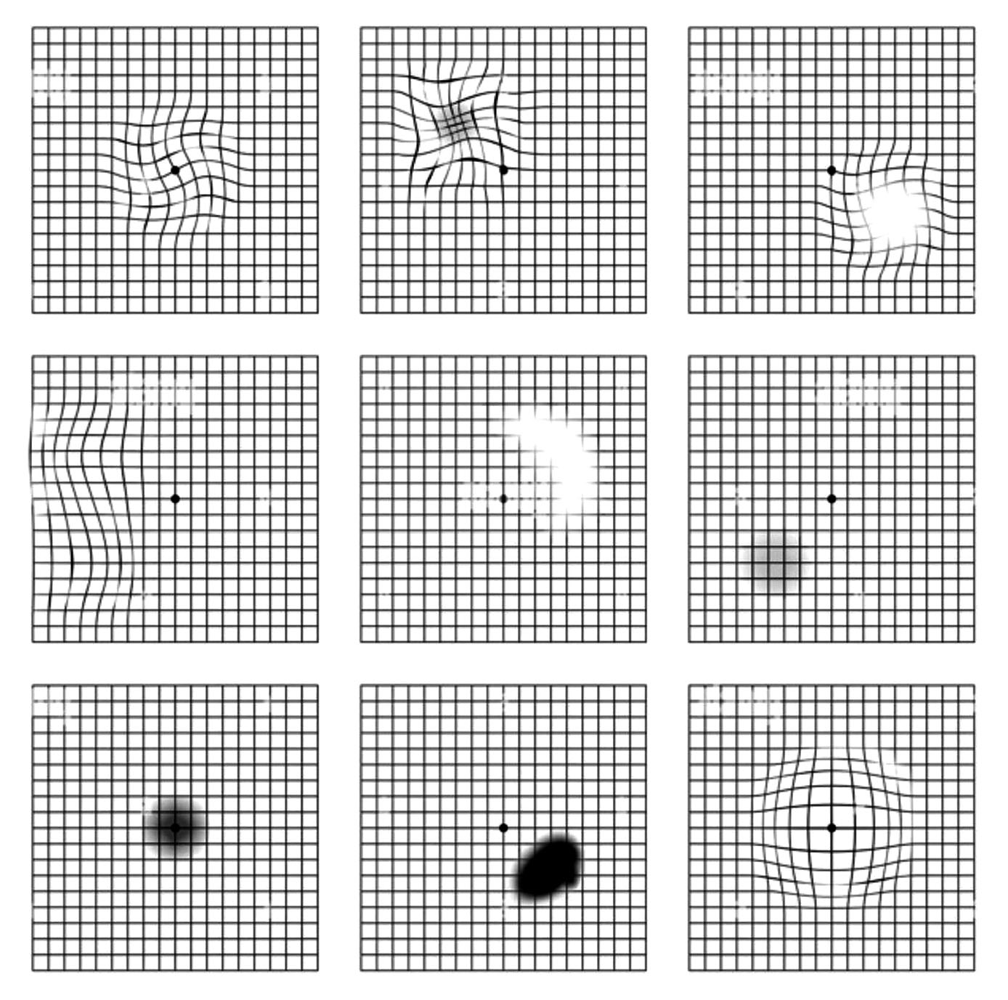

Pages 60-63

Eye Test


Blind Low Vision NZ around the country, Kāpō Matarehu Aotearoa puta noa i te motu
Whangārei  277 Kamo Road,  Kamo  Whangārei 0112 | New Plymouth  131 Vivian Street,  New Plymouth 4310
Smales Farm  Q4 Building, 74 Taharoto Road, Takapuna, Auckland 0622 | Napier  77 Raffles Street,  Napier South, Napier 4110
Henderson  Unit C (upper level),  197 Universal Drive, Henderson, Auckland 0610 | Whanganui  102 Peat Street,  Whanganui, 4500
Parnell  539 Parnell Road, Parnell  Auckland 1052 | Palmerston North  64 Taonui Street, Palmerston North Central 4410
Manurewa  30 Mcvilly Road, Manurewa  Auckland 2102 | Wellington  121 Adelaide Road,  Newtown Wellington 6021
Fale Kotuku  20 Mcvilly Road, Manurewa, Auckland 2102 | Nelson and Marlborough  530D Main Road, Stoke  Nelson 7011
Guide Dog Services  30 Mcvilly Road, Manurewa,  Auckland 2102 | Christchurch  96 Bristol Street,  St. Albans  Christchurch 8014
Hamilton  15 Liverpool Street,  Hamilton 3204 | Dunedin  458 Hillside Road,  Caversham  South Dunedin 9012
Tauranga  160 Seventeenth Avenue,  Tauranga South  Tauranga 3112 | Invercargill  172 Queens Drive, Richmond  Invercargill 9810
Gisborne
39 Grey Street,
Gisborne 4010
Ngā mihi nui for your support!
From the team at
Blind Low Vision NZ

BlindLowVision.org.nz
0800 24 33 33
PO Box: Private Bag 99910, Newmarket, Auckland 1149
Facebook: BlindLowVisionNZ
Instagram: @BlindLowVisionNZ
End of Community Impact Report 2026, Pūrongo Whakaaweawe Haporia

