Kōrero – 27 August 2026
Kaua e takahia te mana o te tangata means
Do not trample on the mana of the people.
This whakataukī reminds us to respect the mana, voice and lived experience of every person. It reflects our role in listening to our community, speaking up on the issues that matter, and making sure people’s voices are not only heard, but have the power to shape what happens next.

Formats
Kōrero is available in the following formats:
- HTML webpage: Read the Kōrero newsletter as a webpage on the Blind Low Vision NZ website.
- Alexa: Say “Alexa, open Blind Low Vision”. Alexa will then guide you through the main menu. Then, at any point, say “Alexa, magazines” and then “Alexa, BLVNZ Korero”.
- TIS (Telephone Information Service): Call TIS m341. Find your local TIS number on our Library Services webpage.
- Braille: Download the BRF file of this month’s Korero or Call our Contact Centre on 0800 24 33 33 if you would like to receive Kōrero in Braille.

Message from Andrea

Tune in to Andrea’s latest message
We’re trying something new this month! Grab a cuppa, press play and enjoy a quick five-minute catch up with Andrea.
This month’s message is in a podcast style format, making it easier to listen and stay connected wherever you are.
We hope you enjoy this new way of hearing the latest updates from Andrea.
Click on the image link below, and it will open and play in a browser window. When you are done, close it and return to this newsletter to resume reading.
Alternatively, you can download Andrea’s video message transcript.
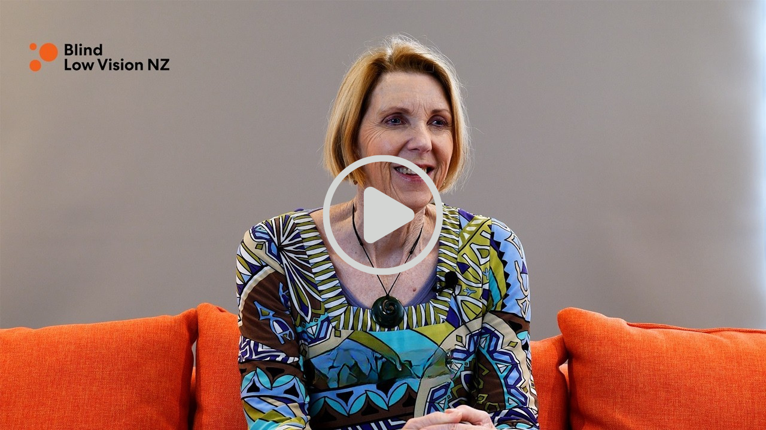
Image description: Blind Low Vision NZ Chief Executive Andrea Midgen on an orange couch, smiling in the middle of her interview. Clicking on the image will play Andrea’s interview video on YouTube.

Community Bulletin

Remembering Jonathan Sharp: a quiet pioneer in accessible technology
Many people who are blind or have low vision have benefited from Jonathan Sharp's work, even if they never knew his name.
Jonathan, a quiet and humble Kiwi, passed away on 12 July at the age of 67. He was a pioneering software developer whose innovations helped shape accessible technology used by blind people in New Zealand and around the world.
Often described as the "father of KeySoft", Jonathan began developing accessible technology in the 1980s with Keynote, one of the first portable talking computers. His work later formed the foundation of the BrailleNote, a device that opened new opportunities for many people in education, employment and everyday life. He also played an important role in the development of accessible GPS navigation.
What made Jonathan's work so special was his commitment to designing technology around people's needs. He listened carefully to feedback from blind users and created software that was practical, intuitive and reliable. His work empowered thousands of people to communicate, learn, work and participate more fully in their communities.
Jonathan's influence continues to be felt through the technology many people still use today. While his achievements were recognised internationally, his legacy began here in New Zealand and has had a lasting impact on the global blind community.
Blind Low Vision NZ extends our sincere condolences to Jonathan's family, friends and former colleagues. We also acknowledge and celebrate the remarkable contribution he made to accessible technology and the lasting difference he has made in the lives of people who are blind or have low vision.
You can read Jonathan Mosen's full tribute to Jonathan Sharp on LinkedIn to learn more about his life, career and legacy at LinkedIn.com.

Good in the Hood returns to Z
The Good in the Hood campaign returns to Z Petrol Stations from 18 August to 14 September. Each participating Z station will share $5,000 between four local charities or community groups. Customers receive an orange token to vote for their favourite charity, and at the end of the campaign, the funding is divided between the participating charities based on the number of votes they receive.
This year, Blind Low Vision NZ has been selected at:
- Z Carlton Corner (Merivale, Christchurch);
- Z Kaikohe (Far North District);
- Z Cambridge (Waikato).
Help us spread the word! If you have family, whānau or friends who use Z stations, let them know they can vote for Blind Low Vision NZ between 18 August and 14 September. Every vote is a great way to show support for people who are blind, deafblind or have low vision.
For more details about the campaign, visit the Z website.

Get ready for the 2026 general election
Enrol to vote by Sunday 25 October.
It’s that time again – the general election is upon us!
This time around, enrolment closes 13 days before the actual election! If you are not enrolled to vote by , Sunday 25 October, you will not be able to vote. Enrolment support is planned at some Blind Low Vision NZ offices. We will share an update soon with more details about where support will be available.
Even if you have previously been enrolled, you will still need to check that your information is up to date. You can enrol or update your details online at vote.nz if you have one of the following forms of ID:
- A New Zealand passport.
- A RealMe ID.
- A New Zealand driver’s license.
If you don’t have one of these three forms of ID, you can enrol or update your details in one of the following ways:
- Complete an enrolment form online and have it emailed or posted for you to sign and return. Upload, email or post your completed form to the Electoral Commission.
- Download a blank enrolment form to your computer to print, fill out and return.
- To get an enrolment form posted to you, call 0800 36 76 56, or text your name and address to 3676. Fill out the form and return it to the Electoral Commission.
Every one with an email address on file will have their EasyVote card emailed to them rather than posted.
If you are planning to receive your EasyVote card via the post, you must enrol to vote by Sunday 4 October as this is when they will be posting them out.
You do not need your EasyVote card to vote, however, so you will still be able to vote even if you don’t receive it in time.
You can view all the alternative enrolment options on the Vote.nz website.

Accessible voting in four local by-elections
Four local council by-elections are taking place in the Bay of Plenty, South Wairarapa, Buller and Porirua areas from late August to October 2026.You can wait until you receive your voting pack before using the service. This lets you review the candidate information first.
What is dictation voting and how does it work?
Dictation voting is a confidential and secure service that allows eligible voters to cast their vote by telephone.
Find out more about telephone dictation voting and whether you are eligible in the PDF document or contact the election call centre on 0800 666 040.

Auckland: City Rail Link opening in September
Auckland’s City Rail Link (CRL) will open on Sunday 13 September, creating new ways to travel across Tāmaki Makaurau. The project includes new underground stations at Te Waihorotiu and Karanga-a-Hape, along with the redeveloped Maungawhau Station. As Auckland’s new City Rail Link opens to the public, its new stations include accessibility features designed to make public transport easier to use for everyone. This includes tactile and braille signage and step-free access to trains for people who are blind or have low vision.
Several of our staff have visited some of the stations during pre-opening viewings. This has included staff who provide orientation and mobility support, so they can become familiar with the new facilities and help our clients feel more confident when using the new stations.
We’ve received mixed feedback about the accessibility of these new stations. If you’re planning to travel using the CRL, we’d love to hear what you think about the accessibility features.
One of our clients, Chantelle Griffiths, was among the first to experience the new Maungawhau Station with her guide dog Izzy.
Read the NZ Herald story about their experience.

Noticeboard

Coming in October: Some news for book lovers
Did you know our Accessible Library has more than 36,000 titles? From audiobooks and Braille to e-text, magazines and newspapers, there are plenty of ways to discover something new.
We’re changing to how we deliver your library news:
- Sound and Touch will continue to be delivered each quarter and will remain a comprehensive round up of new titles, recommendations and reviews.
- Bookmarks, our monthly library newsletter will discontinue after the September 2026 issue, replaced by a new section in our monthly Korero client newsletter.
From October, you’ll find a new library section in Kōrero, featuring a Top 5 list of titles chosen by our Library and Studio teams. You might find a new release, an old favourite or a hidden gem to enjoy.
If you have any questions about these changes or would like to share your feedback, please contact our Library team at library@BlindLowVision.org.nz or call our Contact Centre on 0800 24 33 33.

MSD Training and Support Funds Programme
You may be eligible for MSD Support Funds if you live with a disability and are working or training. The funds can help cover disability-related costs, such as equipment, workplace support or training costs.
Find out more about Job and Training Support Funds on the Work and Income website, or call 0800 551 001 if you have any questions.

Telefriend: Here to Support You
Telefriend offers empathetic, non-judgmental, and confidential peer support for people who are blind, deafblind, or have low vision, as well as their caregivers, family, and friends. Whether you need guidance or just want a friendly chat, we're here to help.
Call us at 0800 100 051, from 1 pm to 4 pm, Monday through Friday. If you call outside these hours, leave a message – we will return your call. Connect with a Telefriend today by dialing 0800 100 051.

Tune into this week’s accessible TV programmes
How to access Audio Descriptions: In general, Audio Description (AD) can be switched on or off by pressing the AD button on a TV Remote Control. However, some TVs have a different label on the remote button, and others require AD to be switched on or off via the menu.
You’ll find listings of audio described programmes for this week on the Able website or via TIS Menu 6607.

Thumbs Up

Discover New Possibilities with the Blind Low Vision NZ Careers Network
Have you ever wondered what career paths other people who are blind, deafblind, or have low vision have taken? The Careers Network is a new online resource designed to help you explore different career options, hear real stories, and connect with people who are working across a wide range of industries.
The network showcases people with lived experience of sight loss who are pursuing careers in fields such as business, technology, education, healthcare, the arts, and many others. By sharing their journeys, challenges, and successes, they offer valuable insights into what is possible and how they have navigated their own career paths.
Whether you are a student thinking about future employment, considering a career change, or simply curious about different industries, the Careers Network can provide ideas, inspiration, and practical advice.
We are also looking for more people to join the network and share their stories. If you are working, studying, volunteering, or building a career in any field, your experiences could help inspire and guide others within the blind and low vision community.
You can visit the Careers Network hub on the Blind Low Vision NZ website to learn more. If you would like to contribute your own profile and story, email CommunityAndInclusion@BlindLowVision.org.nz.

Supporting research to improve access to eye care
Blind Low Vision NZ recently collaborated with the University of Auckland’s Community Eye Health team to host a pop-up eye clinic at the Chris Orr Recreation Centre in South Auckland. The clinic provided eye examinations, referrals for follow-up care, and free glasses for people referred by participating GP clinics.
The clinic is one part of an ongoing research project which aims to understand and improve access to health services for New Zealanders with eye, hearing, or foot problems, particularly if they also have diabetes. Read more about the community eye clinic and the work being done to help make eye care more accessible.

Local businesses are making support easier with Tap and Go
Foundation On George (F.O.G) Cafe, next to our Parnell office, has recently joined a growing group of businesses supporting Blind Low Vision NZ.
FOG Cafe now has a Tap and Go device, giving customers a simple and convenient way to show their support while enjoying a coffee. Customers can choose to make a $3, $5, $10 or $20 donation with a credit or debit card.
This is a great step in making giving more accessible and convenient. FOG Café joins a growing group of businesses that have chosen to support our work, including one of our first Tap and Go locations at Chuffed Cafe on High Street in Auckland CBD, and our board member John Billings’ Andrew Black Optometrists in Kilbirnie, Wellington.
It’s great to see businesses across New Zealand getting behind our community and finding new ways to make a difference.
Thank you to all the businesses that support Blind Low Vision NZ and help make a difference in our community!
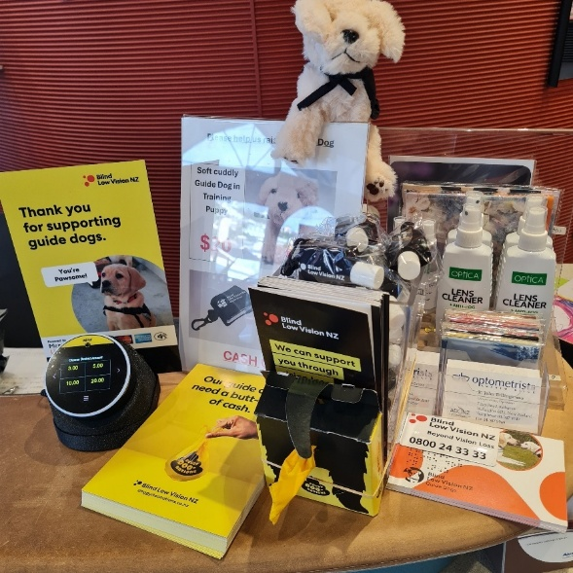
Image description: A plush toy dog wearing a black harness is positioned at the top centre. Below the toy are several promotional materials, including a yellow card with the text “Thank you for supporting guide dogs” and a picture of a guide dog puppy. There is also a black donation box with the Blind Low Vision NZ logo and the text “We can support you through vision loss”.
If you’d like to know more about Tap & Go, help spread the word, or share an idea, contact our Community Fundraising Lead, Melissa Addams at MAddams@BlindLowVision.org.nz.

Subscribe to sports fixtures in accessible formats
A new service can help you stay connected with your favourite sports! Blind Low Vision NZ members can now subscribe to receive selected sports fixtures in accessible formats. Current options include Black Caps cricket, All Blacks rugby, Super Rugby, National Provincial Championship (NPC), National Rugby League (NRL), and other rugby or cricket fixtures by request, where fixture information is publicly available.
If you would like to subscribe, you can contact the Blind Low Vision NZ Contact Centre team on 0800 24 33 33, or email Accessible Format Services at AFSInfo@BlindLowVision.org.nz.
Learn more about this service and how members can subscribe on our website.

Tell me about it
This is your space to share bite-sized learnings from your experiences as someone who is blind, deafblind, or has low vision. Maybe you’ve got a new gadget you’re loving, or you’re an Excel expert with great tips on accessibility features. Whatever it is, your knowledge could help someone else. Whether it’s a tech trick, a daily living hack, or anything in between, we want to hear from you! Your insights could make a big difference to others in the community.
If you’d like to submit an idea, please email Communications@BlindLowVision.org.nz.

Upcoming events

Work Ready Webinar: Blind Low Vision NZ Support Grants
When: Tuesday, 8 September, 9am.
Work Ready Webinars are here to support you in your employment journey.
Our September session will focus on Blind Low Vision NZ Support Grants and how they can help you take your next step.
We’ll walk you through the different grants available, explain how to apply, and share a few practical application tips. This is a great opportunity to learn what support may be available and how to make the most of it!
There will also be time for general questions at the end of the session.
Join us for the September Work Ready webinar on Zoom

Work Ready Webinar Recordings & Resources
Can’t make the live webinar? You can catch up in your own time.
Listen to Work Ready Webinar Recordings at your leisure on the Blind Low Vision NZ website.

Campaign updates

Free online Will offer returns from 7 to 21 September
Our free online Will offer with Safewill is back from 7 to 21 September. If you've been putting off writing or updating your Will, now's the time. The offer is available to all Blind Low Vision NZ staff, clients, volunteers, supporters and their families, making it quick and easy to create a legally reviewed Will online at no cost.
Once you've looked after your loved ones, we'd be grateful if you'd consider leaving a gift to Blind Low Vision NZ in your Will. Every gift, no matter the size, helps make a lasting difference.
An online Wills seminar will be held on 4 September. Join us to learn more about Safewill, Wills in general, and why having a Will is important.
People can start creating their Will at any time through the dedicated Safewill online page for Blind Low Vision NZ.
To access a free Will through this offer, you will need to complete your Will between 7–21 September.
Outside of these dates, Safewill is offering 50% off, with prices starting from $80.
To find out more about Safewill or to request the webinar link, contact Jo Eve at legacies@BlindLowVision.org.nz or 022 015 9216.

PAWGUST 2026
PAWGUST is one of our annual fundraising campaigns supporting Blind Low Vision NZ Guide Dogs.
The challenge encourages people and their dogs to walk or run 60, 100, or 125 kilometres during August. You don’t need a dog to take part, and it’s free to register.
At the time of writing, our PAWGUST community has already raised an incredible $105,691 and clocked 22,683 km for Guide Dogs.
Every donation helps support future Guide Dogs and the greater independence they can bring to people who are blind or have low vision. As PAWGUST nears the finish line, we want to say a big thank you to everyone who has taken part, supported the challenge, and helped spread the word. Your support is helping raise awareness and funds for Guide Dogs services.
Find out more or share your support for the campaign on the PAWGUST website.

PAWGUST with a special Pic’s partnership
This year, we’re proud to partner with Pic’s Peanut Butter, who have created a special edition jar to support PAWGUST.
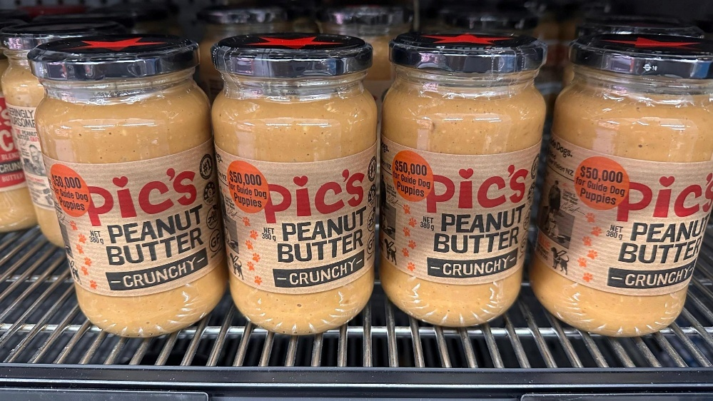
Image description: A row of Pic’s special edition peanut butter jars. The jars feature an orange sticker which reads $50,000 for guide dog puppies.
You’ll find Pic’s Crunchy Peanut Butter special edition jars on shelves across New Zealand throughout August. Every jar sold helps Pic’s donate to Blind Low Vision NZ, supporting the breeding, raising, and training of life-changing guide dogs.

The jars feature Ollie, Pic’s own vision loss assistance dog. His story makes this a cause that is close to Pic’s hearts and ours.

Blind Low Vision Month
We’re looking for stories from our community about the impact of the Total Mobility funding cuts. If you, or someone you know, has a story to share about how the changes have affected your daily life, please email Communications@BlindLowVision.org.nz.
We hope to use these stories to help build a powerful media story as part of our Blind Low Vision Month awareness raising.

News from the Royal New Zealand Foundation of The Blind (RNZFB) Board
This month for the Board update, we begin with a video chat with RNZFB Board Chair, Donna McCaskill.
Listen to our full chat with Donna on the Blind Low Vision NZ YouTube channel.
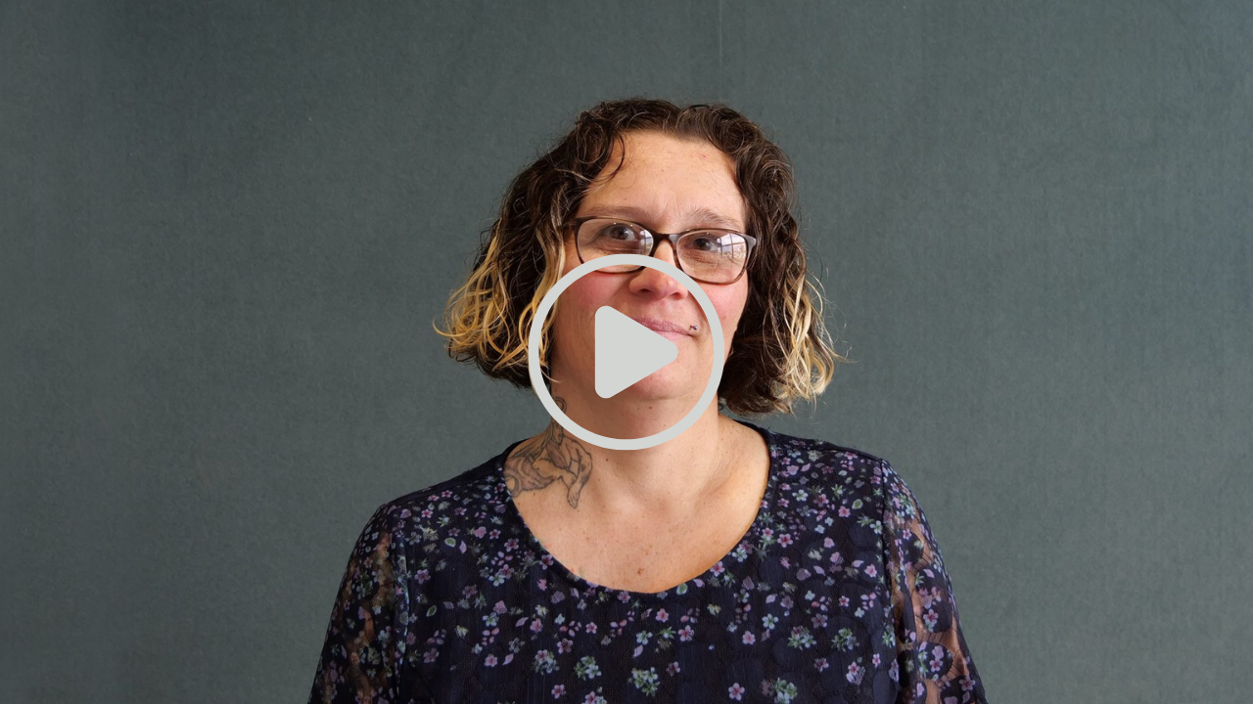
Image description: RNZFB Board Chair, Donna McCaskill a woman with wavy brown hair with blonde highlights, wearing glasses smiles for the camera. Clicking on the image will play the video of Donna’s interview on YouTube.
If you want to find out more information about some of the items mentioned by our Board Chair in her video update, here are links to the key items:
- Download the full Board minutes from our website at BlindLowVision.co.nz.
- Read the Board Chair’s full report on our website at BlindLowVision.co.nz.
- Find out more about how you can have your say on Constitutional change discussions on our Governance page at BlindLowVision.co.nz.
Other key dates:
- Board Elections 16 October - 13 November. Find out more about the Board elections on the Blind Low Vision NZ website.
- Nominations close for the 2026 Chair’s Award Sunday 18 October. More information about the Chair’s Award is available on the Blind Low Vision NZ website.
- Auckland Board Meet and Greet Saturday 19 September, from 1:00pm to 3:00pm.

Auckland Board meet and Greet
Join us for the RNZFB Board “Meet and Greet” event in South Auckland in September. This event also provides an opportunity to meet with the BLVNZ Chief Executive, Andrea Midgen.

When: Saturday 19 September, from 1:00pm to 3:00pm.
Where: Chris Orr Recreation Centre, 30 McVilly Road, Manurewa, Auckland.
This is your opportunity to meet our Board members, ask questions, and raise any concerns you might have. Afterwards, you’ll be invited to stay for tea, coffee, biscuits, and a chat.
If you have any questions for Donna, please email the RNZFB Board Secretary at BoardSecretary@BlindLowVision.org.nz.

In the News

Accessibility at the heart of Museum of Southland
Learn about how the new Te Unua Museum of Southland has been designed with accessibility at its core on the Southland App website at SouthLandApp.nz

Auckland Transport apologises after assist dog incident
Read the 1News article about Auckland Transport's apology after a bus driver wrongly refused travel to a person with an assistance dog at 1News.co.nz.

New service dog IDs improve access and recognition
Read the full announcement on the Beehive Government website about new service dog IDs improving disability access at beehive.govt.nz.

Privacy experts warn of gaps in NZ law, as camera glasses hit Kmart shelves
Read the RNZ article about privacy concerns and gaps in New Zealand law as affordable camera-equipped smart glasses become more widely available at Rnz.co.nz.

Blind by 31, Julie still loves to travel the world. ‘With my other senses, I see in a new way’
Explore this inspiring story of Julie Woods, who continues to travel the world, embrace new experiences and live life to the fullest with blindness at ThatsLife.com.au.

Job Opportunities at Blind Low Vision NZ
For the latest job opportunities at Blind Low Vision NZ, go to the Blind Low Vision NZ Careers website or call TIS m 3 4 6.

Ka kite anō
Please let us know what you think of Kōrero. We welcome suggestions for what you would like us to include and any tips or stories you would like to share with the community. Get in touch on 0800 24 33 33 or via communications@blindlowvision.org.nz.
Did you know that you can request Kōrero in Braille? Call our contact centre on 0800 24 33 33 if you would like to receive Kōrero in this format.

