Kōrero – 11 December 2025
Kia whakatōmuri te haere whakamua.
I walk backwards into the future with my mind fixed on my past.
This whakataukī encourages us to use the lessons and knowledge gained from the past year to inform and guide our future actions and plans.

Formats
Kōrero is available in the following formats:
- HTML webpage: Read the Kōrero newsletter as a webpage on the Blind Low Vision NZ website.
- Alexa: Say “Alexa, open Blind Low Vision”. Alexa will then guide you through the main menu. Then, at any point, say “Alexa, magazines” and then “Alexa, BLVNZ Korero”.
- TIS (Telephone Information Service): Call TIS m341. Find your local TIS number on our Library Services webpage.
- Braille: Call our Contact Centre on 0800 24 33 33 if you would like to receive Kōrero in Braille.

Message from Andrea
As we come to the end of 2025, I’ve been thinking about the many people I’ve had the chance to meet this year. Every time I sit down with you, visit a local group, or hear your story, I’m reminded how lucky I am to be part of this community. You welcome me into your world with honesty and trust, and that’s something I never take for granted.
Your insights shape the way we work. When you tell us what’s going well, we learn. When you tell us what gets in the way, we learn even more. You show us what matters most in daily life – staying connected, feeling confident, and having the tools and support to keep doing the things you love. That guidance makes our services stronger and more useful for the next person who reaches out.
I’ve also seen the power of people supporting each other. I’ve seen friendships grow, peer groups thrive, and small acts of kindness that make a big difference. You remind us that community isn’t a nice-to-have – it’s the heart of everything. You show what it looks like when people back each other, celebrate each other’s wins, and lift each other up during the tough days.
To everyone who took the time to talk with us, share feedback, or let us walk alongside you this year – thank you. You help us pave the path forward.
As we head into summer and a new year, I’m excited for what we can build together. I hope the next few weeks bring you rest, joy, and good company. Take care of yourself, stay safe, and know that we’re here when you need us.
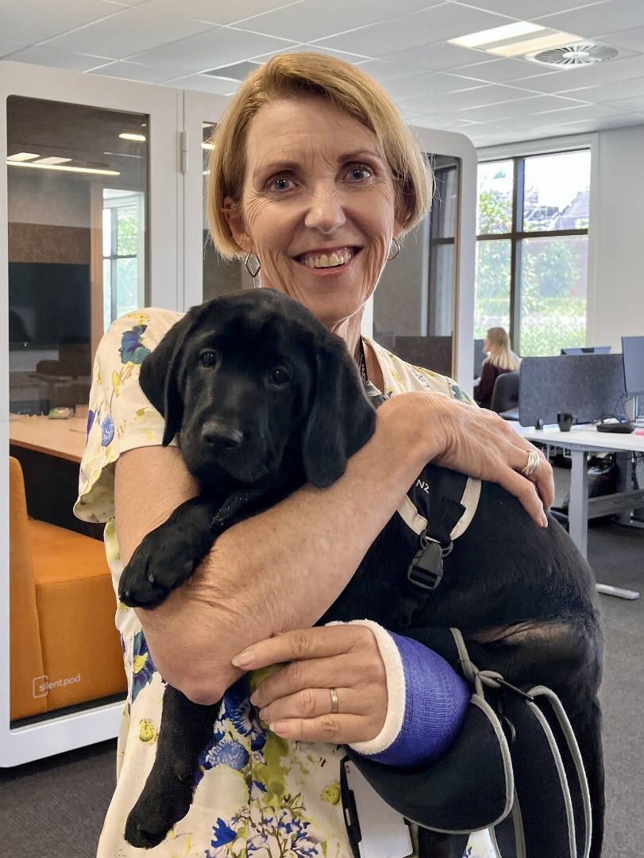
Image description: Andrea Midgen, CE, at the Parnell office during her first weeks at Blind Low Vision NZ, holding guide dog puppy Ralph, who is in training. Her left arm is in a cast.
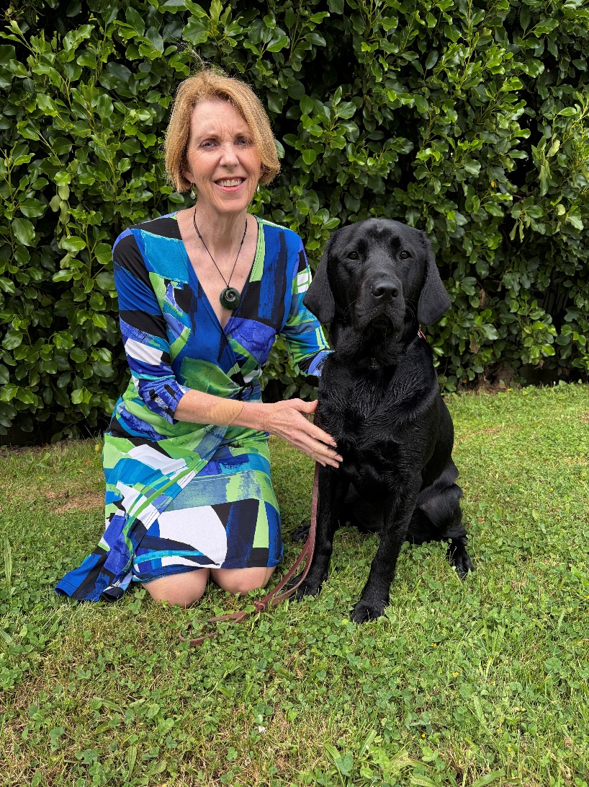
Image description: Andrea Midgen, CE, outdoors, kneeling next to Ralph, now a fully trained guide dog, with her arm around him.
Warm wishes for a very Merry Christmas and Happy New Year
Andrea

Community Impact Series
Welcome to our new Community Impact series where we share key highlights from the past year. Each instalment brings together the figures, stories, and moments that show how people in our community are connecting, learning, and moving through life with support from Blind Low Vision NZ.
These aren’t just numbers – they’re real experiences. They show how many people we’ve reached, the services they’ve used, and the difference support can make day to day. Through this series, we want to celebrate those moments and reflect on what they tell us about life in our community.
Over the last financial year, that story included 1758 people became new clients, and 6340 people received support from our team. These numbers tell a simple story: more people are reaching out, and more people are getting the services they need to keep moving through daily life.
Behind every number is someone learning new skills, finding tools that work for them, or reconnecting with things they enjoy. Growth like this helps us understand what people need right now, and where we should focus next.

Community Bulletin

Have a go at tandem cycling
Back in October, Biketober events in Auckland, Christchurch, Invercargill, and Dunedin promoted tandem cycling to diverse audiences. Coinciding with Emmy Foy and pilot Jesse Hodges winning silver in the Women’s 2025 Para Cycling Track World Championships in Rio.
Blind Low Vision NZ, Blind Sport NZ, and Cycling NZ championed tandem cycling, giving people with eye conditions the chance to ride with trained pilots and build confidence on the bikes.
In Auckland, 40 participants joined in. Five had never heard of a tandem bike before, yet four enjoyed it so much they rode multiple times. One rider described the experience as “accessible speed.” The two person electric trike was another highlight, drawing smiles and repeat rides throughout the day.
As a follow-up, Cycling NZ has updated its website with new resources on Para Cycling. This includes a tandem guide reviewed with support from Blind Sport NZ and Blind Low Vision NZ. Blind Low Vision NZ also provides tandem bike hire. Together, these groups want to help more riders get trained and feel confident. For more information, you can visit cyclingnewzealand.nz.
If you’d like to give tandem cycling a go, get in touch with your local Sport & Leisure Advisor by calling our Contact Centre on 0800 24 33 33 or check out the information on Blind Sport NZ Cycling page at blindsport.kiwi.

International day of persons with disabilities
Every year on 3 December, people around the world celebrate inclusion and the right for everyone to take part in daily life. This year’s theme is fostering disability-inclusive societies for advancing social progress.
You might know this already from being a regular reader of Kōrero, there are plenty of accessible events for people who are blind or have low vision, like hands on art experiences, audio described tours, and meet ups. Stay tuned for Blind Low Vision NZ news, local libraries, and galleries to find the next event near you, or call our contact centre on 0800 24 33 33 to be connected with your local Sport and Leisure Advisor.
You can also read our 2025 Community Impact Report on the Blind Low Vision NZ website to know more about the activities, initiatives, and support we have provided and continue to offer.
Find out more about International Day of Persons with Disabilities at the New Zealand Disability Equality Network (nzden.org.nz).

Auckland: Volunteer and share your experience at Low Vision Day
Every year, the University of Auckland runs Matarehu/Low Vision Day. This is a great chance to share your experiences and help students understand the challenges people with low vision face, while allowing them to explore practical ways to offer support.
Event details
- Date: Monday, 23 February 2026.
- Time: 10:30 am – 2:45 pm.
- Location: University of Auckland, Grafton Campus, 85 Park Road, Auckland.
- Parking: Free.
Who can volunteer
- People with low vision who can read any of the letters on a vision chart from arm’s length (50 cm) away or further.
- People with tunnel vision or hemianopia.
What volunteers will do:
- Share experiences of everyday tasks such as reading, cooking, or getting around.
- Support students practicing vision assessments (no drops) and using low vision aids.
Volunteers will receive a $50 Woolworths voucher as a thank you. Complimentary low vision eye exams can be booked for a later date, and volunteers may be eligible for Ministry of Health funding for glasses. Clients are encouraged to bring their cellphone or tablet, glasses, and any portable magnifiers.
Limited places available, first registrations taken. For any questions or to register, please contact Michelle O’Hanlon by phone at 09 923 6592 (leave a voice message) or by email at m.ohanlon@auckland.ac.nz.
This is a great way for you to contribute to the education of future optometrists while sharing your real-life experiences with low vision.

Noticeboard

Graduate Programme 2025 – 2026
We’re pleased to share that three graduates have joined Blind Low Vision NZ as part of our 2025–2026 Graduate Programme. They started with us on 1 December and are now part of our Community and Inclusion team. It’s great to have them here as they begin their careers with us.
Please join us in welcoming:
Riley Hovell-Allomes – based in Parnell.
James Carrick – based in Parnell.
William Richardson – based in Christchurch.
Riley, James, and William bring fresh ideas, energy and a strong willingness to learn. Over the next year, they’ll be working alongside many of you, building their skills and contributing to projects that support our community.
Our Graduate Programme is an investment in the future. When we back emerging talent, we strengthen our organisation and build the capability we need to keep moving forward. We’re excited to support their growth and to see how their work enriches our organisation and community.

Holiday hours update for Blind Low Vision NZ Offices
With the festive season upon us, we’re winding down for the year so our teams can recharge and get ready for 2026.
Blind Low Vision NZ will be closed from 5 pm on Friday 19 December 2025, reopening on Monday 5 January 2026. Please note that a few offices will close one day earlier. Some offices will run on reduced hours or by appointment only, as outlined below. Our Contact Centre, including 0800 24 33 33, will also be closed during the standard holiday period and will reopen on Monday 5 January 2026.
Whangārei: Closed 19 December 2025, reopens 7 January 2026: 9am to 2pm, Monday to Friday.
Takapuna: Closed 20 December 2025, reopens 5 January 2026: 9am to 1pm, Monday to Friday.
Parnell: Closed 20 December 2025, reopens 5 January 2026, with reduced reception hours from 5 to 9 January 2026: 9:30am to 2pm. Standard hours resume from 12 January 2026 (9am – 4pm.)
Community Hub (Parnell): Closed 20 December 2025: reopens 5 January 2026, by appointment only.
Henderson: Closed 20 December 2025, reopens 5 January 2026: 8am – 2pm, Monday to Friday.
South Auckland: Closes at 2pm Friday 19 December 2025, reopens 5 January 2026: 8am to 2pm, Monday to Friday.
Hamilton: Closed 20 December 2025, reopens 5 January 2026: 8:30am to 4.30pm, Monday to Friday.
Tauranga: Closed 20 December 2025, reopens 5 January 2026: 9am to 4pm, Monday to Friday.
Whanganui: Closed 20 December 2025, reopens 5 January 2026, 10am to 1pm, Monday to Thursday.
New Plymouth: Closed 20 December 2025, reopens 5 January 2026, 9am to 1pm, Monday to Friday.
Wellington: Closed 20 December 2025, reopens 5 January 2026, 9am to 4pm, Monday to Friday.
Gisborne: Closed 20 December 2025, reception reopens 20 January 2026: 11am to 2pm, Tuesday to Friday.
Palmerston North: Closed 20 December 2025, reopens 5 January 2026, 9am to 3pm, Monday to Friday.
Napier: Closed 20 December 2025, reopens 5 January 2026, 9am to 2:30 pm, Monday to Thursday.
Nelson: Closed 20 December 2025, reopens 5 January 2026, 10am to 2pm, Monday to Friday.
Christchurch: Closed 20 December 2025, reopens 5 January 2026, with appointment only from 5 to 9 January 2026. Reduced reception hours from 12 to 23 January 2026, 9am to 2pm, Monday to Friday. Standard hours resume from 26 January 2026, 8:30 am to 5pm.
Dunedin: Closed 20 December 2025, reopens 5 January 2026, with appointment only from 5 to 9 January 2026, 9am to 5pm, Monday to Friday. Standard hours resume from 12 January 2026, 9am to 5pm.
Invercargill: Closed 20 December 2025, reopens 5 January 2026, 10am to 2pm, Monday to Wednesday.

Text Messages for support
Did you know you can text us if you need support or just want to ask a question? Get in touch on 022 011 7407 (Text only) and our team will reply during business hours. If you’d prefer to talk, you can call 0800 24 33 33.
This service has been in place since early 2025, giving you a simple and steady way to stay in touch whenever you need support.

What you might want to know
When will I get a reply?
We’ll respond as soon as we can, our Contact Centre is open Monday to Friday, 8:30am to 5pm.
What support can I get by text?
You can ask questions, request help, or get in touch with our team.
Can I use a screen reader or Braille display?
Yes – the service works with assistive technology.
Will the person replying understand my needs?
Yes – our team understands the communication needs of people who are blind, deafblind, or have low vision.
Is my information safe?
Yes. Your messages are protected under the Blind Low Vision NZ privacy policy. You can find more details on our website at blindlowvision.org.nz.
Do I need to sign up first?
No need to register – if you’re a client with Blind Low Vision NZ, you can start texting us now.
Does it cost anything?
There’s no extra charge from us. Standard text message rates from your provider apply.
Need help or want to give feedback?
Compliments – compliments@BlindLowVision.org.nz
Complaints – complaints@BlindLowvVision.org.nz
If you send a text and don’t get a reply, feel free to send another message or call us directly on 0800 24 33 33.

Telefriend: Here to Support You
Telefriend offers empathetic, non-judgmental, and confidential peer support for people who are blind, deafblind, or have low vision, as well as their caregivers, family, and friends. Whether you need guidance or just want a friendly chat, we're here to help.
Call us at 0800 100 051, from 1 pm to 4 pm, Monday through Friday. If you call outside these hours, leave a message—we will return your call. Connect with a Telefriend today by dialing 0800 100 051.

Holiday update
To make sure our Telefriend team gets a well-deserved break over the holidays, the Telefriend 0800 service will pause from Friday 12 December and return on Tuesday 20 January. Any messages left during this time will be picked up when the service resumes.

Key dates for your Vision Store shopping
It’s December, so now is the perfect time to sort your gift list. We’re proud to offer the latest in accessible products, supported by the care you know and trust, made possible through our partnership with Vision Australia.

Holiday closures
To help you plan your shopping, please take note of our holiday closure dates. Vision Store and Equipment Service (EQS) have slightly different schedules, so check the dates below to make sure your orders arrive on time.

Vision Store
- Monday, 1 December 2025: the deadline for placing orders for in-stock Vision Australia items has now passed.
- Friday, 19 December 2025 – Monday, 6 January 2026: Customer Support closed for the holidays.
- Monday, 6 January 2026: Warehouse reopens and dispatch resumes.

Equipment Service (EQS)
Don’t forget, our Equipment Service team will also be taking a short break over the holidays. Please plan ahead to make sure you have everything you need before the close down.
- Monday, 15 December 2025: Last day to place orders.
- Wednesday, 17 December 2025: Last day for dispatch before the holiday break.
During our Customer Support closure, you’ll receive an automated reply letting you know about our temporary break if you contact us by email.

Wanting gift inspiration?
Visit our Vision Store Christmas Gift Ideas webpage (shop.visionaustralia.org.nz/) for thoughtful, accessible presents this holiday season.
If you have any questions, please email shop@BlindLowVision.org.nz or call our Contact Centre on 0800 24 33 33.

Make a lasting difference for others living with blindness or vision loss
Every day, our clients experience the difference Blind Low Vision NZ makes. Many choose to give back, and their generosity helps others living with blindness or vision loss.
One supporter knows the organisation well – both as someone who works alongside clients and as a guide dog handler. Some years ago, a decision was made to update a Will and leave a gift:
“Leaving a gift in my Will was an easy choice – it feels good to know I will continue to help others, just as my guide dog has helped me move through life with confidence.” – Blind Low Vision NZ client staff member.
Gifts like this help keep services available to everyone who needs them. They also let the organisation grow and support more people. Even 1% of an estate can make a big difference to future generations living with blindness or vision loss.
You might like to become a Regular Giver, make a one-time donation , or you may want to consider leaving a gift in your Will. Contact our friendly Supporter Care team at supportercare@BlindLowVision.org.nz or call 0800 DONATE, that’s 0800 366 283.
Thank you for taking the time to consider supporting our community. Your thoughtfulness means a great deal to us.

FAQs
- Why are you asking clients to donate? We believe in our community, and we've heard from many clients who want a way to give back. We're creating this program to offer a clear and simple opportunity for those who are in a position to contribute and wish to do so.
- Will the services I receive change if I don’t donate? Absolutely not. Your access to our services and the quality of support you receive will never be affected by whether or not you choose to donate. Our services are here for you, unconditionally.
- How will my donation be used? Your gift will go directly toward funding the core services you know and experience every day. It will help us provide support to more people, develop new programs, and ensure we are here for our community long into the future.
- Is my donation confidential? Yes. Your decision to donate and any financial details are kept strictly confidential within our fundraising team. This information is not shared with the staff who provide your services.

Tune into this week’s accessible TV programmes
How to access Audio Descriptions: In general, Audio Description (AD) can be switched on or off by pressing the AD button on a TV Remote Control. However, some TVs have a different label on the remote button, and others require AD to be switched on or off via the menu.
Find listings of audio described programmes for this week on the Able website (able.co.nz) or via TIS Menu 6 6 0 7.

Sizzle and Serve with the Blind Low Vision NZ Library
If you’re after some tasty recipes this festive season, the Blind Low Vision NZ Library is the place to go. From fresh outdoor meals to roasts with all the trimmings, you’ll find plenty of inspiration. Our collection includes cookbooks by well-known chefs like Jamie Oliver and Nadia Lim, as well as books by authors who are blind or have low vision, so there’s something for everyone.
Check out our curated list of need-to-read cookbooks on our website. For more inspiration, visit our Confidence in the Kitchen with Vision Store Tech blog post at blindlowvision.org.nz.

Staying safe online series
The ‘Staying Safe Online’ series shares simple, practical tips to help you spot warning signs, protect your information, and feel more confident online.

Episode Five: Holiday shopping safely
The holiday season is a busy time for shopping, whether it’s for gifts, Boxing Day sales, or end of year deals. Buying online is convenient, but it can come with hidden risks. Fake websites, phishing ads, and suspicious sale prices can trick you into giving personal information or paying for something that isn’t real.
How to shop safely:
- Use trusted websites only: Stick to well-known stores or brands. Look for “https” in the web address for secure pages.
- Be careful with ads and links: Some social media or website ads appear to be from brands you know but may be phishing attempts. Only follow links from official websites.
- Check suspicious deals: If a sale price looks too good to be true, compare it with the official website or contact the store.
- Keep devices updated: Make sure your phone, tablet, or computer has the latest updates and security settings.
- Use secure payment methods: Prefer credit cards or trusted online payment services, and avoid public Wi-Fi when entering sensitive information.
- Preview your order: Check your cart, delivery details, and total cost before completing the purchase.
- Ask for help if needed: Many stores offer phone or chat support if the checkout process is tricky.
Shopping online can be safe and enjoyable when you follow these simple steps. By being cautious, you can avoid scams and enjoy the holiday season!

Thumbs Up

Teece museum wins top global award
Exciting news! The Teece Museum in Christchurch has been named a joint first place winner of the 2025 UMAC Award. UMAC is the University Museums and Collections Committee, a global network under the International Council of Museums that celebrates the best work from university museums around the world. Judges were especially impressed with how the museum incorporated unique initiatives that reflect contemporary museum values, including inclusivity, accessibility, and wellbeing.
The 2025 UMAC Award received a record number of nominations from across the globe. The projects nominated covered a wide range of themes, and the judges were so impressed with the overall quality that they decided to recognise two winners this year.
This recognition is especially meaningful for New Zealand. It highlights the progress local museums are making in accessibility and inclusive design. We are also pleased to have played a part by providing support and advice to help showcase accessibility in practice.
You can read more on the UMAC website by visiting the page titled “2025 UMAC award joint winners” (umac.icom.museum/).
If you’d like to experience the museum’s accessible features for yourself, it’s well worth a visit:
Teece Museum
17 Manchester Street, Christchurch.
Opening hours: Wednesday to Sunday, 11am to 4pm.

Looking ahead to World Braille Day 2026
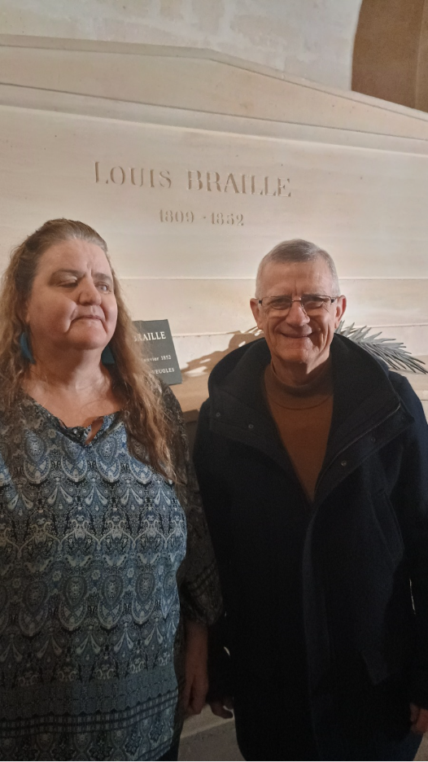
Image description: To the left, RNZFB Board Member, Martine Abel-Williamson, and to the right Joël Hardy, a UNESCO staff member are standing in front of Louis Braille’s tomb at the Panthéon. The tomb is inscribed with: Louis Braille, 1809–1852.
Each year on 4 January, World Braille Day celebrates the lasting impact of this remarkable writing system.
Last month, Martine Abel-Williamson, one of our board members attended a landmark international event in Paris from 13 to 15 November 2025, marking the 200th anniversary of the invention of Braille. Experts, advocates, and people from around the world came together to reflect on how braille has shaped the past — and how it continues to matter today.
During the three-day event, participants explored themes such as Braille in the digital age, global literacy initiatives, and ways to support independence and inclusion. Martine shared the work of the World Blind Union (WBU) and the International Council on Education of Persons with Visual Impairment (ICEVI), presenting on their newly launched Braille Literacy Campaign. She also visited Louis Braille’s tomb at the Panthéon in Paris. The tribute was put up in 1952, 100 years after he died, and reflected on the far-reaching legacy of his work.
The event was more than a celebration. It highlighted global efforts to make braille accessible everywhere.
You can read more about Blind Low Vision NZ’s work with Braille, including resources and support services on our website at blindlowvision.org.nz and join the early January celebration!

Funding Opportunities

How the Pearson Fund can help these holidays
Heading into the holidays with equipment that’s no longer meeting your needs?
The Pearson Fund may help cover the cost of upgrades or replacements.
Support is available to eligible Blind Low Vision NZ members.

Learn more about the Pearson Fund and see how to apply on the Blind Low Vision NZ website.

December 2025 – Don’t miss out! Oppenheim Fund applications close soon
If you’re studying in 2026 and haven’t yet applied for the Oppenheim Fund, this is your final call.
The fund supports course fees for recognised degrees or vocational training.
Applications close Wednesday 14 January 2026 at 1pm.
Apply now before the holiday break at blindlowvision.org.nz.

Bring your musical dreams to life with the Shirley Owen Trust
Are you learning a musical instrument, or thinking about starting lessons? The Shirley Owen Trust may be able to help.
Established through a generous gift from the late Shirley Owen, this Trust provides funding support for Blind Low Vision NZ clients who want to study music. You can apply for help with tuition fees, access to Braille music, or limited funding towards the purchase of instruments.
Music is a wonderful way to express yourself and build confidence. This year, we’ve heard such exciting news from members who recently received instruments and started their musical journey – it’s been inspiring to see their passion grow.
Find out more about the Shirley Owen Trust and download the application form on our support grants webpage at blindlowvision.org.nz.

MSD Training and Support Funds Programme
The Ministry of Social Development offers Support Funds to help people with disabilities or health conditions get either Job Support or Training Support, depending on what you need help with. Support Funds can help with the additional costs incurred as a direct consequence of disability or health condition, when undertaking the same employment or training as a person without a disability or health condition.
There are two types of Support Funds:
- Job Support helps meet disability costs when in employment or self-employment.
- Training Support helps meet disability costs when participating in work related training, or tertiary education.
To be eligible for Support Funds, you must meet MSD’s eligibility criteria (outlined on the Support Funds web page and application forms linked below), plus have a disability or health condition that has lasted or is likely to last longer than six months.
To apply for Support Funds, you need to complete either a Training Support Application (PDF) or Job Support Application (PDF) and send it, with supporting documentation to Support_Funds@msd.govt.nz. If the PDF forms are troublesome to fill out on your own, please call the MSD Job and Training Support Fund number 0800 551 001 so they can help you out.

Tell me about it
This is your space to share bite-sized learnings from your experiences as someone who is blind, deafblind, or has low vision. Maybe you’ve got a new gadget you’re loving, or you’re an Excel expert with great tips on accessibility features. Whatever it is, your knowledge could help someone else. Whether it’s a tech trick, a daily living hack, or anything in between, we want to hear from you! Your insights could make a big difference to others in the community.
If you’d like to submit an idea, please email communications@BlindLowVision.org.nz.

Upcoming events

Work Ready Webinar Recordings & Resources
Explore a series of standout webinars covering topics from cutting-edge accessible technology to vital support funds. Listen to Work Ready Webinar Recordings at your leisure on the Blind Low Vision NZ website.

Surveys and Research
Blind Low Vision NZ shares research relevant to the blind, deafblind, and low vision community for information only. We are not involved in or responsible for the research. For more details or to decide whether to participate, please contact the relevant organisation.

Intopia’s Assistive Technology Survey 2025
Intopia, a research organisation focused on improving inclusion, is running the Assistive Technology (AT) Survey 2025 across Australia and New Zealand. This is the third year of the survey, exploring how people use, access and experience assistive technology. It covers everything from screen readers and mobility aids to communication tools, and identifies the barriers people face in cost, access, and design.

Who can take part
- People with a disability who use assistive technology.
- Older adults who rely on technology for independence or wellbeing.
- Support professionals, educators, and allied health staff who assist with assistive technology. Participants need to be aged 18+ and live in Australia or New Zealand.

How to take part
The survey is online, anonymous, and takes about 15–25 minutes. To take part in this survey, visit the Intopia Assistive Technology Survey website (www.intopia.digital/).

Key dates
Survey opens: 3 December 2025.
Survey closes: 6 February 2026.
Results released: May 2026.
If you need help or have questions, please contact Jacinta Gregory, Inclusive Research Consultant, at +61 3 9977 9610 or Jacinta.Gregory@intopia.digital.

Ask Me Anything
You’ve told us that better communication matters – and we’ve heard you. This is your direct line to our Chief Executive, Andrea Midgen, and the RNZFB Board (blindlowvision.org.nz).
Whether it is about the services we provide, the direction of the organisation, or ideas for the future, we want to hear from you. Your voice helps us grow and improve.
Submit your question anonymously or include your details for a direct response. It’s quick and easy! Access the Ask Me Anything form via Microsoft Forms. Alternatively, you can call our friendly Contact Centre team on 0800 24 33 33 to submit your question.

News from the Royal New Zealand Foundation of The Blind (RNZFB) Board

Update from the Board Chair
This is a short article because the deadline for articles for this issue of Kōrero came very soon after our last meeting.
The AGM and Board elections are now behind us. The next task for the Board is to elect the Chair, Deputy Chair and its various committees, took place on 3 December. You can find the latest news from this meeting on the Governance webpage of the Blind Low Vision NZ website.

RNZFB Board of Directors meeting
The 2026 Board meeting dates have been set and are now published on the Blind Low Vision NZ Governance webpage. Please note that the Board meeting on 9 May will now be held in New Plymouth.
The next RNZFB Board of Directors Meeting is scheduled for Saturday 7 March 2026 in Christchurch.
The minutes of the 21 November Board meeting will soon be available. If you require a copy of any of our minutes, please email the Board Secretary boardscretary@blindlowvision.org.nz or phone the Blind Low Vision NZ Contact Centre on 0800 24 33 33. The Board meeting minutes are also available on the telephone information service, option 3, 1, 3.

Independent Review of the RNZFB Constitution
The review of the RNZFB Constitution, led by Simpson Grierson, is in its final stages, with a recommendation paper expected at the 7 March Board meeting.

Client Reference Group
A recommendation paper was presented at the November Board meeting approving the finalised terms of reference and budget. The Expressions of Interest process is scheduled to be launched in February 2026.

Annual General Meeting
The Board held its 2025 AGM in Wellington on Saturday 22 November. The meeting accepted the minutes of the 2025 AGM, and 2025 Special Meeting of Members minutes, announced the results of the election of Directors, approved the appointment of the Auditor, approved the Financial Statements for the year ended 30 June 2025 and the Annual Report for the year ending 30 June 2025, and also provided time for Members’ questions.

RNZFB Board Election Results
Congratulations to our three sitting directors, Clive Lansink, Judy Small, and John Billings, who have been re-elected to serve another three years on the Board. We would also like to acknowledge and thank Latoa Halatau-Talagi, Paul Brown, Jody Cruickshank, and Maria Stevens for standing in the election. Their commitment to supporting Blind Low Vision NZ is greatly appreciated.

Chair’s Report
The Chair's report to the AGM highlights the Board's achievements throughout the past year and the goals we are striving towards. A written version of the report will be included in the meeting minutes, and will soon be published in the Chair's Newsletters section on the Governance webpage at blindlowvision.org.nz.

Chair's Award 2025: Robert Hunt
This year, I was honoured to present the Chair's Award to an exceptional young New Zealander, Robert Hunt.
At just 12 years old Robert achieved global recognition by winning the Lions International Peace Essay competition for 2025 with his essay on the topic “Peace Without Limits,” entitled “Beauty is in the judgement of the beholder.” In this powerful piece, Robert challenges us to look beyond appearances and to practise empathy and dignity in our everyday lives.
He’s also a keen runner, winning the David Levene Foundation Award for Most Promising Athlete at this year’s Halberg Games and qualifying in first place as an AWS athlete for the Wellington Regional Cross Country team.
There can be only one recipient, but I did pause to recognise other nominations that were particularly compelling:
- Haehaetu Barrett: until recently Chief Executive of Lifewise Trust, Kiwibank New Zealander of the Year semi-finalist and one of 2024’s 100 leading Māori.
- Peter Herrington: for a life-time of achievements and leadership in business, the forestry industry and the community.
- Laura Feavearyear: for starting her own graphic design company that successfully helps food and beverage companies get their products noticed on supermarket shelves here in New Zealand and around the world.
- Martine Abel-Williamson: for outstanding leadership and advocacy on behalf of blind people here and around the world, culminating in holding the position of President of the World Blind Union for the last four years.
All these people are particularly inspirational in what they have achieved throughout their adult lives.
But this year I was particularly moved by Robert's international achievement at his young age and his simple "get on with life" attitude as a blind child growing up and developing his place in a sighted world. To me his attitude really captures what we value most and what Blind Low Vision NZ is all about.
Thank you for your support and engagement with Blind Low Vision NZ. We look forward to sharing more updates soon, including the Chair's full report.

Wrapping up 2025 and looking ahead to 2026
We have a lot more information on our Blind Low Vision NZ Governance webpage, including my regular Chair’s newsletter. So, I urge you to check there regularly for information on what the Board is doing.
This is my last Kōrero update for the year. I will close by extending my heart felt thanks to all my fellow directors who continue to work diligently to carry out their governance obligations, and all our staff and volunteers who work passionately to help blind and low vision kiwis. It has been a pleasure to chair a Board that has a strong, unified sense of purpose.
I hope you all have a relaxing, safe and enjoyable Christmas break! Again I’m looking forward to relaxing, a little fishing and catching up on reading. I look forward to celebrating Christmas day with family in Auckland.
Clive Lansink
RNZFB Board Chair

In the News

The risk of blind skiing: Thomas’s story
Watch Thomas, a blind skier, navigate the slopes using sound and guidance, and hear his story on youtube.com.

Navigating NCEA exams without sight
Learn how a student who is blind navigates six-hour NCEA exams using touch and ingenuity in an RNZ article at rnz.co.nz.

Council seeks information on attack on Timaru guide dog
- Read the article to learn how council officers in Timaru are seeking public information after a guide dog was attacked at thepress.co.nz.
- Learn about the witness who has come forward to help with the investigation into the attack on a Timaru guide dog on the Press website.
- Listen to a discussion on The Panel with Verity Johnson and Nick Leggett about attacks on guide dogs, including the Timaru case at rnz.co.nz.

By Andrea Midgen: How disabled New Zealanders are being excluded from the workforce
Read Blind Low Vision NZ Chief Executive, Andrea Midgen’s article about including disabled people in New Zealand’s workforce by visiting waikatotimes.co.nz.

Job Opportunities at Blind Low Vision NZ
For the latest job opportunities at Blind Low Vision NZ, go to the Blind Low Vision NZ Careers website or call TIS m 3 4 6.

Ka kite anō
Please let us know what you think of Kōrero. We welcome suggestions for what you would like us to include and any tips or stories you would like to share with the community. Get in touch on 0800 24 33 33 or via communications@blindlowvision.org.nz.
Did you know that you can request Kōrero in Braille? Call our contact centre on 0800 24 33 33 if you would like to receive Kōrero in this format.

