
Community Impact Report, 2025
Pūrongo Whakaaweawe Haporia
Adapted in 2025 by Accessible Formats Service,
Blind Low Vision NZ, Auckland
Total print pages: [52]
Total large print pages: [103]

Transcriber's Note: The logo at the top of the page is Blind Low Vision NZ. The bold formatting has been removed from the names under the photographs in this document.

Notes for the Large Print Reader
Print page numbers are indicated as:
Page 1
Main text is in Arial typeface, 18 point.
Headings are indicated as:

Heading 1

Heading 2

Heading 3

Heading 4

Transcriber's Note: In this document’s contents, “PP” refers to print pages and “LPP” refers to large print pages.

Contents, Nga kai oroto
Section | PP | LPP
The Year in Review | 1 | 1
Who we help | 6 | 10
Registrations and Referrals | 8 | 13
A snapshot of blindness in Aotearoa | 9 | 14
Our Services | 11 | 18
Employment and Youth Pathways Service | 11 | 20
Guide Dogs Services Highlights | 13 | 24
Library Highlights | 14 | 26
Accessible Formats | 16 | 30
Innovations and Insights | 18 | 33
Sport and Leisure Highlights | 19 | 35
Client Stories | 20 | 38
Our People | 22-23 | 43
Volunteer Highlights | 24 | 46
Community and Inclusion | 26 | 50
Fundraising Highlights | 27 | 52
Equipment Solutions | 28 | 55
Support Grants | 29 | 57
Policy and Advocacy Highlights | 30 | 59
Philanthropy and Corporate Partnerships | 31 | 61
In Gratitude and Gifts in Wills | 34 | 67
Financials | 39 | 76
Consumer Organisations' Impact | 39 | 77
The Board | 43 | 83
Executive Leadership Team | 47 | 89
Amsler Grid | 49 | 95
Blind Low Vision NZ across the country | 51-52 | 98

Audit key:  Verified search icon (Verified search icon) Denotes an audited number. It was verified as part of our FY25 financial statements.

Pages 1-2

Community Impact Report 2025, Pūrongo Whakaaweawe Haporia

He aha te mea nui o te ao? He tangata, he tangata, he tangata.
What is the most important thing in the world? It is people, it is people, it is people.

The Year in Review, Pūrongo Arotake i Tēnei Tau
Tēnā koe,
As we look back on 2025, we do so with deep gratitude for the people who walk alongside us every day. To our clients, volunteers, staff, supporters, and partners: thank you. Your trust and commitment are what allow Blind Low Vision NZ to keep growing, changing, and delivering support where and how it's needed most.
This year marked the first phase of our new Strategic Plan for 2024−2028—a clear direction focusing on teaching our clients the essential skills of daily life and helping them live full, productive lives in the community. This was shaped by the voices of our community and grounded in our shared vision for equity, partnership, and inclusion. It sets the priorities that guide our mahi over the next four years and reflects our focus on delivering services that are meaningful, accessible, and client led.
To support this direction, we've taken important steps to strengthen the way we govern, engage, and connect. Simpson Grierson was engaged to conduct an independent review of the RNZFB Constitution which will be completed at the end of this year, helping us consider whether our governance structures truly reflect the diversity of the community we serve. At the 2024 Annual General Meeting, members also approved key constitutional changes in line with the new Incorporated Societies Act—updates that will support more transparent and responsive governance.
Client voice has remained central throughout the year. Planning is underway to establish a new client reference group, co-designed with clients, members, and consumer organisations to guide service design and delivery. We've also begun reaching out to clients who may not have received services in a while, embedding new practices to make sure more people are aware of the support available to them.
Page 3
As we look inward, we also reflect on a difficult part of our past. In 2024, the Government issued a public apology to survivors of abuse in state and faith-based care. Blind Low Vision NZ is affected by this, with people coming forward to share allegations of harm that occurred while attending the former school for blind children once operated by the Foundation. The Board has reaffirmed its commitment to working with survivors to prepare a meaningful public acknowledgment and apology, which was delivered in September 2025.
This year also saw a strong focus on accessibility, inclusion, and innovation. We're developing a national Accessibility Framework that brings clients, members, and staff together to identify and address access barriers. We've also approved the Engagement and Marketing Strategy for 2025−2028, which shifts our fundraising efforts away from street collections and towards more digital, competitive campaigns such as Pawgust. The intention is to reach younger and more diverse audiences and develop sustainable and inclusive approaches, including deeper engagement with Māori, Pasifika, and Asian communities.
We continue to evolve and modernise our services. The Pearson Fund Subsidy has been made easier to access, with increased discounts on equipment. We are keenly evaluating new products to embed them into our training to create exciting new possibilities for our clients. We're also pleased to have approved a proposal to make white canes and cane tips available to clients at no charge—a small change with a significant impact. Our Library service is keeping pace with rapidly changing technology. And our partnership with Vision Australia has led to a wider range of equipment options through a more accessible website, supported locally by our staff. While we're proud of this progress, we're also working hard to address the issues raised—including reducing freight costs and reviewing the affordability of higher-cost items.
Facilities have seen major improvements this year. The new Guide Dog Development Centre at Homai is now complete, providing an enhanced training environment that gives our dogs the best start in their working lives. Rebuilding work on our Dunedin centre was completed and a new dedicated client area, opening in October was created in Auckland, allowing clients to access welcoming, modern, inclusive spaces for social connection, support and client-driven activities.
Several other initiatives have moved forward, including our Braille Strategy Project, increased equipment demonstrations, and a growing graduate intern programme that continues to bring fresh talent into the organisation. We continue to advocate for safer public spaces, as stray and dangerous dogs remain a serious risk to people using guide dogs and other assistance dogs. Insight workshops with employers helped raise awareness of the strengths and potential of blind, deafblind, and low vision jobseekers, and we remain in active discussions with government to explore new ways to work together and support people to thrive.
Page 4
We've also listened to feedback about communication—and in response, have taken steps to improve how we share information, both with clients and within the organisation. Staff webinars and more visible Board engagement are helping build stronger, more transparent relationships across the motu.
Finally, we want to acknowledge the dedication of our people. To our clients, staff, and volunteers—thank you. You support people every day to live, work, and take part in their communities. You are part of something truly important, and we're proud of what we've achieved together.
Clive Lansink
Royal New Zealand Foundation of the Blind (RNZFB) Board Chair
***
Andrea Midgen
Blind Low Vision NZ
Chief Executive

Strategic Plan: 2024−2028, Mahere Rautaki: 2024−2028

Our Mission
Empower New Zealanders who are blind, deafblind, or have low vision to live the life they choose.

Our Vision for the Future
We aspire to create an Aotearoa New Zealand that is inclusive for all those with blindness, deafblindness, or sight loss.

Our organisational priorities

Empower Independence
Supporting our clients in their communities.

Educate and train
Training clients with practical and essential skills for daily life.

Social inclusion
Raise awareness and advocate for an inclusive Aotearoa New Zealand.

Supported by our for-purpose team
We will foster a diverse team that supports our strategy through a culture of strong communication, financial sustainability, and specialist expertise.

Delivered through our Values
This strategy will be delivered through our values: Person-centred, Collaborative, Adaptable, and Accountable.
Page 5

How our priorities will be delivered

Empowering Independence
We are committed to empowering our clients to live independent lives in their communities. Independence is individual, often relying on support from the community. We will offer and facilitate services that meet our clients' diverse needs. To achieve this, we will:
- Support clients to access key services in the community like employment, transport, education, and recreation.
- Offer counselling and refer to other mental wellness services, focusing on adjusting to sight loss for an integrated community life.
- Facilitate community connection, ensuring holistic support to encourage our clients to be confident, autonomous members of the community.
- Work collaboratively with external partners and our clients to create an environment and network of inclusive support.

Education and training
Teaching self-reliance and practical skills enables people who are blind, deafblind, or have low vision to confidently live the life they choose. Learning the skills of blindness, deafblindness or sight loss gives our clients the confidence to be autonomous citizens in their communities. To achieve this, we will:
- Provide specialised training and adaptive technologies to foster clients' skills for independent living, either directly or through their families or support networks.
- Provide training in daily living, mobility, and communication, promoting self-reliance.
- Provide access to empowering tools, technologies, peer support, and other resources.

Social inclusion
We know that those who are blind, deafblind, or have low vision are at a higher risk of isolation or exclusion. We will work towards an inclusive and safe Aotearoa for all. To achieve this, we will:
- Advocate nationally and locally to eliminate barriers that hinder our clients' independence.
- Launch awareness campaigns to promote societal understanding, knowledge, and acceptance of blindness, deafblindness, and sight loss.
- Offer expert advice on environment, information, and technology accessibility for those with vision impairments and deafblindness.

Supported by our for-purpose team
- Uphold high-quality, cost-effective services led by well-trained, diverse staff, emphasising growth and recognition.
- Foster a culture attuned to our clients' needs, valuing knowledge-sharing, and learning.
- Lead practices reflecting our clients' needs and aspirations.
- Foster a culture of open communication and transparency.
- Grow individual and community support through donations and legacies.
Page 6

Our objectives: the 2024-2028 focus

Support Services
Expand and refine our support services to effectively meet the unique needs of individuals who are blind, deafblind, or have low vision.

Education and Training
Deliver impactful training programmes, equipping clients, as well as their families and support networks, with the skills and knowledge for enhanced independence and community inclusion.

Collaboration and Partnerships
Proactively collaborate with external stakeholders and clients, fostering an inclusive and supportive environment and involving those we serve in decisions that affect them.

Policy advocacy
Campaign for policies and practices in our communities that foster accessibility and inclusion for individuals who are blind, deafblind, or have low vision, aiming for tangible improvements in their daily lives.

Awareness and future-focus
Increase awareness about vision health and proactively communicate, ensuring support is within reach for New Zealanders at all stages of their lives.
Read on to discover the progress we've made towards our objectives.

Who we help, Ka āwhina mātou i a wai

Blind Low Vision NZ in numbers
Total number of clients: 15,590
Number of new clients this year: 1,758

Age Breakdown
Age Bracket | Count | Percentage
0-21 | 1,119 | 7.2
22-44 | 2,057 | 13.2
45-64 | 2,433 | 15.6
65-75 | 2,031 | 13.0
76 and greater | 7,950 | 51.0
Total | 15,590 | 100.0%
Page 7

Region Breakdown
Region | Count
Upper North | 618
Auckland | 3,855
Lower North | 5,350
Wellington | 1,485
Christchurch | 2,257
Other South Island | 2,025
Total | 15,590
Clients receiving services in FY25: 6,340
Total Library loans: 82,330
Books in our accessible library: 39,328
We received an average of 2000−2800 calls each month last year.

Gender Breakdown
Gender | Count | Percentage
Female | 8,901 | 57.1
Male | 6,675 | 42.8
Non-Binary | 9 | 0.1
Other | 2 | 0.0
No data on record | 3 | 0.0
Page 8

Ethnicity Breakdown
Our services reach a diverse community, supporting people from 82 unique ethnic groups.
Summary of Ethnic Groups Served
- NZ European/Pakeha: 69.3%
- Māori: 8.8%
- Samoan: 2.1%
- Not Stated: 6.2%
- Indian: 1.4%
- Chinese: 1.3%
- Other Ethnic Groups: 10.9%

Registrations and Referrals, Ngā rēhitatanga me ngā tuku tohutoro
Over the past year, we have made big strides in how we welcome people, connect with the eye health sector, and track the impact of our work. It all adds up to a more responsive, accessible experience, from first contact to ongoing support.
We've refined our welcome process to be more client friendly. People can now choose how they want to receive information, whether that's by email, SMS, or in large print. It's a small change, but it helps people feel understood and supported right from day one.
We've also been strengthening our presence in the eye health sector, building stronger relationships, so that more people with significant vision support needs can connect with Blind Low Vision NZ at the right time. A pilot with one of New Zealand's large eye care providers led to a 20% lift in referrals and gave us fresh insight into what referrers need to feel confident in referring people to us.
Our presence at key industry events, including hosting an open day for the final year University of Auckland Optometry Students, attendance at the NZ Association of Optometrists Conference, and collaborative World Sight Day events have helped raise awareness and trust with both experienced and emerging professionals. This work has contributed to a 46% rise in the number of specialist referrers who regularly connect their patients to Blind Low Vision NZ.
Behind the scenes, we've continued to improve the way we gather and report on data. This helps us better understand what's working, where the gaps are, and how we can continue to adapt to meet people's needs. By making these changes, we're making it easier for people to reach out, feel welcomed, and start their journey with confidence, knowing they're not alone.
Page 9

A snapshot of blindness in Aotearoa, He tīpako matapōtanga i Aotearoa
Many people believe that blindness, deafblindness, or low vision are rare conditions that only affect a small number of people. However, these conditions are more prevalent than most people imagine.
In fact, Census data shows that between 2018 and 2023 the number of people reporting no sight or limited sight that affects their daily activities rose by about 8%—from approximately 168,000 people in 2018 to almost 183,000 in 2023.
The reality is that anyone can experience vision loss, either personally or through a loved one, at any point in life. It's a reminder that accessibility and support are crucial for all of us.
In New Zealand, the primary eye conditions contributing to blindness and low vision are age-related macular degeneration (AMD), diabetic retinopathy, glaucoma, and cataracts. These conditions significantly impact the quality of life for many, making awareness and early detection crucial.

Age-related Macular Degeneration (AMD)
Age-related macular degeneration (AMD) is the leading cause of blindness and partial sight in New Zealand, affecting 29% of Blind Low Vision NZ clients. It is also the primary cause of vision loss in the developed world.
Awareness and education about AMD are crucial, as early detection and management can make a significant difference to people's quality of life.
This highlights the urgent need for increased awareness and education about this common and impactful condition, as understanding AMD is crucial for early detection and management.

Diabetic Retinopathy
Diabetic retinopathy (DR) stands as the leading cause of blindness and low vision among New Zealand's working-age population. Approximately 291,000 New Zealanders over the age of 15 live with diabetes, making up about 7% of the population. Of these, around 20-25% develop diabetic retinopathy, equating to between 68,000 and 72,000 people. Almost everyone with Type I diabetes and 60% of those with Type II diabetes develop some form of DR within 20 years of being diagnosed. At Blind Low Vision NZ, 3.4% of our clients are affected by diabetic retinopathy.
The good news is that most vision loss from DR can be prevented. Effective management of glucose levels, regular exercise, early detection, and treatment are key to preserving vision.

Glaucoma
According to estimates from Glaucoma New Zealand, over 100,000 New Zealanders have glaucoma, yet only about half are aware of it. The Ministry of Health estimates that 2% of New Zealanders over 40 have the condition, which translates to approximately 50,000 people, with half unaware of their diagnosis.
Page 10
Glaucoma is the second most common cause of blindness and partial sight among New Zealanders over 65, affecting 7.1% of Blind Low Vision NZ clients.
Managing glaucoma involves strict adherence to medication, typically prescription eye drops, or surgery to control this condition and protect vision.

Cataracts
Cataracts are the most common correctable eye condition that causes blindness and partial sight in New Zealand. About 412,000 New Zealanders have some form of cataract. Each year, around 41,000 cataract surgeries are performed in New Zealand, with about 20,000 of these being publicly funded. Remarkably, over 95% of people experience significant improvement in their vision following cataract surgery.
These statistics highlight the importance of regular eye check-ups, early detection, and treatment to maintain eye health and prevent vision loss. We believe our current eye health system can do better, and we have a role to play in shaping the solutions alongside others in the sector.

The future we want
We want a future where New Zealanders value and understand the importance of proactive eye care, and where our health system is resourced and integrated to support equitable eye health services.
This includes investment in awareness and education programmes that promote knowledge and preventative action, so people have the opportunity to access services at the earliest time to support the best outcomes. It also includes all Kiwis having access to regular eye checks and eye treatment if needed, especially for our vulnerable communities. And when people do need to learn new skills through low vision support or vision rehabilitation, the eye health system supports this.

What you can do
Encourage your friends and family to have regular eye health checks with your local optometrist. It is the best way to make sure that any changes are caught early.
Contact us, if you or your loved one needs support in living with blindness, deafblindness, or low vision. Call 0800 24 33 33 or email info@blindlowvision.org.nz.
Page 11

Our Services, Ā Mātou Ratonga
- Mobility Training: We offer a wide range of mobility services to help you get around.
- Skills for Independence: Our programmes provide skills to retain independence.
- Sport and Leisure Support: We empower people to take part in the activities they choose by connecting them with people, services and communities, building strong partnerships, and advocating for inclusive opportunities.
- Community Support: We foster a supportive community, helping people connect with each other through shared interests.
- Emotional Wellbeing: Receive emotional support for adjusting to vision loss and ongoing wellbeing.
- Accessible Library: Explore our accessible library for knowledge and cultural enrichment.
- Deafblind Services: Our specialist staff support people who are deafblind to communicate in new ways, access services and equipment, and stay connected with their communities.
- Employment Readiness: Prepare for career stability through our employment readiness programs.
- Youth Work Readiness: We support youth in preparing for their future careers.
- Specialised Services: Tailored services are available for Māori, Pasifika, youth, and children.
- Adaptive Technology Support: Get support for your technological needs.
- Guide Dogs: Our guide dogs are trained to help people move safely and confidently while also being wonderful companions.
- Online Webstore: We've partnered with Vision Australia to offer a dedicated online webstore for purchasing equipment.
- Accessible Formats Service: For individuals or businesses wanting documents and literature transcribed into Braille, large print, audio and other similar formats.

Employment and Youth Pathways Service, Ratonga Whakawhiti Mahi me te Rangatahi
Blind Low Vision NZ is committed to empowering people through our Employment and Youth Pathways Service. We focus on understanding each person's strengths and recognising their value, helping build the confidence to explore meaningful career paths. With support from experienced staff, a professional development toolkit, key partner relationships, and external service providers, we offer wrap-around support that helps people plan their careers and reach their full potential.

Number of youths we have supported via our employment and youth pathways programmes aged 16-21 years
27
Number of members we have supported via our employment and youth pathways programmes aged 22-65 years
169

Who we support
- Young people aged 16 to 21 receive personalised guidance on study and career options through our youth-focused programmes.
- Adults aged 22 and over benefit from structured support, tailored development plans, and flexible ways to engage.

Work Ready
Work Ready continues to open doors to education and employment by helping people grow their confidence and skills. This flexible programme supports clients to progress at their own pace, with activities that suit their personal goals.
- The programme includes:
- Monthly online professional development webinars.
- One-on-one coaching for CV writing and interviews.
- Peer mentoring.
- CliftonStrengths (Gallup) assessment.
As one participant shared:
"My personal thinking has changed. I now focus on what I can do, not what I can't."
Work Ready is more than a programme. It's a pathway to self-belief and opportunity.

2025 Highlights
This year, education continued to play a big part in helping people challenge perceptions, grow self-assurance, and work towards long-term employment outcomes.
We hosted monthly webinars on job-seeking skills, workplace communication, and career planning. These sessions are now part of the Blind Low Vision Education Network NZ (BLENNZ) transition programme timetable, creating a stronger link between school and adult life.
We also delivered In-sight workshops to external corporate organisations. These two-hour sessions invite employers to rethink how they attract, recruit, and retain disabled talent. One attendee summed it up:
"It just isn't that complicated."
The feedback has been overwhelmingly positive. These workshops are helping break down stereotypes and build more inclusive workplaces.
Page 13

Internship Programme 2024 to 2025
Our internship programme continues to create valuable pathways into paid work. This year's interns have made a real impact in their teams and across the wider Blind Low Vision NZ organisation. It shows how investing in people benefits both our organisation and the clients we serve.
- Nevé Billing joined the Christchurch Community Engagement team and has now been offered a permanent role as Community Engagement Lead at Blind Low Vision NZ.
- Rae Shardlow supported the Communications team with proofreading newsletters, promoting Library Services with her "Loving the Library" series of blog posts, and contributed to social media and website content. Rae is set to begin a 12-week publishing internship with Hachette Aotearoa New Zealand in September 2025.
- Alix Coysh contributed to Client Services through research and data analysis, supporting programme development across Employment, Sport and Leisure, and Guide Dogs. Alix has secured a permanent role at the University of Auckland as a Research Fellow in the Applied Translational Genetics Lab, School of Biological Sciences.
All three have been praised by their managers for their performance, professionalism, and commitment. Each has become a valued part of our organisation.

Guide Dogs Services Highlights, Hiranga Ratonga Kurī Arataki
The 2024−2025 year has been one of growth, real progress, and setting strong foundations for the future—building on our four-year strategy.
At the start of this journey, people could wait up to 15 months for a guide dog, with some complex cases peaking at 48 months. By 30 June, we had reduced the overall wait time to seven months. Non-complex cases are now at just five months, and the final person in a complex case was matched after 54 months.
Our early neurological stimulation and development programmes have made a real difference. The average Behaviour Checklist score lifted from 3.9 to 5.8—a sign of the high-quality training and the dedication of our team.
We set out to qualify 26 dogs this year but finished with 32 successfully completing training. We also saw 39 guide dog teams graduate—exceeding our target and changing lives across the country.
A big milestone was the opening of our new Guide Dogs Development Centre—three purpose-built buildings designed to give our dogs the very best start, with canine welfare and formal training needs at the heart.
Page 14
These achievements are only possible thanks to our committed workforce, the selfless volunteers who give their time and care, and the immense generosity of our donors. To each of you—thank you. Your support is creating life-changing partnerships and building a more accessible future for people who are blind, deafblind, or have low vision.
As of June 2025:
- 66 puppies born
- 77 dogs with our volunteers
- 35 qualified guide dogs from training
- 24 dogs in training
- 226 days: the average wait time to receive a guide dog
- 24 clients waiting to be matched with a dog
- 148 active working teams
Audited and verified as part of our FY25 financial statements.

Library Highlights, Hiranga Pātaka Pukapuka
This year, the Library team has made huge progress in making books, newspapers, and magazines more accessible than ever. From adding thousands of new titles to improving how our recordings sound and feel, we've been working hard to deliver a better reading experience—no matter where you are or how you like to read.

Reaching more people with Envoy Connect
Envoy Connect is designed for people who don't have internet access. It gives them a simple, reliable way to listen to audiobooks and other library content. This year, 2,244 books were downloaded by members using Envoy players. We're continuing to build on this platform and are researching new features for future updates.

A world of books through Alexa
Thanks to new development work, members can now access more than 90,000 extra books through Alexa using the Accessible Books Consortium (ABC). These DAISY books come from all around the world—and since the feature launched, 2,796 books have already been borrowed. DAISY stands for Digital Accessible Information System. It is a digital talking book format that offers many advantages over traditional audio books. DAISY books can be read on a portable digital playback device, a regular mp3 player or on a computer equipped with playback software.
Page 15

Alexa device distribution
Alexa continues to be our most popular way for people to use the library. On average, we're now distributing 97 Alexa Gen 5 devices each month, mainly to new clients.
Alexa is a voice-activated smart speaker that lets people easily access books, newspapers, and updates from Blind Low Vision NZ. This is different from the EasyReader platform, which is an app for iOS, Android, and Windows that lets users read books from our Library as well as other accessible collections.
Giving people Alexa devices has made it easier than ever to stay informed, entertained, and connected.

Better listening, better experience
We've made changes to improve how our recordings sound and feel. Long introductions are now placed at the end, so listeners can get straight into the story. We've also updated how we choose narrators, matching their voices with the tone and themes of each book.

Usability improvements
We're improving how our Library works behind the scenes, too. New updates will include publication dates so it's easier to find the latest titles. We've also welcomed a volunteer whose focus is on reviewing and improving the quality of our collection.

More books you want to read
This year, we've added 1,162 new books. These are based on what people told us in the Library survey, popular requests, and the current NZ Top 50 list. Alongside new content, our studios are also restoring older audio using Artificial Intelligence (AI)—making sure great stories from the past are easier to enjoy again.

EasyReader improvements on the way
In the coming months a new "Quick Download" feature will be introduced to the EasyReader app. This will make it faster to search, download, and begin reading a book. EasyReader is a free app for iOS, Android, and Windows where members can browse and read DAISY and EPUB titles.

Spaces that support listening and learning
Creating welcoming spaces to enjoy audio is an important part of the Library experience—whether it's listening to a book with others, joining a group session, or learning how to use library devices.

Improved acoustics across the motu
To support this, we've upgraded the acoustics in 11 of our offices, from Auckland to Invercargill. These spaces are often used for Library device setup, audiobook demonstrations, and group learning, so having clear, accessible sound makes a real difference.
New sound-absorbing panels and ceiling baffles have made meeting rooms, lounges, and training spaces more comfortable and accessible. All work was completed on time and without disruption to services.
Page 16

Upgraded audio in Wellington
In Wellington, a new audio-visual system has transformed our social space into a flexible, inclusive area for everything from movie nights to exercise classes. Blind Low Vision NZ Staff can easily switch settings using an accessible touchscreen. The system includes Bluetooth Auracast and hearing loops, making shared listening experiences more accessible for everyone, whether you're using headphones or hearing aids.

Alexa Stats FY25
- Total number of books borrowed: 48,651
- Number of newspapers read: 5,494
- Total number of magazines borrowed: 2,250
- Number of unique users: 1762

EasyReader Stats FY25
- Number of books borrowed: 15,507
- Number of magazines borrowed: 1,189
- Number of newspapers read: 1,022
- Number of unique users: 268

Accessible Formats Service, Ratonga Whakahōputu Ka taea te uru
This year has been a time of real growth for the Accessible Formats Service (AFS), with a strong focus on innovation, smarter systems, and giving clients more independence and choice.

Making Braille Library services better
We've worked closely with the Library team this year, with the Content Delivery Specialist now part of AFS operations. Together, we've made some important updates:
- Improved how we lend, return, and curate Braille books.
- Launched a Braille Book Giveaway to rehome donated and de-selected titles.
- Set up a new Address Shelving System for easier and more efficient storage, based on a successful model used by Vision Australia.
Page 17

Helping clients access what they need, independently
We proudly reintroduced access to the Articles for the Blind postal service—giving people the tools to send and receive Braille and audio materials themselves.
Our new Mailing Package Service includes:
- A starter kit with six sets of posting supplies.
- Clear, accessible instructions.
It's a small change that makes a big difference to autonomy.

Innovating with UV printing and new tech
We introduced a UV ink tactile graphics printer, opening the door to more durable, detailed tactile materials. Our team received specialist training and is currently testing outputs. Early feedback has been incredibly positive:
"The clarity and feel of the UV-printed floor plan inspires me to continue learning Braille. I love touching this map."—Charlene, new Braille learner
"Knowing where the stairs and restrooms are is huge when you're blind. My husband is more confident roaming this space now."—Kim, support person
We also brought in an international embossing expert to train our team and external partners—helping us get the best from our tools and keep quality high across all formats.

Improving how we work
We've redesigned our workspace using production efficiency principles. The new open-plan layout supports:
- Faster turnaround times.
- Easier collaboration.
- A better experience for both staff and clients.

What we delivered
Over the past year, the AFS team completed:
- 593 accessible format jobs
—326 in Braille
—91 in audio
- 57% of work was chargeable—supporting financial sustainability while continuing to offer free formats to members when needed
Page 18

Looking ahead
We're continuing to improve and expand our services. In development right now:
- A new Braille calendar format, co-designed with clients.
- More durable materials for Braille books.
- UV-printed accessible signage for all our offices.
- Reintroduction of Perkins Braille Typewriter servicing.
- AI-assisted pre-production tools for tasks like sports fixture transcription and book digitisation.
Our team also took part in professional development across the region, including:
- The Round Table Conference in Melbourne.
- Site visits to Vision Australia.
These experiences help us stay connected to best practice and bring new thinking back to Aotearoa.

Highlights from Innovations and Insights, Ngā Auahatanga me Ngā Mōhiotanga
This year, we introduced two new initiatives to reconnect people with our services and share the latest technology tools that support everyday life for people who are blind, deafblind, or have low vision.

Reconnection Calls
In FY25, we rolled out a national project to reach people who hadn't used our services in the past three years. Nearly 4,000 calls were made across the country, leading to meaningful conversations. Many people asked for further support or updated their contact details, helping us refresh our records and rebuild connections.
These calls reminded us of the power of simply picking up the phone. They also helped us create a new Reconnection Tool in our system. Now, when someone finishes using our services, we ask when they'd like us to get back in touch. This is recorded in their file so future follow-ups are timely and respectful of their preferences.
These steps help us stay connected and ensure support is there when people need it most.

Adaptive Technology Webinar Series
We also launched a webinar series to build digital confidence and share helpful tech tips. So far, 246 people have joined live, and the recordings have had 924 views on YouTube (at the time of writing).
Each session focuses on practical tools and real-life experiences. We've covered the basics of adaptive tech, smart devices, useful apps, and insights from people in our community using technology in their everyday lives.
The series will continue in FY26, with upcoming topics including AI tools, mobile navigation apps, and client stories. Every session is designed to be practical, accessible, and engaging—helping people and their whānau see what's possible with the right tech by their side.
Page 19

Comprehensive health and wellness through the Sport and Leisure team, Matawhānui hauora me te orange na roto i te tīma Hākinakina me te Rēhia
The 2025 financial year was another busy and impactful one for the Sport and Leisure team. Guided by the Enabling Good Lives Principles, our staff have empowered many members to become more active and participate in hobbies of their choice, fostering independence and building stronger community connections.
A key highlight was our continued partnership with the Spirit of Adventure Trust, which saw six members aged 16 to 30 join the Inspiration Voyage. Living and working on a tall mast sailing ship provided a unique environment for challenge and growth, with participants climbing masts and rowing to nearby islands. The experience was filled with hard work, fun, and laughter, creating lifelong memories.
By establishing new connections in the regions, we have empowered members with greater autonomy over the activities they participate in. We have observed that once members are aware of an inclusive coach, activity, or organisation, they grow in confidence to make these connections themselves.

A Pathway to Independence
One of our key successes involved supporting a member who wanted to become more active, make new friends, and do something independently from their family and support worker. Our team worked closely with them to unpack their goals and address the emotional and transport-related barriers preventing them from joining group settings. Through dedicated problem-solving and support, this member is now confidently attending weekly club sport on their own and is working towards bigger life goals, such as independent living.

Finding a New Purpose with Blind Tennis
This year, our team helped two clients join Blind Tennis for the first time, supporting them every step of the way to ensure a smooth and enjoyable experience. The impact has been profound, as new player Russell K. shares:
"The Blind Tennis Group is where I feel like I belong. The people are incredible. From the very first time I met them, they didn't feel like strangers at all. They're so warm, kind, and motivating. They've become like family, pushing me to achieve more than I ever thought possible. We are all different and get coached differently depending on our vision and adaptive needs, but together we're just playing tennis. Playing tennis has given me a new purpose. I feel like great things are happening to me now and I am truly grateful to be a part of this."
Page 20

More Than Just a Workout
Our popular gym groups, where clients work out safely with a personal trainer, have now been expanded to include Napier residents at a Napier City Council Gym. This initiative not only benefits our members but also raises awareness among personal trainers about running inclusive gym sessions. For many, these groups are a gateway to social inclusion and renewed confidence.
"As I gradually lost my sight, I could do less and less. I live alone and was seeing nobody. A Blind Low Vision NZ email offered gym classes which I made the effort to attend. Those classes have changed my world. Not only did I improve my fitness, but I made new friends there and made contacts which opened further opportunities. I am now swimming and cycling, have entered the women's triathlon twice and ride in club cycle races. I enjoy regular contact with my friends at Blind Low Vision NZ, and we are a great encouragement to each other."

Kicking Off Blind Football
Looking ahead, we are thrilled to have established a new partnership with the Wellington Phoenix FC and Lower Hutt FC to kick off Blind Football, creating another exciting, inclusive opportunity for our community to get active.

Client Stories, Kiritaki Pūrākau

Ethan
Ethan from Hamilton is showing that vision loss doesn't define his future. Born with Septo-Optic Dysplasia, his vision challenges were identified when he was a baby. His parents reached out early to Blind Low Vision NZ for support. Ethan, who is now 21, says that helped lay the foundation for the life he's now building.
He describes his vision simply as "terrible." He can't see colours or shades clearly, often mistaking dark blue for black, and can only make out the outlines of large shapes, like his dog or a doorframe. But while his sight is limited, his determination is not.
Ethan's proudest moments include earning a spot on the national kapa haka team, getting into university, and being matched with his guide dog, Jack. A yellow Labrador, Jack came into Ethan's life just after his 21st birthday. "The best 21st present I could've asked for," he says.
To Ethan, Jack is more than a guide dog. He gives him emotional support and calm.
"I just throw myself on the floor, and Jack will lie on me," says Ethan. "Sometimes I rest my head on him, or he rests his on me. They're such healers. They just know."
This might give you the impression that Ethan prefers peace and quiet. Far from it. Ethan says he feels most at ease in busy spaces.
"At home, all my mental alarms go off. But in a factory or industrial kitchen, I'm calm. I feel safe," he says, describing what it feels like to visit his cousin who works in a factory.
Page 21
Ethan was raised in a whānau full of strong role models. His dad is a police officer, his aunt is a chef, and his cousin works in a peg factory.
"My family never wrapped me in cotton wool. They taught me to try everything."
Would he want his vision back?
"No. It's made me who I am. I'm stronger for it."
Ethan says Blind Low Vision NZ has played a big role in his journey. He says orientation and mobility training, Braille, and being matched with Jack have been life changing. He's also grateful for support from staff like Guide Dog Mobility Instructor Rochelle and Rehabilitation Instructor Maddie
Despite the support from his whānau and guide dog, Ethan still faces barriers. These include inaccessible websites, confusing systems, and stray dogs running up to guide dog Jack. He has also been mocked for being blind.
"No matter what happens, I'm still going to get out of the house."
His advice for the sighted community is clear.
"Don't be an idiot. Ask respectful questions. Not how many fingers someone's holding up. Ask us about our lives."
And to other blind or low vision young people:
"Be happy with who you are. Don't hide from the hard stuff. What some people see as a massive inconvenience, I see as opportunity."
Today, Ethan is proud to be doing things he never thought possible. He is competing nationally, training in high-pressure spaces, and walking confidently beside Jack, his loyal, highly trained friend with four paws and a wagging tail.
None of this would be possible without the generous support of donors and supporters of Blind Low Vision NZ.

Olivia
Olivia lost her vision at 18 months old after contracting measles. She and her family were living in Vietnam as refugees from the Pol Pot regime in Cambodia. From then on, blindness shaped every chapter of her life, but never as a barrier.
Instead, blindness became part of who she is, a source of pride, and in many ways, a doorway to new opportunities.
When, at age 3, she arrived in Aotearoa New Zealand with her family, Blind Low Vision NZ helped to fling those doors wide open.
Today, Olivia is a mum of four, a high school counsellor, and a competitive Scrabble player. She's also quick to say she wouldn't change being blind, even if she could. "Maybe for a day, just to experience it," she laughs. "But I'd always want to go back to being me."
That confidence didn't come overnight. Olivia started off at Homai College, a specialist school for blind children, but quickly moved to a mainstream school where she was supported by Blind Low Vision NZ with Braille books, adaptive technology, and accessible learning materials. Later, as a university student and then a lawyer, she continued using our services, especially for Braille music and textbooks.
Page 22
"Education's been a huge part of my life," she says. "And it would've been so much harder without those resources." These days, Olivia is supported by Kyle, her black Labrador guide dog.
"He's the fourth guide dog I've had, and he's definitely the best. So responsible and focused. He gives me confidence and brings me independence—two priceless gifts."
Even with all she's achieved, Olivia is honest about the daily barriers she still faces, like silent electric vehicles, badly laid-out pram ramps that face dangerously into the middle of intersections, inaccessible websites, and new EFTPOS machines with touch screen buttons she can't use on her own.
"Every time I leave the house, there's something. It might be vehicles blocking the footpath, crossing the road, public transport, it all takes time and mental energy." To Olivia, these aren't just frustrations. They carry a message.
"Over time, all those small barriers start to say, "You're not worth investing in." That accessibility is a luxury, not a right. And that hurts."
Despite everything, Olivia is proud of who she is.
"I've had so many advantages because I'm blind. It's given me problem-solving skills, empathy, and the chance to see people's best selves. People assume blindness limits me, but I believe that it has expanded my horizons."
She's also a strong advocate for better emotional support when people start to lose their sight.
"Vision loss isn't just a physical change, it is a searing grief, too. People need support that helps them to grow through the grief and to reclaim their optimism and joy." Her advice for others?
"Be persistent. Don't be afraid to ask for help, and don't give up if you don't get what you need straight away. You're not a burden. You deserve to thrive. The world is a better place because you're in it."

Our People, Ō Mātou Tāngata—ngā Kaimahi o Kāpō Matarehu Aotearoa
Number of Staff:
277
Number of Staff who are Clients:
- 30
Page 23
Age:
- 18−34 years—24%
- 35-54 years—40 %
- 55−64 years—21%
- 65+ years—10%
- Undeclared—5%
Gender:
- Male—24%
- Female—74%
- Undeclared—2%
Ethnicity:
- NZ European/Pākehā—65%
- Māori—8%
- Asian—6 %
- European—6%
- MELAA—4%
- Pasifika—1%
- Undeclared—10%
Audited and verified as part of our FY25 financial statements.

Benefits Review 2025
As part of Blind Low Vision NZ's ongoing commitment to supporting our people in meaningful ways, we carried out a full review of our employee benefits. This was led by a dedicated workgroup made up of staff from across the organisation.
The group recognised that in today's competitive market, a strong benefits package is key—not just for attracting talent, but for valuing and retaining the incredible people who help us deliver on our mission every day. Together, we explored how to make our benefits more impactful, relevant, and reflective of our appreciation.
Several existing benefits were improved, including:
- An increase to five weeks' annual leave for all permanent employees.
- Increased reimbursement for eye tests and prescription lenses.
- A renewed spotlight on our flexi-working options.
We also introduced new benefits, including:
- A dedicated Wellbeing Day to rest and recharge.
- An annual Wellbeing Allowance.
- A Birthday Leave Day.
- Access to 70+ discounts from a range of businesses around Aotearoa.
Page 24
These updates reflect our view that when our people are supported, healthy and empowered, they can bring their best—to each other and to our clients.

Leadership Development
In April 2025, we launched a dedicated leadership development programme for 36 leaders from across the organisation—a significant step in investing in the people who guide and support our teams every day.
Delivered in partnership with The Learning Wave, the programme covered a mix of topics designed to challenge thinking, build capability, and grow confidence. Key focus areas included:
- Mindset Mastery—exploring the power of growth versus fixed mindsets.
- Resilience Ready—practical strategies for managing stress and supporting wellbeing.
- Strengths Spotlight—identifying individual strengths and opportunities for growth.
- Core Clarity—deepening self-awareness through core values and behaviours.
Feedback has been overwhelmingly positive. Our leaders came away with more clarity, confidence, and a deeper understanding of how to lead with purpose. Their commitment to learning and growth reflects the culture we're building together.
This programme is just one step in our journey to grow capable, compassionate leaders at all levels. Planning is already underway for Phase Two.

Volunteer Highlights, Hiranga Tūao
At Blind Low Vision NZ, close to 1,400 volunteers generously give over 1 million hours of their time each year—the equivalent of more than 500 full-time roles. This incredible contribution significantly enhances our ability to deliver services to our clients across Aotearoa.
Volunteers take on a wide variety of roles, including guided walking, driving, arranging group outings to local events, running exercise classes, support groups, and supporting recreational activities such as tandem biking, walking, skiing, and cricket. Others help raise and care for guide dog and guide dog puppies or assist with accessible technology and formats to support client independence.
Whether it's providing one-on-one support, helping a client attend an appointment, or assisting with physical activity or social connection, volunteers play a vital part in enhancing wellbeing and independence for people who are blind, deafblind or have low vision.
Volunteers bring compassion, skills, and time. They are an integral part of our workforce. Their contribution enables us to deliver more services, more often, and in more places, than would otherwise be possible.
Page 25
At Blind Low Vision NZ, volunteers are valued team members helping people live the life they choose.

Volunteer Story

Betty
Betty Betham knows what it means to walk in two sets of shoes, those of a client and those of a volunteer. As an active member of Blind Low Vision NZ and a volunteer leader within the Aka Ora support group in Porirua, Betty brings lived experience, empathy, and a deep sense of service to everything she does.
Betty first connected with Blind Low Vision NZ through a referral from her ophthalmologist. It wasn't long before she found her place in a number of local groups, including the Mana support group, the indoor bowls group, and the Wellington social group. But it was the creation of Aka Ora, our Pasifika and Māori members support group, that opened a new chapter in her journey.
"I was part of the group from the beginning," Betty says. "After some time getting to know each other, I was asked to consider leading the group as one of two registered volunteers. It meant stepping up and learning along the way."
For Betty, volunteering isn't just about helping, it's about understanding.
"As someone with low vision myself, I know how important it is to feel safe and supported, especially when being guided. But I also know there are things I can help others with too," she says. "People want to feel safe, and they all have different needs. That's something I keep front of mind."
Betty's role in Aka Ora started with making phone calls, keeping members informed about events and checking in with how they were doing. Over time, she grew into a broader support role, becoming a trusted point of contact and an advocate for her peers.
"Volunteering has taught me to really listen. It's helped me become more aware of how I communicate and how I can support others without taking away their independence."
Being a client has shaped how Betty volunteers. She knows first-hand what a difference a good volunteer can make. "The ones who stand out are good communicators. They're respectful, helpful, and make you feel comfortable. I remember one woman in particular, she was accommodating, reliable, and just had a way of making everyone feel at ease."
That same spirit of care and thoughtfulness is what Betty now brings to her volunteer work. She's especially mindful of the additional challenges others may face, like hearing loss or mobility issues, and how those impact someone's ability to fully participate in group activities. "Being aware of those things is so important. It helps people feel safe and encourages them to take part."
When asked what she'd say to someone considering becoming a volunteer, Betty doesn't hesitate. "It's not just about helping, it's about understanding. The volunteer training gives a really good insight into our experiences as people who are blind or have low vision. Volunteers need to be clear communicators, but also compassionate, and open to learning."
Betty's story is a reminder that volunteers come from all walks of life to give their time with humility, respect, and heart.
Page 26

Community & Inclusion, Hapori me te Whakauru
FY25 marked a new chapter in how we connect with communities across Aotearoa—with a stronger focus on awareness, inclusion and local impact.
Our approach is simple: we deliver awareness programmes that are shaped by clients, with clients, for clients—and shared with the community.

Teaching the next generation
Our schools awareness programme was one of the highlights this year. It's designed for primary and intermediate students. The sessions help them learn about what it means to live with vision loss and how they can support others in their communities. Students explore how the physical environment affects people who are blind, deafblind, or have low vision. They also learn how simple changes can make spaces safer for everyone.
In FY25, we visited 22 schools and reached more than 4,600 students. These workshops help young people understand more about others—and about themselves.
"It was lovely to meet Nevé, and I think the workshop really made our learners think a little more deeply about ways they can support others in our community." Adele O'Connor, Teacher, Hoon Hay School.

A moment that mattered
Some of the biggest impacts are the ones we don't expect. One team member shared this story:
"I led a workshop at a school where one of the students has low vision. He took part in the session and shared his story with the class. Later, I was walking out with the principal, and we saw him using his white cane—something she said he hadn't done at school before. That moment showed us the power of awareness. It helped him feel more confident in himself. That's the best result we could hope for."

Reaching communities where they are
Many community groups invite us to speak—from libraries to Brownies and Guides. These sessions help people understand vision loss through personal stories. They often lead to deeper connection and action.
"Thank you for the fantastic session! Your presentation was engaging, informative and fun. It made a real impact." Sophia Roulston, Teacher, Isleworth School.
Page 27

Making aged care more inclusive
In FY25, we ran a pilot for our new Aged Care Awareness Programme. This programme will launch in FY26. It's designed to help aged care staff support residents who are blind, deafblind or have low vision. As our population grows older, this programme will help more people get the support they need—and feel safe and respected in care.

Local voices, real change
The Volunteer Ambassador Network grew stronger this year. These volunteers—many of them clients—share their lived experiences and represent Blind Low Vision NZ in their local areas. Their voices help more people understand vision loss and how to support change in their communities.
***
Looking ahead to FY26, we'll continue this important work. We're committed to helping more people, in more places, understand what it means to be blind, deafblind, or have low vision—and how we can all help build a more inclusive Aotearoa.

Fundraising Highlights, Hiranga Mahi Moni

Together, we've made a real difference
This year has been one of growth, creativity, and strong connections—both within our fundraising team and with the incredible community of supporters who stand with Blind Low Vision NZ.
Your generosity has helped us reach more people, build stronger donor relationships, and make bold changes for a future full of possibility for people who are blind, deafblind, or have low vision.

New ways to connect
We launched our Malls Fundraising programme to work alongside our street campaigns. Malls have helped us meet more people and welcome more new supporters than ever before.
By separating street and mall teams, we've increased capacity without stretching resources—a real game-changer. Behind the scenes, improved training and secure gift processing have strengthened the donor experience from day one.

Digital fundraising—powered by purpose
We improved every step of the online giving journey. Smarter design and strategy meant more donations through our new pages. Campaigns like PAWGUST and the Guide Dog Puppy Appeal didn't just meet goals—they exceeded them.
Page 28

Introducing Doggy Doonations
This fun initiative offered $20 compostable dog poop bags featuring adorable guide dog pups.
The results were outstanding:
- 1,458 packs sold—raising over $35,000.
- 900+ new donors.
- Over 1 million people reached via social media and PR.
Some of these new supporters are now taking part in PAWGUST—proof that value and connection inspire people to stay involved.

Keeping donors engaged
Attracting donors is only the start. Our new Customer Relationship Management system will help us understand what matters most to them and respond with care and relevance.

Working together
Collaboration has been key. From Gifts in Wills to Advocacy and Digital, our teams are now better aligned, more efficient, and more connected. Staff development—from accessible communication training to leadership courses—ensures we serve with skill and empathy.

Community in action
The tenth annual Ahmadiyya Muslim Community walkathon saw nearly 100 people come together to raise over $10,500 for our cause. Grassroots events like this remind us of the joy and power of community giving.

Looking ahead
Next year we'll expand successful pilots like Doggy Doonations, explore new digital opportunities, and keep clients and supporters at the heart of all we do.
To everyone who has given, walked, shared, liked, commented, volunteered, or donated—thank you. You're helping shape a future where no one is left behind because of vision loss.

Equipment Solutions
Over the past year, our small but dedicated Equipment Solutions team has focused on helping both staff and members. We've supported people with product advice, solved technical issues, and provided equipment that helps maintain confidence and independence in daily life.
A standout moment was distributing 500 liquid level indicators. These simple but essential tools help prevent spills and burns when pouring hot drinks—a common challenge for many. We learned that some members had never used one before, often relying on their finger to measure liquid in a cup. This gave us the chance to raise awareness about a product that can make the kitchen safer and life easier.
The model we shared was created by Vision Australia and RNIB (Royal National Institute of Blind People, UK) to meet updated safety rules, including the removal of button batteries. While an earlier battery version received mixed feedback, the new design was shaped by member input and keeps the familiar feel of the trusted RNIB original.
Page 29
We also hosted five demonstration days in Dunedin, Nelson, Tauranga, Hamilton, and Parnell. These gave members a chance to try equipment, ask questions, and enjoy a cuppa and biscuit in a relaxed setting. Meeting people in person, especially in regional areas, was a highlight.
Our partnership with Vision Australia continues to deliver innovation. New products this year included a talking microwave with multilingual support, a talking power bank, the OrCam Read Lite, and the updated We Walk 2 smart cane. Vision Australia also provided training webinars and research to ensure a wide range of affordable, high-quality products. Members could choose from 449 items through the Vision Store, with new ones added often. We recorded an 85% satisfaction rate in the Vision Store customer survey, opened 347 new accounts, fulfilled 1,841 orders, and delivered 6,914 items.
We also increased the Pearson Fund subsidy for eligible members and reduced freight charges, making essential equipment more affordable and accessible.
This year, we launched our new White Cane Initiative. All registered full and partially eligible Blind Low Vision NZ members will be able to apply for one cane and up to two tips per year. This initiative has already received great feedback and will further support members' mobility and independence.
We also plan to expand our demonstration days to more regions, giving members more opportunities to try equipment, ask questions, and connect with our team face to face. We look forward to meeting more of you along the way.

Support grants, Tautoko nga karaati
Blind Low Vision NZ administers several funds that provide additional financial help and support to people who are blind, deafblind or have low vision. If you or someone you know needs financial assistance meeting the costs of vision rehabilitation, or tertiary education we may be able to help. To know more about the Support Grants listed below, please email pf@blindlowvision.org.nz or call 0800 24 33 33.

Sir Arthur Pearson Memorial Fund
The Pearson Fund can provide grants for a range of items that support with the additional cost of being blind, deafblind or having low vision. All fully eligible members of Blind Low Vision NZ are welcome to apply.

Oppenheim Tertiary Education Trust Fund
The Trust aims to provide support to school leavers accessing tertiary education. While adult students may be eligible for consideration, the primary focus of the funding is for people who have not yet entered the workforce in their speciality field. Applications open annually on the first of September and close the second Wednesday of January each year at 1pm. For more information, please contact us on oppenheim@blindlowvision.org.nz.
Page 30

Henderson Fund
This Trust seeks to provide assistance for those who are blind, deafblind, or have low vision up to the age of 21 years in the New Plymouth, Whanganui, Manawatū, Wairarapa, and Wellington areas. Funding can also be applied for children who have received assistance from the Henderson Trust Fund and no longer reside in such areas.

The Shirley Owen Trust
The Shirley Owen Trust offers financial assistance to fully eligible clients of Blind Low Vision NZ, covering tuition fees, Braille music, and limited funding for instruments.

Forsyth Fund
The Forsyth Fund invites applications for financial assistance from clients of Blind Low Vision NZ residing within the boundaries of the Waikato Regional Council or the Waikato District Health Board.

Policy and Advocacy Highlights, Hiranga Kaupapa Here, Kaupapa Whiri
Blind Low Vision NZ's Policy and Advocacy team turns ideas into action to create positive change at both central and local government levels. We advocate for the societal changes that people who are blind, deafblind, or have low vision need and want, producing evidence-based solutions and working collaboratively to promote an accessible and inclusive Aotearoa.
This year, guided by input from our community, we were proud to launch three major campaigns that will be our strategic focus for the next three years: See the Person (tackling attitudes and assumptions), Seeing Streets Differently (improving transport and pedestrian access), and Accessing the Essentials (focusing on digital accessibility and IDs).

Campaigns in Action: Our Key Achievements
- Successfully launched our Seeing Streets Differently campaign at a key event at Government House. Our Patron, Dame Cindy Kiro, also hosted the event which brought together 80 influential stakeholders, including major donors, Members of Parliament, and consumer groups—to address the critical issue of accessible public spaces.
- Championed accessibility standards in meetings with Members of Parliament from across the political spectrum and submitted feedback on key pieces of legislation to embed accessibility requirements in government policy.
- Improved transparency and community engagement by launching Access in Focus, our new Policy and Advocacy newsletter. This provides supporters with clear information and new pathways to get involved in our work.
- Provided expert accessibility guidance to local councils, resulting in tangible improvements to the everyday lives of our clients in their local communities.
- Empowered our community with new self-advocacy resources by refreshing the Policy and Advocacy section of the Blind Low Vision NZ website. This includes an Access Barriers Register to help us track and respond to issues directly.
- Strengthened the disability advocacy sector by working collaboratively with allied organisations and supporting Eye Health Aotearoa in their mission to achieve universal eye care in New Zealand.
Page 31

Philanthropy, Nga mahi atawhai

Corporate Partnerships
We truly appreciate our corporate partners for their ongoing support. It is their continued commitment that is vital in helping Blind Low Vision NZ empower people who are blind, deafblind, or have low vision to live the life they choose. Working together we have continued to create a more inclusive and accessible community. These partnerships drive meaningful change, and we are excited to keep building a future where everyone can thrive.

Royal Canin
Thanks to Royal Canin our dogs receive the best possible start on their journey to becoming life changing companions for New Zealanders who are blind, deafblind or have low vision. This year Royal Canin continued their support for the health and wellbeing of guide dogs nationwide. Recognising that a dog's nutritional needs evolve throughout its life, Royal Canin provides tailored, science-based nutrition for our puppies, continuing through the Guide Dogs in Training programme and supporting them as qualified guide dogs.

Zoetis NZ
We are deeply grateful for Zoetis New Zealand's ongoing support of Blind Low Vision NZ Guide Dogs. Their commitment ensures our dogs remain healthy and protected, supporting their critical role in offering freedom and independence to the people they serve. Guide dogs are more than companions—they are trusted partners who enhance safety, confidence, and connection. Zoetis delivers comprehensive care and preventative solutions, from puppyhood through to becoming a fully qualified guide dog, keeping our dogs at their best every step of the way.

Park Hyatt Auckland
The Park Hyatt Auckland have continued their incredible support of Blind Low Vision NZ. The hotel's General Manager, Brett Sweetman and his family are the proud owners of Beau, a retired guide dog-in-training, who now serves as the hotel's four-legged Ambassadog, assisting with welcoming guests, accompanying staff on daily rounds and sometimes sleeping on the job. Beau is a great mascot and helps his guide dog friends by selling Beau shaped plushie toys to hotel guests.
This partnership not only raises awareness but also contributes to the ongoing training and care of our guide dogs. We thank Park Hyatt Auckland for championing inclusion and connection in such a meaningful way.
Page 32

Southern Cross Pet Insurance
While insurance for pets is not new, it is only recently that guide dogs, and most other working dogs can be insured. This meant that our invaluable guide dogs were not protected while carrying out their important roles. Thanks to the team at Southern Cross Pet Insurance, that's now changed. From just wee pups through to retirement, our guide dogs are now protected by a comprehensive policy that helps keep them safe and supported throughout their lives.

Petstock Foundation
We are so grateful to the Petstock Foundation for their generous support which has made a significant impact in helping us train and provide life-changing guide dogs to people with vision loss across Aotearoa New Zealand.

Donor Stories, Ngā Kōrero Kaikoha

Dorothy Cutts
A Legacy of Leading the Way: How Harness Racing Pioneer Dorothy Cutts Champions Independence
In 1979, Dorothy broke new ground in the world of New Zealand harness racing, becoming one of the first women to be granted a professional driver's licence and the very first to win a race where betting was allowed. A true trailblazer, she carved a path in a male-dominated sport, proving that determination and passion can overcome any barrier.
Today, at 85, Dorothy continues to lead the way, not on the racetrack, but as a dedicated champion for New Zealanders who are blind, deafblind, or have low vision.
Her journey with Blind Low Vision NZ began in 2011. While she didn't have a personal connection to vision loss, the cause resonated deeply with her.
"I can't quite remember where I first heard about Blind Low Vision NZ," she recalls, "But I do remember feeling that it was something I wanted to support—the cause just spoke to me."
A lifelong dog lover, Dorothy was particularly moved by the Guide Dog service. "I've always loved dogs, and the thought of helping someone have a guide dog felt like something very special," she says. "I thought, "If that ever happened to me, I'd want a dog beside me.""
That simple, empathetic thought sparked over a decade of incredible generosity. Today, Dorothy sponsors four guide dog puppies every single year.
Her support is a vital part of a journey that transforms a playful puppy into a life-changing companion. Guide dogs in training undergo an extensive, evidence-based training program designed to give them the best possible start and prepare them for their crucial role. For their handlers, a guide dog provides not just mobility, but essential support, independence, and freedom.
Page 33
Knowing she plays a part in guide dogs' journey is a source of immense satisfaction for Dorothy.
"Every time I hear about someone receiving their guide dog, it makes me proud," she shares. "Knowing that I've played even a small part in helping that happen is incredibly rewarding. It makes me feel proud that I'm helping someone live more freely and not feel alone. I think that's a lovely thing to be able to do."
From breaking records on the racetrack to helping people who are blind or have low vision break down barriers in their own lives, Dorothy's legacy is one of empowerment and quiet strength. Her support directly helps us in our mission to empower New Zealanders who are blind, deafblind, or low vision to live the life they choose.
When asked what she would say to someone thinking about donating, her message is as direct and clear as her famous start-to-finish race win:
"I'd say: Do it! Your donation really does change lives. You're not just giving money—you're helping give someone a whole new life, and a special friend."
We are incredibly grateful to Dorothy for her enduring support. She is a true pioneer, and her generosity continues to create a legacy that changes lives for the better across Aotearoa.

Ross and Ronelle Lund
Since 2006, Ross and Ronelle Lund have generously donated $1,000 every month to Blind Low Vision NZ. Their ongoing commitment is a powerful example of how steady, personal support can help change lives over the long term.
Their connection to Blind Low Vision NZ began with a TV programme about guide dogs that left a lasting impression on Ross. "I was amazed by the work they do and wanted to be part of it in some way," he says. At the time, Ross had just started Timaru Construction after leaving his family business. While many charities reached out, Ross and Ronelle chose to focus their giving on one organisation close to their values and their love for guide dogs made Blind Low Vision NZ an easy choice.
Even after selling their business, their support did not waver. Ross's dedication is deeply personal. His father and grandmother both lost their sight, and Ross lives with sight in only one eye. "It often crosses my mind how I would manage if I lost sight in my remaining eye," he shares. This personal experience gives their giving an extra layer of meaning.
What resonates most with Ross and Ronelle is how Blind Low Vision NZ enables people to regain independence and stay connected to life. "The work you do gives people a whole new outlook, it gives them their life back," Ross explains. He recalls a friend's father in Timaru whose guide dog was not only a constant companion but also a trusted guide through daily life. "That dog was part of the community, guiding him confidently on the streets and offering comfort when he needed it. They truly are remarkable animals."
Page 34
For Ross and Ronelle, knowing their support helps people who are blind, deafblind, or have low vision brings a deep sense of pride and fulfilment. "Giving back in this way feels meaningful," Ross says. "It's one of the most rewarding choices we've made."
When asked to describe Blind Low Vision NZ in one word, Ross chose "inspirational." Their story shows how consistent, thoughtful giving can create lasting impact, quietly but profoundly changing lives.

In Gratitude
We want to extend our heartfelt appreciation to every supporter who has stood by us. Your generosity continues to transform the lives of people in New Zealand facing challenges with blindness, deaf blindness, or low vision. Your compassion empowers them to live the life they choose, and we can't thank you enough for the profound impact you've had.

Major Donors
Alison & Andrew Cochrane Charitable Trust
Anna Buchly
Beverley Newton
Bill Torrance Charitable Trust
BR Thorp Charitable Trust
Bruce and Merle McIntosh
Central Lakes Trust
Charles Edward Otley Memorial Trust
Clive Jones
Community Trust South
Dean Sutcliffe
Des Hunt
Dorothy Cutts
Douglas Goodfellow Charitable Trust
Dr Marian E Carter
ecostore
Elaine Hutchinson
Elray Holdings Ltd
Estate of Rebecca Maude Chalmers
Frances Allen
Freemasons Lodge Discovery No. 501
Graham Still
Grassroots Trust
Page 35
Grumitt Sisters Charitable Trust
Hilda Bottomley Charitable Trust
InternetNZ
Ivy Mearle Shaw Trust
Jack and Marilyn Nazer
Jane Scoular
Margaret Morris
Margaret Winn
Marriott Trust
Masfen Foundation
N H Taylor Charitable Trust
N R Thomson Charitable Trust
Nanette K White
Neville and Marion Handcock
New Zealand Community Trust (NZCT)
New Zealand Optical Wholesalers Association Inc
Nikau Foundation
One Foundation Ltd
Otago Community Trust
Owen & John Whitfield Charitable Trusts
Pamela Mailing Memorial Trust
Papanui Rotary Club
Pelorus Trust
Percy Wheatley Trust
Perpetual Guardian
Philippa Horn
Pic's Peanut Butter
Public Trust
Ray Watts Charitable Trust
Rod and Sylvia Smith
Roland Stead Charitable Trust
Page 36
Room-Simmonds Charitable Trust
Royston Health Trust
Silk Route Limited
Sir Peter Vela and Family
Stanley V Ratley Trust
Sylvia Burbery
Taumarunui Opportunity Shop
Tennyson Charitable Trust
The Anacab Trust
The Brian John Hurle Charitable Trust
The Claire Simpson Charitable Trust
The Dr Marjorie Barclay Trust
The Fred Ruddenklau Charitable Trust
The Joyce Mary Shanley Trust
The Lion Foundation
The Marion Agnes Wylie Trust
The Reed Charitable Trust
The Shirley Estelle Owen Trust
The Trusts Community Foundation Ltd
The Win Elizabeth Skellerup Charitable Trust
Vivienne Ruth Atchison Estate
Wellington Cable Car

Gifts in Wills
Gifts in Wills fund over one third of all our services at Blind Low Vision NZ. A gift in a Will of as little as 1% makes a tremendous difference. Last year, many of our services would not have been possible without the kind support of the following people who left a gift in their Will.

Legacies
Estate of Adele Poulter
Estate of Amy Mills
Estate of Anne Forbes Wilkins
Estate of Arthur Charles Coleshill
Estate of Arthur Henry Wall
Estate of Audrey Zuurbier
Page 37
Estate of Barbara Parker
Estate of Barbara Picot
Estate of Barbara Steven
Estate of Bernadette McKay
Estate of Bernard Bullock
Estate of Betty Leahy
Estate of Brenda Joyce
Estate of Carolyn Frances Huxtable
Estate of Christine Fuller
Estate of Christopher Applegate
Estate of Clive Edmonson
Estate of Colin R Benbrook
Estate of Colleen Rose Watchorn
Estate of Cyril Geoffrey Amey
Estate of David Denis McEnaney
Estate of Declan Kris Curran
Estate of Diane Holbrook
Estate of Dorothy Andrews
Estate of Dorothy Coleen Ruesink
Estate of Dorothy Jean Douglas
Estate of Elizabeth Wilson
Estate of Elsie M Stewart
Estate of Eric Francis Sullivan
Estate of Gerard Bruin
Estate of Gordon Clinton
Estate of Gordon Mervyn Kelly
Estate of Graeme William Leaming
Estate of Helen MacLean
Estate of Henry George Sparks
Estate of Hildegard MacLean
Estate of Howard Walker

Page 38
Estate of Ian Sexton
Estate of Ivy McAuley Sutherland
Estate of Janice Elizabeth Munden
Estate of Jaqueline Hudson
Estate of Jennifer Williams
Estate of Joan Hinton Woolford
Estate of Joan Sullivan
Estate of Joan Winifred Dodson
Estate of Jocelyn Mary Bell
Estate of Johanna Wessel
Estate of John Boardman
Estate of John Charles McCulloch
Estate of John Hammond
Estate of John Joseph Miner
Estate of John K Speer
Estate of John R H Giltrap
Estate of Joy Daniel
Estate of Kathleen Marion Brown
Estate of Kay De Bernardo
Estate of Kenneth Raymond Parnell
Estate of Leonard F G Taylor
Estate of Lesley and Michael Petterson
Estate of Lesley Cranefield
Estate of Lily Rollings Williamson
Estate of Lisa Pedersen
Estate of Lloyd Christie
Estate of Margaret Swain
Estate of Margaret Keith Gordon
Estate of Marie Olive Nelson
Estate of Marie P McWhannell
Estate of Marilyn Armstrong
Estate of Marjorie Sybil Billington
Page 39
Estate of Mary Elizabeth Guild
Estate of Michelle J K Paterson
Estate of Moyna Abbott
Estate of Nina Evelyn M Drummond
Estate of Noaline Dunning
Estate of Noeline Harvey
Estate of Owen Earnest Hodgetts
Estate of Patricia M Murtagh
Estate of Pauline Riddell
Estate of Pauline Tuck
Estate of Peter David Smillie
Estate of Peter Ivan Lendic
Estate of Peter Morath
Estate of Raima Joan Boyes
Estate of Robert Wallace Trust
Estate of Roger Pugh
Estate of Rosalynne Clair Molloy
Estate of Ruth Ivison
Estate of San Keung Yu
Estate of Sheila Sparks
Estate of Thelma Isobel Hamilton
Estate of Tonia U'Dell Forbes
Estate of Verena Adelaide McDonald
Estate of Victor Mangous
Estate of Winifred Ivy Griffin

Blind Low Vision NZ Financials, Pūrongo Pūtea

Where our income comes from:
Property and rental income | 1%
Government | 18%
Gifts in Wills | 52%
Charitable Gifts | 28%
Other | 1%

Page 40

Where our income goes:
Governance | 1%
Grants to client peer support groups | 2%
Income Generation | 18%
Innovation & adaption for client services | 15%
Personalised rehabilitation & support services | 51%
Awareness raising & advocacy | 13%

Consumer Organisation Impact Highlights, Nga Whakaaturanga Hiranga a te Whakahaere Kaihoko
Blind Low Vision NZ provides essential support to consumer organisations through targeted grants, with $688,000 allocated in FY25. This amount equates to 2% of total expenditure for the year. These grants enable the development of projects and initiatives that support people who are blind, deafblind, or have low vision. The funding helps consumer groups build capacity, foster advocacy, and deliver peer-to-peer support, ensuring a strong network of services across the community. In the past year, recipients of these grants have focused on improving communications, strengthening leadership, and expanding their reach to engage a wider audience, while staying true to their core missions. Below are some highlights from this year's consumer organisation reports.
Page 41

FY25 Grants to Consumer Organisations
Organisation | Amount
(* +GST)
Blind Citizens of New Zealand Inc | $217,000
Parents of Vision Impaired (NZ) Inc | $165,000
Deafblind Association NZ Charitable Trust | $78,000
Kāpō Māori Aotearoa New Zealand Inc | $72,000
Retina New Zealand Inc | $41,000
Community Support Groups | $39,000
Blind Sport New Zealand | $37,000
Braille Authority of New Zealand Aotearoa Trust | $15,000
Goalball New Zealand | $5,000
Manukau South Blind Sports Club | $5,000
New Zealand Lawn Bowling Association | $5,000
New Zealand Blind & Vision Impaired Indoor Bowlers Federation | $4,000
Auckland Blind Sports and Recreation Club Inc | $3,000
Kiwi Blind Fishing | $2,000
Audited and verified as part of our FY25 financial statements.
The summaries below are presented in alphabetical order.

Blind Citizens NZ
Blind Citizens NZ used its $216,300 grant to support a range of organisational goals, including peer support, advocacy, and its two-day AGM and conference held in October 2024 with guest presenters. Advocacy remains at the heart of the organisation's work, covering issues such as access to information, accessible public transport, the Total Mobility Scheme, audio description, and pedestrian safety for blind people.
The organisation operates Branches and Networks across Aotearoa. Its Special Interest Networks for Braille and Guide Dog Handlers provide peer support, meet regularly online, and are open to any blind person nationwide.
Blind Citizens NZ also produces Focus, its national publication, issuing four editions in Braille, large print, audio, and electronic formats to reach approximately 1,500 people, including MPs. A monthly e-bulletin shares updates with a wide audience, including government officials, covering topics of interest to blind people and promoting the work of the organisation.
Page 42

Deafblind Association New Zealand
This year, Deafblind Association New Zealand strengthened leadership opportunities across its peer-to-peer networks, supporting its goals of improving connections and growing confidence for deafblind people.
A highlight was a three-day conference, held alongside the inaugural International Day of Deafblindness—the first time it was officially recognised by the United Nations. Feedback showed progress in bridging the gap between Deaf culture and acquired deafblindness.
The organisation also began a five-year project, in partnership with Deafblind International and the World Health Organisation, to collect data on the prevalence of deafblindness in Aotearoa. This research, based on a functional definition, was launched at the conference.
Its Annual Work Plan with Whaikaha continues to guide efforts, and relationships have been strengthened with other blindness consumer groups and with organisations that help diversify funding.
At the heart of its work is He Tangata, He Tangata, He Tangata—it's people, it's people, it's people—raising awareness of the complexity of dual sensory impairment, guided by the principles of the United Nations Convention on the Rights of Persons with Disabilities (CRPD) and supported by ongoing professional development.

Kāpō Māori Aotearoa
Kāpō Māori Aotearoa focuses on Te Ao Māori approaches to support four strategic priorities: increasing tāngata kāpō Māori leadership, nurturing advocacy skills, developing accessible communication, and delivering its national conference alongside its 40th anniversary celebration.
Key achievements this year included contributions from members and their whānau to the Waitangi Tribunal Health Inquiry (Wai 2572), strengthening regional peer support networks, running governance and young adult leadership wānanga, and designing a members-only portal on their website.
The national conference also delivered two significant outcomes: consultation with members, whānau, and allies to inform the new strategic plan—Te Kukuwhata: Kāpō Māori Aotearoa Strategic Evolution 2024−2030—and endorsement of the Kāpō Māori Aotearoa Declaration on Engagement and Exchange 2023.

Parents of Vision Impaired (NZ) Inc
Parents of Vision Impaired (NZ) Inc (PVI) supports parents and whānau of blind, deafblind, and low vision children and young people to feel less alone, isolated, or overwhelmed.
Through one-on-one phone calls, short emails with key information, a national Facebook group, online Zoom series, and a national conference, PVI offers multiple ways for parents to connect. While each activity is valuable on its own, it is the combined effect that has the greatest impact—creating a strong sense of belonging and community.
PVI's approach is built on a series of invitations into conversation and connection, shifting the focus from isolated moments of contact to an ongoing story of support. Families describe the organisation as friendly, approachable, and willing to go the extra mile—keeping them informed, connected, and aware of every support available so they can make the choices that work best for them.
Page 43

Retina NZ
Retina NZ continued to provide a wide range of peer support to people at different stages of their low vision journey, while also contributing to the education of support professionals.
The organisation shared research updates on progress towards cures for blinding conditions and supported a New Zealand Summer Research Studentship. A highlight was a symposium that brought together international and New Zealand researchers with people living with blinding conditions, fostering new collaborations and creating valuable connections.

The Board, Te Poari Kaitiaki
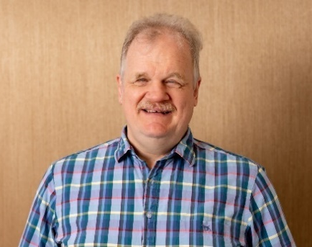  Clive Lansink (Chair) | 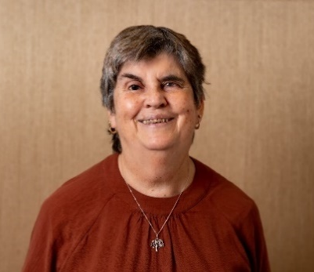  Judy Small (Deputy Chair)
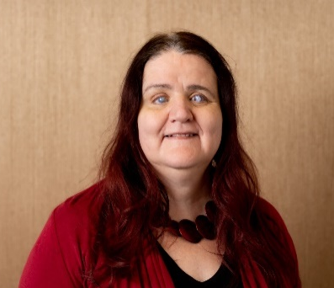  Martine Abel-Williamson | 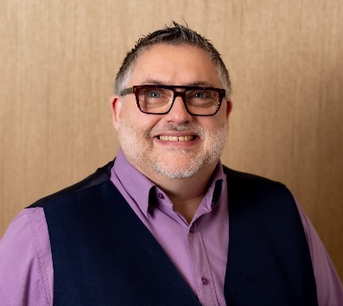  John Billings
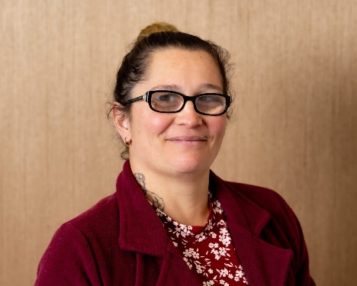  Donna McCaskill | 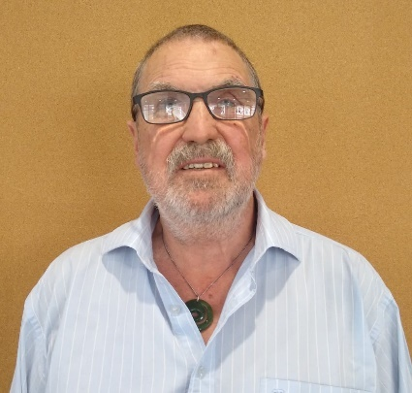  Chris Orr
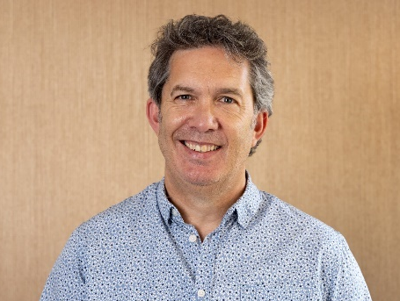  Richard Patete | 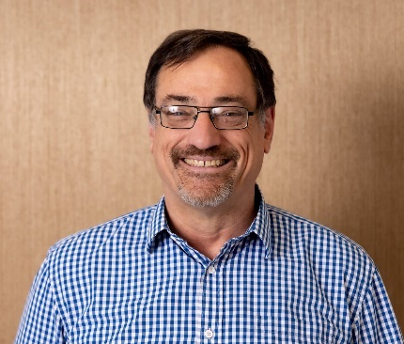  Ronald (Ron) Scott
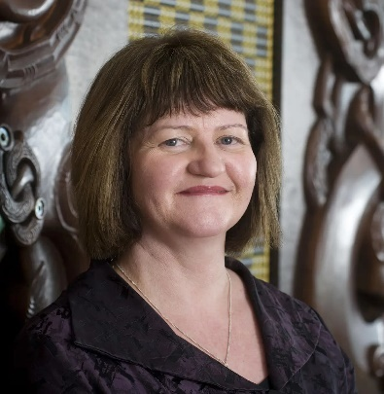
Anne-Marie Taggart
Page 44

Clive Lansink—Chair
Blind since birth, Clive has devoted much of his life to advancing the rights and opportunities of people who are blind, deafblind or have low vision. He holds degrees in engineering and law, and has had a successful career in IT and software development. Alongside his professional achievements, Clive has been a long-standing advocate for the blind community, serving as President of Blind Citizens NZ for thirteen years.

Judy Small—Deputy Chair
Judy has been a client of Blind Low Vision NZ since she was four years old and joined the Board in 2013. After graduating in 1999 with a Master of Social Science (Hons) and serving ten years on the Blind Citizens New Zealand National Executive, she worked as a Policy Analyst for 11½ years in the Office for Disability Issues. After working for ten years at the Hamilton City Council as a Disability Advisor, she has retired. Her focus is now on regular exercise and volunteering in her local community.

Martine Abel-Williamson
Martine's qualifications are in the areas of vision rehabilitation, education and social policy and she previously worked at Blind Low Vision NZ in the fields of blindness awareness training and service co-ordination. She serves on government working groups and committees and she's also on disability organisation related boards such as Blind Citizens NZ, Disability Connect, and National Advocacy Trust. Martine is also the President of the World Blind Union.
Page 45

John Billings
John has been practising his profession as a Dispensing Optician for 41 years. He has always had a strong interest in providing Low Vision Aids and services to the partially sighted in order to help them continue with as good a quality of life as possible. As well as the Low Vision community, he also has experience with the Deaf community and has learned some NZSL and tactile signing to help him communicate with those who are Deafblind. John also does guide dog puppy raising and guide dog/puppy boarding, and volunteers with a number of guide dog fundraising events and initiatives.

Donna McCaskill
Donna joined the Board in 2020 after 20 years of service as a staff member with Blind Low Vision NZ. A member since birth, Donna's family has a close connection to the organisation due to a dominant genetic eye condition. Originally from Auckland, Donna now lives in Ashburton running an agricultural employment support service. Alongside her career, she is a passionate advocate for disability and inclusion in sport. Which has led to her involvement with Te Ope Tāmiro—Te Kahu Raunui (Sport Integrity Commission). Donna is also a trustee for The D*List, a media focused advocacy agency.

Chris Orr
Chris was elected in November 2023. He lost his sight in 1974 as the result of a traumatic injury. Now retired, Chris has dedicated over 46 years to Blind Low Vision NZ, holding diverse roles such as Braille Teacher, Fundraising Manager, Community Education and Awareness Manager, and Access and Awareness Advisor. His wealth of experience and extensive knowledge of Blind Low Vision NZ services make him a valuable addition to the board.
Beyond his contributions to Blind Low Vision NZ, Chris actively serves on the Auckland Council's Disability Advisory Panel and Universal Design Forum. In these roles, he continues to advocate for inclusivity and accessibility, bringing his expertise to the broader community.
Chris competed at the 1984 Winter Paralympics, winning a silver medal in the downhill. He previously won a bronze medal at the 1983 World Blind Marathon Championships. Chris played goalball for many years and continues to be involved in the sport as an official.

Richard Patete
Richard has been involved with Blind Low Vision NZ for over 20 years. His eldest daughter, Renee, was born blind. Raising Renee has given him a strong understanding of the needs and challenges of the blind and low vision community. He brings with him an extensive range of experience working in the not-for-profit sector.
Page 46

Ronald (Ron) Scott
Ron lives in Tauranga where he is an elected member of the Bay of Plenty Regional Council. He is also a director of Consumer NZ, and Workbridge Holdings. He was previously deputy chair of the Bay of Plenty DHB.
Ron is an economist and the founder of Stellaris Ltd which specialises in strategy and governance training for boards and senior executives.
Ron brings to the board his governance and strategic experience and understanding of finances as well as the ability to make connections, for the benefit of members, across the community, disability and local government sectors.

Anne-Marie Taggart
Anne-Marie is an experienced senior leader within the NZ public sector. She began her career as an HR professional but in recent years has branched out and has led both corporate and operational functions. Anne Marie has experience as a Board director having supported several not-for-profit organisations. She is currently employed as General Manager at the Ministry of Education and leads a large team who are responsible for the HR function, as well as all Ministry property, security and sustainability initiatives. Anne Marie has a Bachelor of Business and a Master of Public Administration from Victoria University in Wellington.
Page 47

Executive Leadership Team, Te Ranga Manahautū
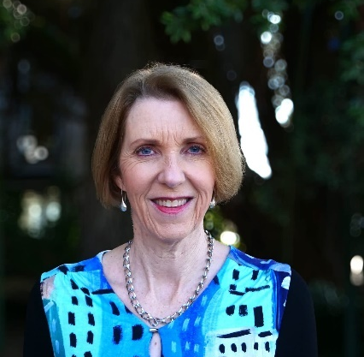  Andrea Midgen | 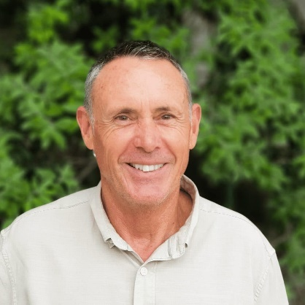  Greg Hurn
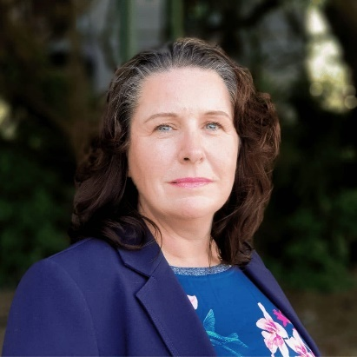  Gwen Green | 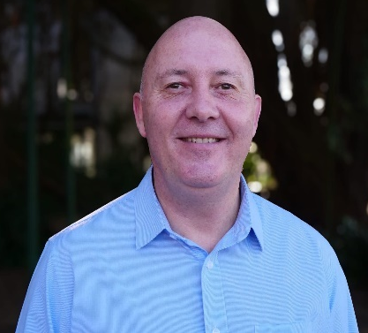  Stephen Keeling
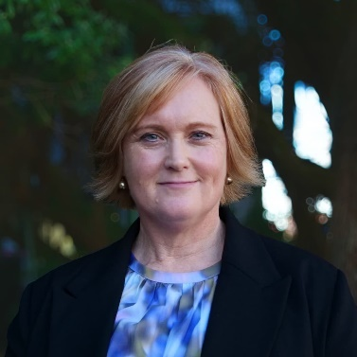  Catherine Simanu  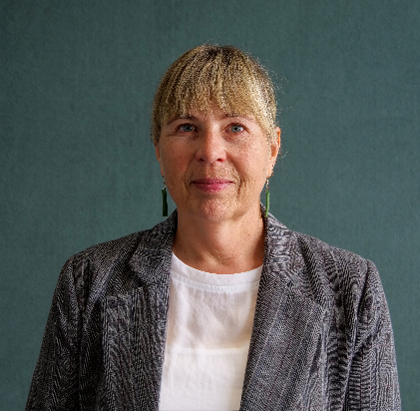  Natasha Mackie | 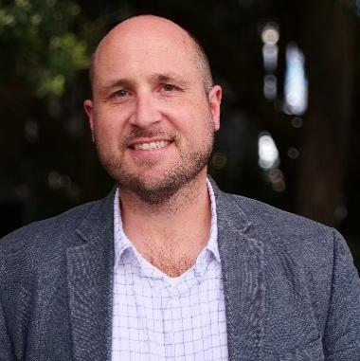  Dan Shepherd

Andrea Midgen, Chief Executive
Andrea is a proven leader with extensive CEO and senior executive experience, both within and outside the not-for-profit sector. She has consistently demonstrated a clear sense of purpose and vision throughout her career. Andrea served as Chief Executive Officer of the Royal New Zealand Society for the Prevention of Cruelty to Animals (SPCA) for over seven years. Prior to that, she was Group Strategist/CFO for Southern Cross Group and held several senior executive roles at Vodafone, culminating as Director of Customer Operations. During her tenure at Vodafone, Andrea also gained valuable governance experience as Chair of the Vodafone New Zealand Foundation.
An alumna of Unitec Te Pūkenga with a Chartered Accountant (CA) qualification, Andrea Midgen brings a wealth of experience in organisational leadership, financial acumen, and stakeholder management. Andrea's leadership focus is on being curious, kind, people and client focused, each and every day.
Page 48

Greg Hurn, Chief Operating Officer
Greg joined Blind Low Vision NZ in 2010 as the Chief Financial Officer. He brings a wealth of experience in financial management, strategic planning, business development initiatives, and customer service. He consistently demonstrates a capacity for swift decision-making and effective problem-solving.
Greg also oversees the property division of Blind Low Vision NZ and is a Board Member of Foundation Properties Limited. He was a key player in the development of the Mobility Training Centre, the new Parnell Office, and Retirement Village project.
Greg believes in leading by example and fostering an environment of open communication and shared purpose. Greg's aim is to ensure we are financially sound and sustainable over the long-term horizon.

Natasha Mackie, General Manager Client Services
Natasha Mackie is a highly experienced senior leader with a proven track record having worked across government, not-for-profit, disability, and community housing sectors. She brings extensive expertise in operational delivery, strategic and policy development, leading high performing teams, consultation, and community development.
Holding a Master's degree in Public Management, Natasha is recognised for her inclusive, results-driven leadership style, and her commitment to improving lives through strategic collaboration, strong relationships, and practical solutions that deliver lasting impact.
With a strong background in delivering consultation, co-design, and participatory models, Natasha's focus is to ensure quality, responsive, client focused services are provided across Aotearoa now and into the future.

Dan Shepherd, General Manager Community and Inclusion
Dan joined the Executive Leadership Team having provided authentic, lived experience leadership across the organisation since 2019. Following roles in Client Services, Awareness and Accessibility, Dan brings his experience working with Blind Low Vision NZ to lead a renewed focus on how communities can lead change and remove access barriers for people who are blind, deafblind or low vision as General Manager Community and Inclusion.
Diagnosed with Retinitis Pigmentosa at the age of 15, Dan adds a client voice to the Executive Leadership Team at Blind Low Vision NZ, which is key to our connection to cause—our clients and members.
Driven by his passion for social inclusion and barrier-free choice for others in their communities, Dan aims to influence change and accessible participation in the community through relationships with communities and engagement with key stakeholders.
Page 49

Gwen Green, General Manager Engagement and Marketing
Gwen has over 25 years' fundraising, marketing, and communications experience both in New Zealand and the UK.
Gwen has a passion for developing donor-focused fundraising, creating new income opportunities, and re-visioning communications and marketing strategies to grow multi touch point engagement, in ways that are flexible to our ever-changing world.

Stephen Keeling, Chief Financial Officer
Stephen joined the Executive Leadership Team as the Chief Financial Officer following a successful career in senior finance roles and as Head of Finance at Blind Low Vision NZ. Joining Blind Low Vision NZ in 2019, Stephen has brought a successful track record in leadership, governance, and delivering financial results on behalf of organisations to their Board and stakeholders. Stephen's aim is to continue to ensure we are financially sound and sustainable over the long-term horizon. Stephen is a Chartered Accountant and has been a member of ICAANZ (Institute of Chartered Accountants Australia and New Zealand) for over 25 years.

Catherine Simanu, General Manager People
Catherine is a seasoned human resources professional with extensive experience leading teams across the health, banking, technology, and telecommunications sectors. She is known for building relationships grounded in trust and respect, leveraging her expertise while honouring the mana of others. Catherine thrives in complex, multi-stakeholder environments, demonstrating adaptability and effectiveness in the face of ambiguity.
Catherine leads the People Partner, Health & Safety, Learning & Development, and Volunteering functions at Blind Low Vision NZ, with a firm focus on partnering and working alongside people leaders and teams to enable the best service delivery and experiences for our clients.
Passionate about creating engaged and connected workplaces, Catherine is committed to fostering a culture where people can work to their full potential—making Blind Low Vision NZ a "great place to work" and achieving lasting value for both the organisation and the communities it serves.

Amsler Grid

How to test your eyes with the Amsler Grid
Tear this page out and keep it somewhere you will remember so that you can test your eyes regularly.
- Wear glasses that you normally wear for reading.
- Hold the grid about 35−40cm away from your face.
- Cover one eye at a time.
- Stare at the dot in the middle.
- Contact your eye care doctor immediately if any of the straight lines appear wavy or bent, any of the boxes differ in size or shape from the others, or any of the lines are missing, blurry or discoloured.

Page 50
Here is what an abnormal reaction to the Amsler grid might look like. If you start to notice this, please consult your doctor. 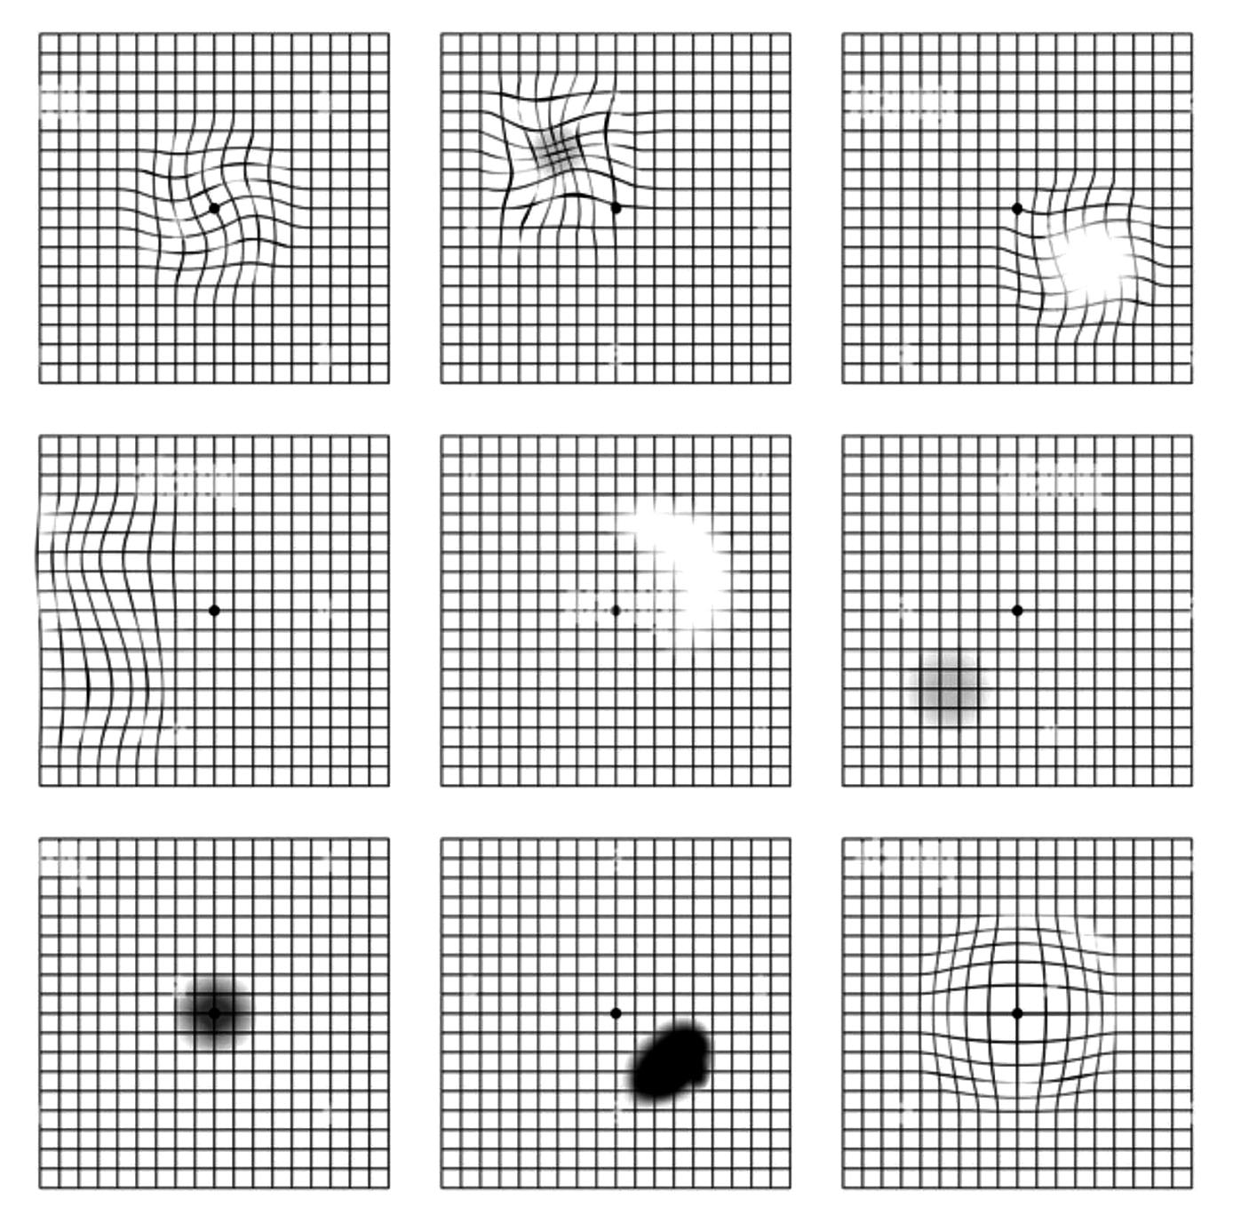

Eye Test



Pages 51-52

Blind Low Vision NZ around the country, Kāpō Matarehu Aotearoa puta noa i te motu
A: Whangārei  277 Kamo Road,  Kamo  Whangārei 0112 | K: New Plymouth  131 Vivian Street,  New Plymouth 4310
B: Smales Farm  Q4 Building, 74 Taharoto Road, Takapuna, Auckland 0622 | L: Napier  77 Raffles Street,  Napier South, Napier 4110
C: Henderson  Unit C (upper level),  197 Universal Drive, Henderson, Auckland 0610 | M: Whanganui  102 Peat Street,  Whanganui  4500
D: Parnell  539 Parnell Road, Parnell  Auckland 1052 | N: Palmerston North  64 Taonui Street, Palmerston North Central 4410
E: Manurewa  30 Mcvilly Road, Manurewa  Auckland 2102 | P: Wellington  121 Adelaide Road, Newtown Wellington 6021
F: Fale Kotuku  20 Mcvilly Road, Manurewa, Auckland 2102 | Q: Nelson and Marlborough  530D Main Road, Stoke  Nelson 7011
G: Guide Dog Services  30 Mcvilly Road, Manurewa,  Auckland 2102 | R: Christchurch  96 Bristol Street, St. Albans  Christchurch 8014
H: Hamilton  15 Liverpool Street,  Hamilton 3204 | S: Dunedin  458 Hillside Road,  Caversham  South Dunedin 9012
I: Tauranga  160 Seventeenth Avenue,  Tauranga South  Tauranga 3112 | T: Invercargill  172 Queens Drive, Richmond  Invercargill 9810
J: Gisborne  39 Grey Street,  Gisborne 4010 | Blank

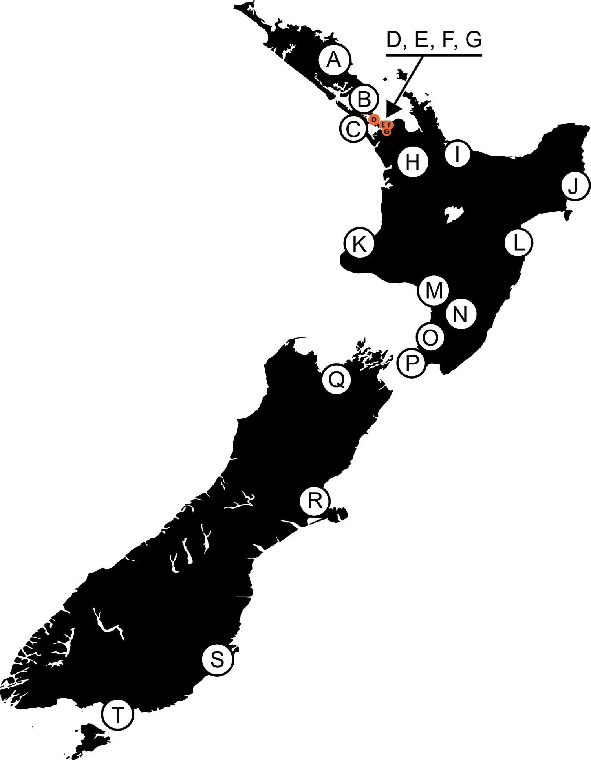
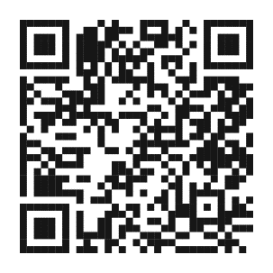
For more information and
opening hours scan the QR code
or visit our website.

Ngā mihi nui for your support!
From the team at Blind Low Vision NZ
blindlowvision.org.nz
0800 24 33 33
PO Box: Private Bag 99910, Newmarket, Auckland 1149
***
Facebook: BlindLowVisionNZ
Instagram: @BlindLowVisionNZ
X (Formerly Twitter): @BlindLowVision
End of Community Impact Report 2025

