Envoy Connect Quick Guide
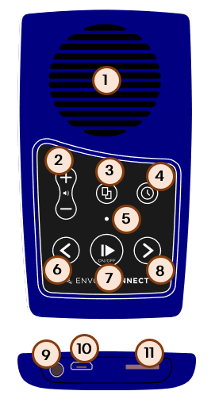
- Speaker
- Volume
- Bookshelf
- Sleep Timer
- LED Indicator
- Back
- Power Play Pause
- Forward
- Headphones
- USB Port
- Micro SD Port

Turning it On
Press the button in the lower middle (7) of the keypad for 2 seconds. The light (5) will turn on and a chime will sound. A preview of the last book is played and then it enters pause mode.

Selecting a Book
While in pause mode press the Bookshelf button (3) to preview the current book. Pressing the Bookshelf button again will preview the next book. When the last book has been previewed, it will then cycle back to the first book.

Navigating
During playback press the backward (6) or forward (8) button to move one section in the current book. If the last section is being played you will hear a sound that indicates the end of the book.
A 2 second press will skip approximately 25 seconds within the current section. A continuous press will continue skipping until the button is released.

Pausing
While playing, press the pause button (7) to pause playback. Press the play button again to resume playing.
The light (5) will blink to show the device is paused. When the device has been paused for 2 minutes, it will automatically turn off.
When paused or turned off, the Envoy will remember the current place of the book (minus approximately 3 seconds).

Volume
Press the volume buttons (2) to increase and decrease the volume level. A continuous press will change the loudness until the maximum or minimum level has been reached. Also, a double beep is played when the minimum or maximum level is reached. The volume level will remain set even if the player is turned off and restarted.
Volume adjustment can be done in playback and pause mode. When in pause mode, the player will beep at each level so you can hear the current loudness setting.

Charging
For the fastest charge, connect any standard USB charger to the USB port (10) at the bottom of the player for about 2 hours or until the LED light (5) stops blinking. While the player is connected to a computer or laptop, it will take about 3 hours to charge.
For solar charging, place the solar panel directly facing bright sunlight for at least 8 hours. The LED light will not blink while solar charging.

Battery Status
While the Envoy is in pause mode, press the back (6) button.
- 3 beeps mean the battery is between 76%-100%.
- 2 beeps mean the battery is between 51%-75%.
- 1 Beep means the battery is between 30%-50%.
If the battery is below 30% the Envoy will chime every minute to warn the battery is low, also the LED light will blink.
If the battery runs out completely, it will save the location of the book and shut down.

Headphones and Speakers
Insert headphones or speakers into the headphone socket on the bottom of the Envoy. The internal speaker (1) will turn off if anything is plugged into the unit.

Sleep Timer
When in pause mode, press the Sleep Timer button (4) to set the Sleep Timer. Each press will sound a different chime and change the setting as follows: 15 mins, 30mins, 60mins and OFF. A 2-second press on the Sleep Timer button will turn off the sleep timer.
When the Sleep Timer finishes, a bookmark will be created, and the Envoy will turn off silently.
If the Envoy is turned off before the timer has finished, the Sleep Timer is reset to OFF when the Envoy is turned on again.

