Downloading Books to Envoy

What you will need
- Windows Laptop or PC
- Aurora Cloud Connect app
- Internet connection
- USB cable
- Envoy Connect eReader

Summary
- Connect the Envoy to a Windows laptop or PC via USB cable.
- Login to the Auroa Cloud Connect App.
- Download books by selecting the Push to Start button.
- Remove the device once the app has finished downloading the books.

Connect
Plug the Envoy into your Windows computer or laptop using a USB cable.
Your device should make a sound indicating that it has been plugged in and connected.
The Envoy Connect needs to be turned off to connect to your device.

Login
Open the Aurora Cloud Connect app. If you do not have the Aurora Cloud Connect app installed, you can download it from blindlowvision.org.nz (search: Envoy).
Select the Login Button and enter your client number and password.
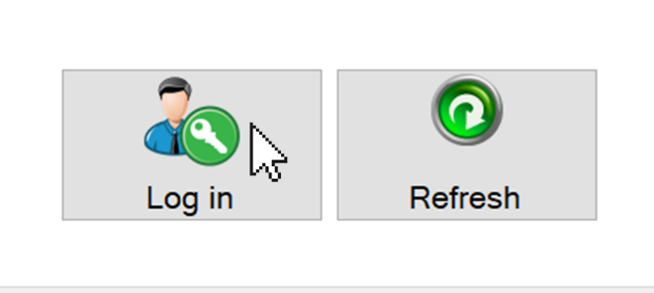
Select the Remember me checkbox if you do not wish to log in every time you use the app.
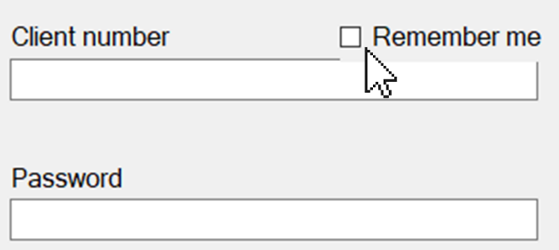
Contact the Blind Low Vision NZ contact centre (0800 24 33 33) if you require your client number and password.
The default number of books that will be downloaded is 10. You can change the amount by changing the number in the New Books to allocate and download box.
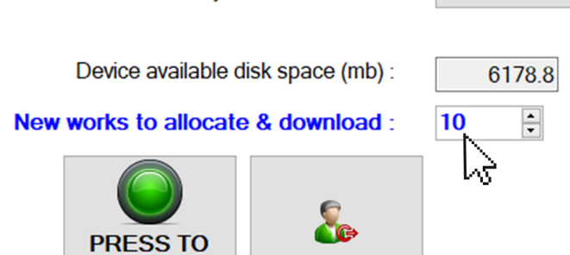
You can check the amount of space that is on your Envoy by reading the Device available disk space (mb): box.

Download
Select the Press to Start Button to start downloading books.
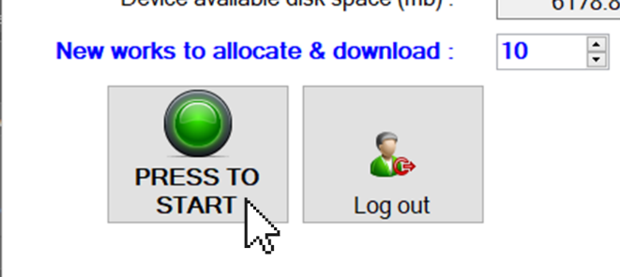
Details of the downloading progress will be displayed on the left side of the screen.
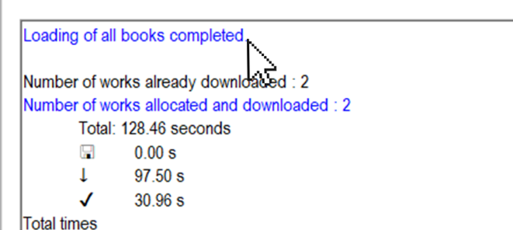
Note: To download a specific book, you can make a request calling the Contact Centre 0800 24 33 33

Deleting Books
You can choose the books you wish to delete by selecting the checkbox by each book.
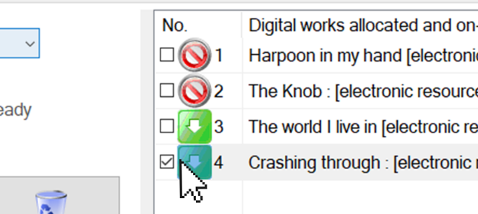
Once a book is selected the Delete off device button appears. Press the button to remove the selected books off the device.
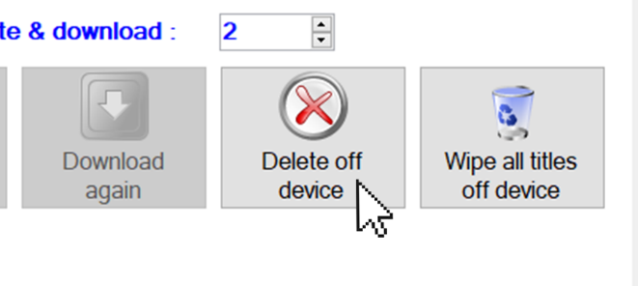
The amount of space that the selected books take up on your device is shown in the Selected titles disk space box. This can help you decide which books to remove.
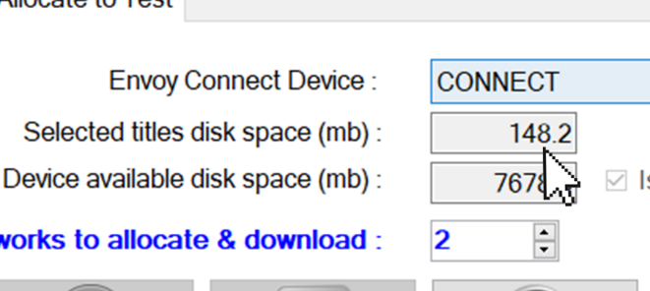
Note: The book titles are remembered in the app, and you can download the books again. Once a book is selected the Download again button appears. Press the button to download the books again.
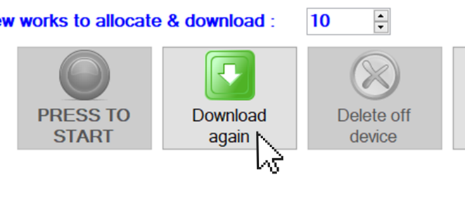

Remove
Remove the device once all the books have been downloaded.
Power on the Envoy Connect and press play to start reading. Press the Bookshelf button to skip to the next book.

